SRI SIVASUBRAMANIYA NADAR COLLEGE OF ENGINEERING

(AN AUTONOMOUS INSTITUTION, AFFILIATED TO ANNA UNIVERSITY)
RAJIV GANDHI SALAI (OMR), KALAVAKKAM – 630110.

LABORATORY RECORD

NAME : Boobathi V
REG. NO : 3122245001032
DEPT : CSE – A SEM : V
SRI SIVASUBRAMANIYA NADAR COLLEGE OF ENGINEERING
(AN AUTONOMOUS INSTITUTION, AFFILIATED TO ANNA UNIVERSITY)
RAJIV GANDHI SALAI (OMR), KALAVAKKAM – 630110.

BONAFIDE CERTIFICATE

Certified that this is the bonafide record of the practical work done in the
ETHICAL HACKING (UCS3568)
Laboratory by
Name : Boobathi V
Register Number : 3122245001032
Semester : V
Branch : B.E. Computer Science and Engineering – A
During the Academic Year : 2026 – 2027 (ODD)

Faculty Head of the Department

Submitted for the End Semester Practical Examination held at SSNCE on
_____________.

Internal Examiner External Examiner
INDEX

NAME: Boobathi V REG. NO: 3122245001032
SEM: V
S. No | Date | Experiment | Page No | Signature
1 | 24/06/2026 | Lab Setup: Install Kali Linux & Metasploitable | 1
2 | 01/07/2026 &  15/07/2026 | Practice the basics of reconnaissance | 23
3 | 22/07/2026 | Using FOCA / SearchDiggity tools, extract metadata and expanding the target list | 46
4 | 29/07/2026 | Aggregates information from the public databases using online free tools like Paterva’s Maltego | 56
5 | 12/08/2026 | View and capture network traffic using Wireshark | 61
6 | 09/09/2026 | Scan the target using tools like Nessus | 67
7 | 16/09/2026 | Information gathering using tools like Robtex | 85
8 | 23/09/2026 | Automate dig for vulnerabilities and match exploits using Armitage | 90

Ex. No. 1 Date: 24/06/2026
Lab Setup: Install Kali Linux & Metasploitable
Objective:
The aim of this experiment is to design and build a safe, self-contained virtual cyber-security laboratory on a single host computer. Oracle VM VirtualBox is installed as the virtualisation platform, and three guest operating systems are created inside it: Kali Linux, which acts as the attacker or auditor machine; Metasploitable 2, an intentionally vulnerable Linux machine that acts as a target; and Windows XP, a legacy Windows machine that acts as a second target.
Practising ethical hacking on real, production systems is illegal without written permission, so every later experiment in this record is carried out only inside this isolated lab. Virtual machines can be snapshotted, restored and destroyed at will, which makes it possible to attack and repair the same system as many times as required without any real-world damage. The experiment also verifies that the three machines can communicate with each other, because scanning and exploitation cannot be practised until this connectivity is working.
Tools:
• Oracle VM VirtualBox 7.2.10 – a free, open-source type-2 hypervisor that runs on top of the host operating system and lets several guest operating systems run side by side as virtual machines (VMs). It provides NAT, Bridged and Host-Only virtual networking, snapshots and virtual hard disks (VDI/VMDK).
• Kali Linux 2026.1 (64-bit installer image) – a Debian-based distribution maintained by Offensive Security and designed for penetration testing, digital forensics and security research. It ships with several hundred pre-installed security tools.
• Metasploitable 2 (Rapid7) – a deliberately vulnerable Ubuntu-based virtual machine containing many weak and outdated network services. It is distributed as a ready-made VMDK disk and is the standard practice target for scanning and exploitation.
• Windows XP Professional SP3 (x86 ISO) – an old desktop operating system released by Microsoft on 25 October 2001. It is no longer supported, so it is useful as a vulnerable Windows target.
• Host system – a Windows computer with hardware virtualisation enabled and enough RAM and disk space for three virtual machines.
Methodology:
Introduction
A virtual machine is a software-defined computer that has its own virtual processor, memory, disk and network card. The hypervisor shares the real hardware of the host among all guests, while keeping the guests isolated from each other. For security testing this isolation is the key benefit: malware or an exploit that crashes a guest cannot harm the host.
VirtualBox offers three networking modes that matter in this lab. In NAT mode the guest reaches the internet through the host but is not visible from outside. In Host-Only mode the guest can talk only to the host and to other guests on the same private network. In Bridged mode the guest is attached directly to the physical network like a separate computer. A Host-Only network between Kali and the targets keeps vulnerable machines away from the real network.
A. Installing VirtualBox
1. Open the VirtualBox download page (virtualbox.org) and download the installer for Windows hosts.
2. Run the installer, accept the licence agreement and keep the default custom-setup features (USB support, Bridged Networking, Host-Only Networking). Click Yes on the network-disconnection warning, then Install.
3. Click Finish and start VirtualBox; the VirtualBox Manager window confirms a successful installation.
B. Installing Kali Linux
1. Download the 64-bit Installer image from kali.org (Get Kali → Installer Images).
2. In VirtualBox click New and enter Name: Kali Linux, Type: Linux, Version: Debian (64-bit). Attach the Kali ISO, allocate memory and create a VDI virtual hard disk of 20 GB or more.
3. Start the VM and choose Graphical Install. Select language English, location India and keyboard American English.
4. Set hostname to kali, leave the domain blank, create the user account (full name, username and a strong password).
5. Partition the disk using Guided – use entire disk → All files in one partition → Finish partitioning and write changes to disk → Yes.
6. Accept the default software selection, install the GRUB boot loader on /dev/sda and click Continue to reboot.
7. Log in with the credentials created during installation; the Kali desktop loads.
C. Installing Metasploitable 2
1. Download Metasploitable2-Linux.zip (Rapid7 / SourceForge) and extract it to obtain Metasploitable.vmdk.
2. In VirtualBox click New: Name Metasploitable2, Type Linux, Version Ubuntu (64-bit). Choose “Use an Existing Virtual Hard Disk File” and select Metasploitable.vmdk.
3. Open Settings → Network. Set Adapter 1 to Host-Only Adapter (optionally Adapter 2 to NAT).
4. Start the VM and log in with username msfadmin and password msfadmin.
5. Note the IP address of the machine:
ip a
6. From the Kali terminal verify connectivity (replies mean the lab is ready):
ping <Metasploitable-IP>
D. Installing Windows XP
1. Download the Windows XP Professional SP3 (x86) ISO image.
2. Create a new VM: Name Windows XP, Type Microsoft Windows, Version Windows XP (32-bit), and create a VDI virtual hard disk.
3. Open Settings → Storage, click the empty optical drive and choose the Windows XP ISO.
4. Start the VM. Press Enter to begin setup, F8 to accept the licence, select Unpartitioned space and format the partition using NTFS (Quick).
5. After the first restart (do not press any key to boot from CD) complete the graphical setup: regional options, name, computer name, date and time, typical network settings and workgroup.
6. When the desktop appears, remove the ISO (Devices → Optical Drives → Remove disk) and restart. Press Windows + R, type cmd and run ipconfig to find the IP address.
Screenshots:
A. VirtualBox
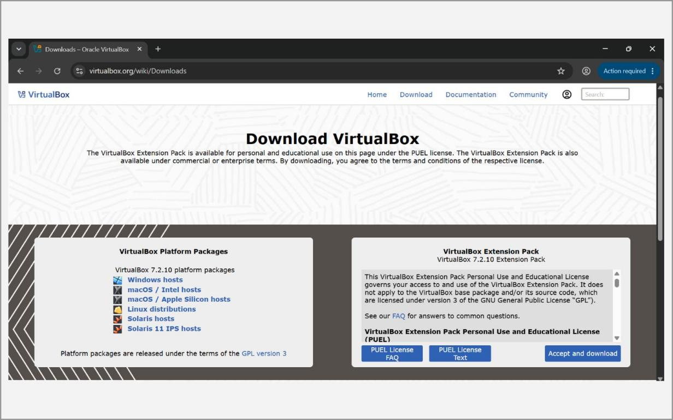
Fig. 1.1 – VirtualBox download page
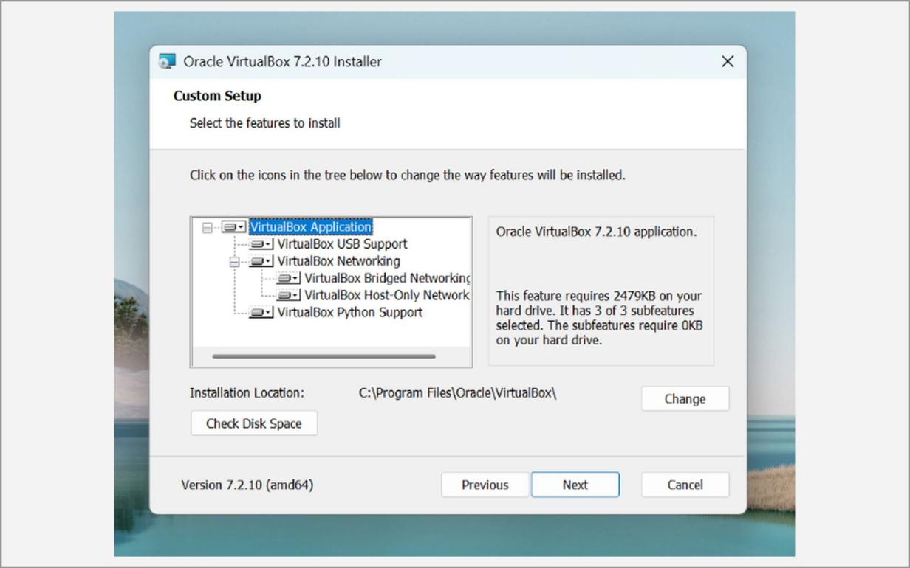
Fig. 1.2 – VirtualBox setup – custom features
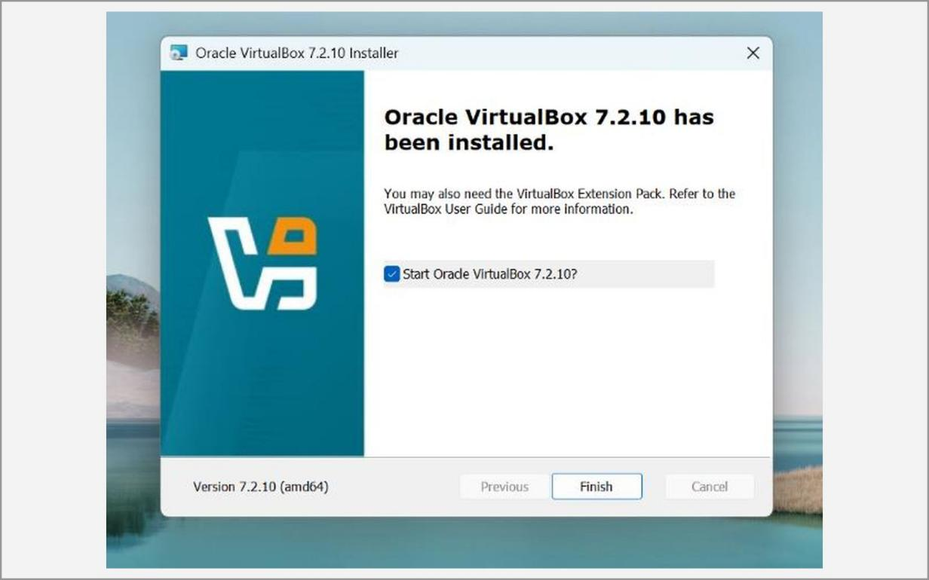
Fig. 1.3 – VirtualBox installation completed
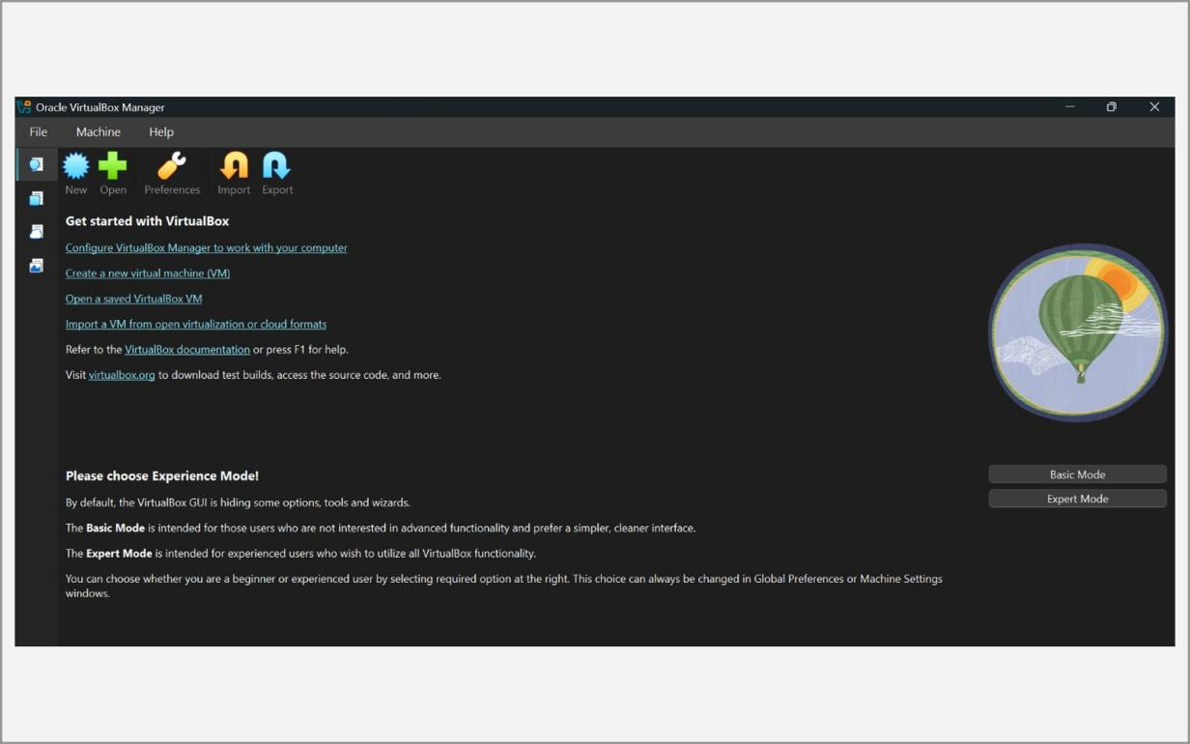
Fig. 1.4 – VirtualBox Manager window
B. Kali Linux
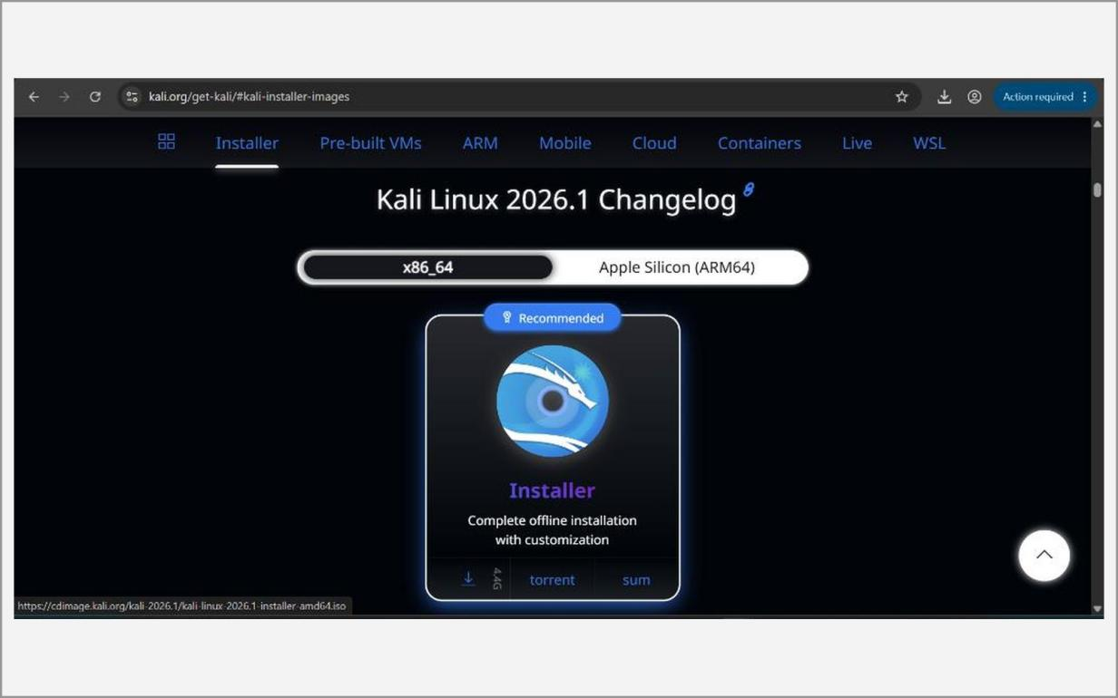
Fig. 1.5 – Kali Linux installer image download (kali.org)
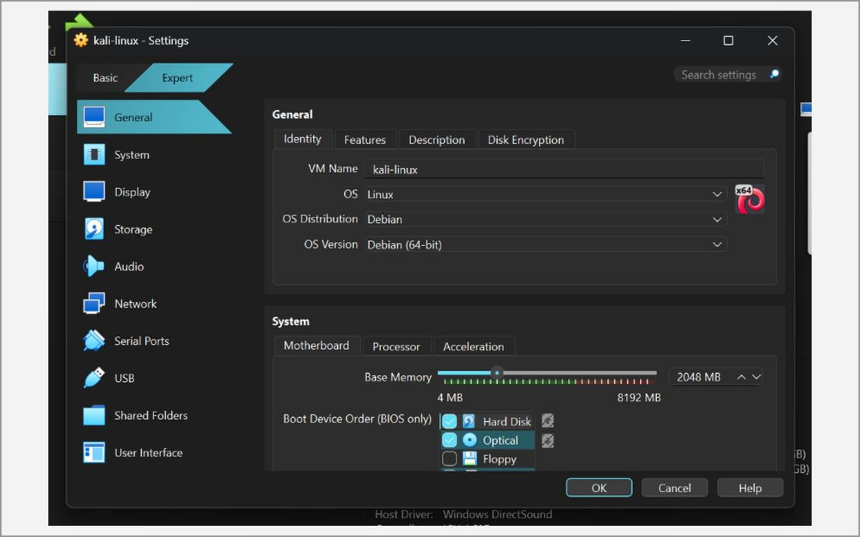
Fig. 1.6 – Kali VM settings – name, type, version and memory
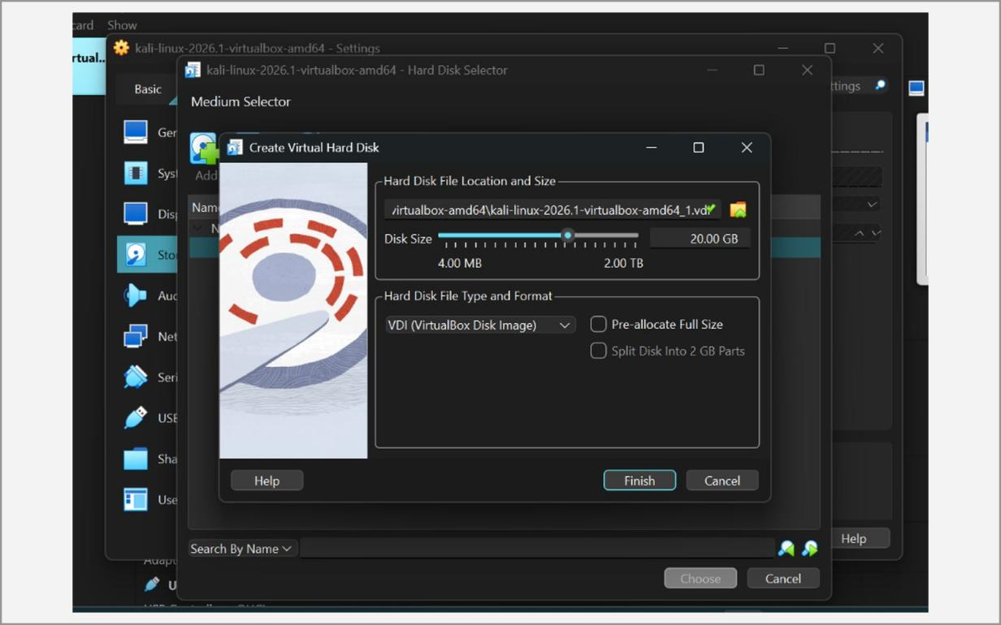
Fig. 1.7 – Creating the virtual hard disk (VDI)
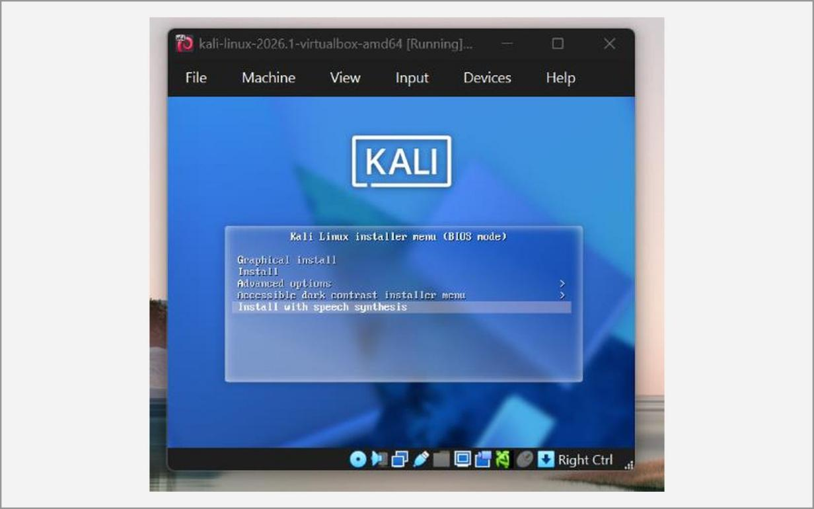
Fig. 1.8 – Kali boot menu – Graphical Install
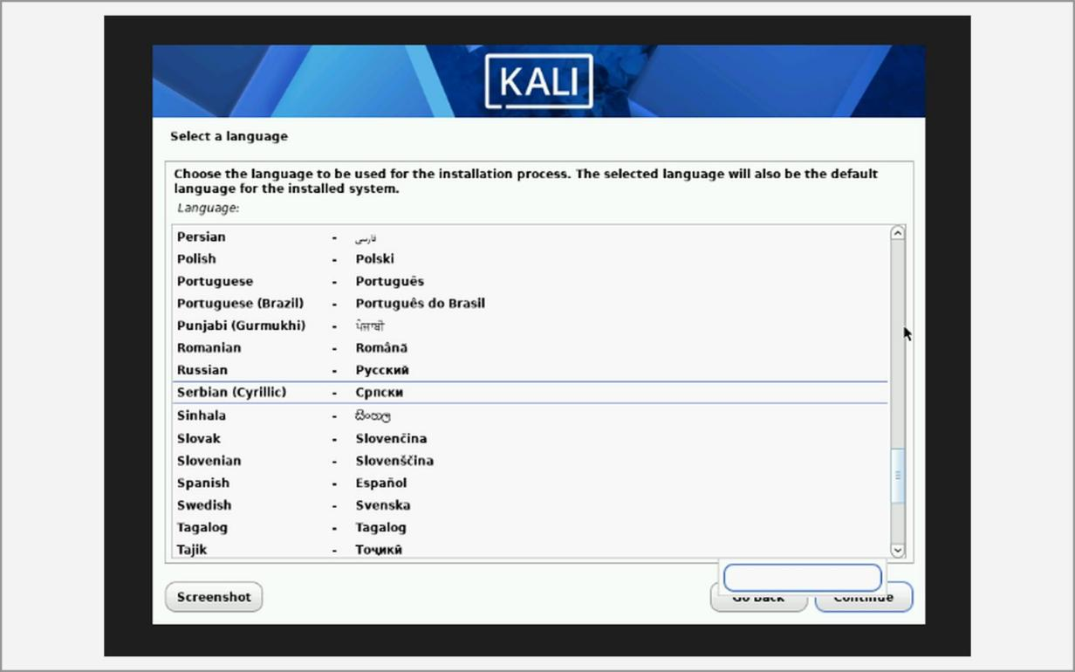
Fig. 1.9 – Select language
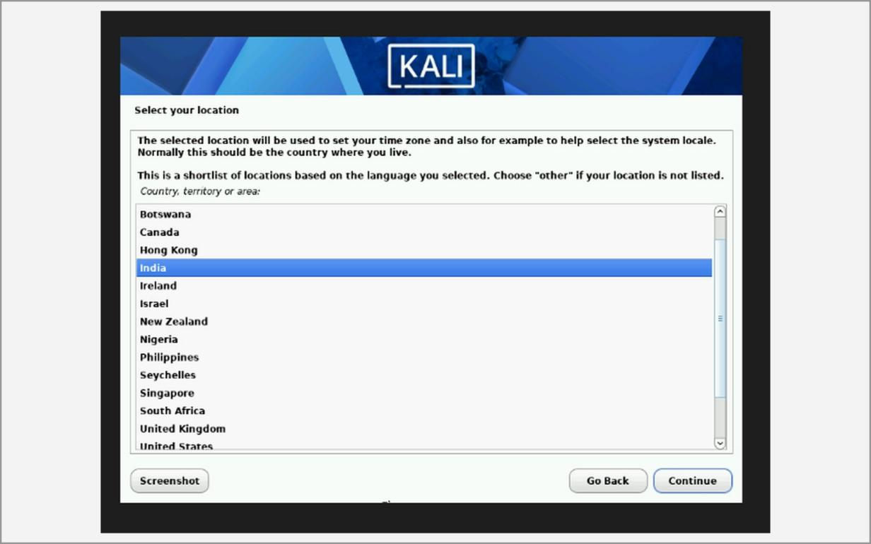
Fig. 1.10 – Select location
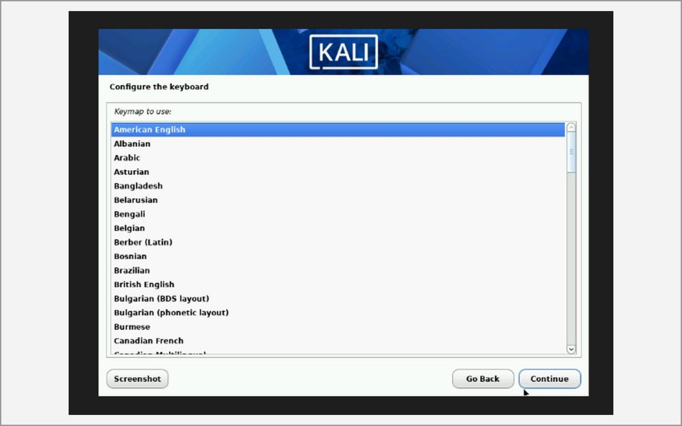
Fig. 1.11 – Configure the keyboard
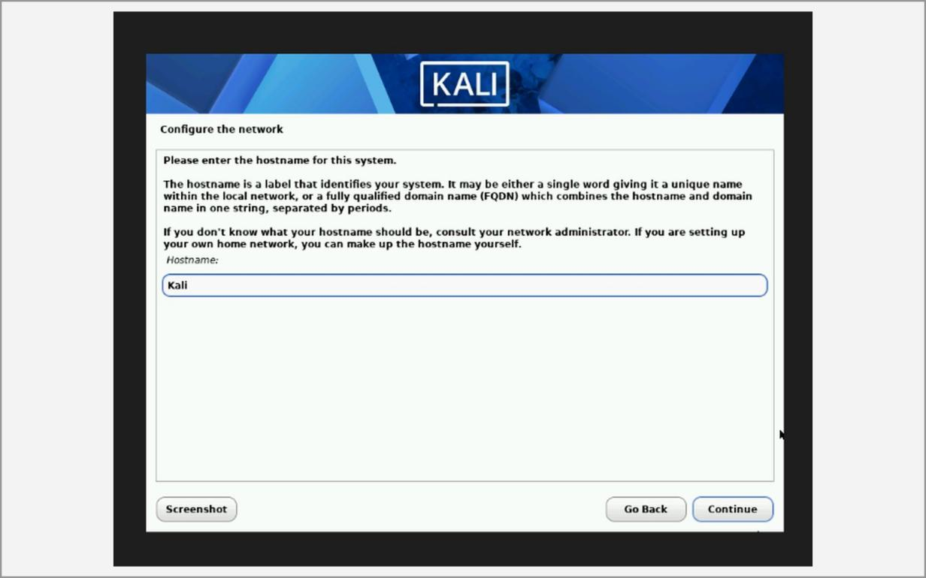
Fig. 1.12 – Configure the network – hostname
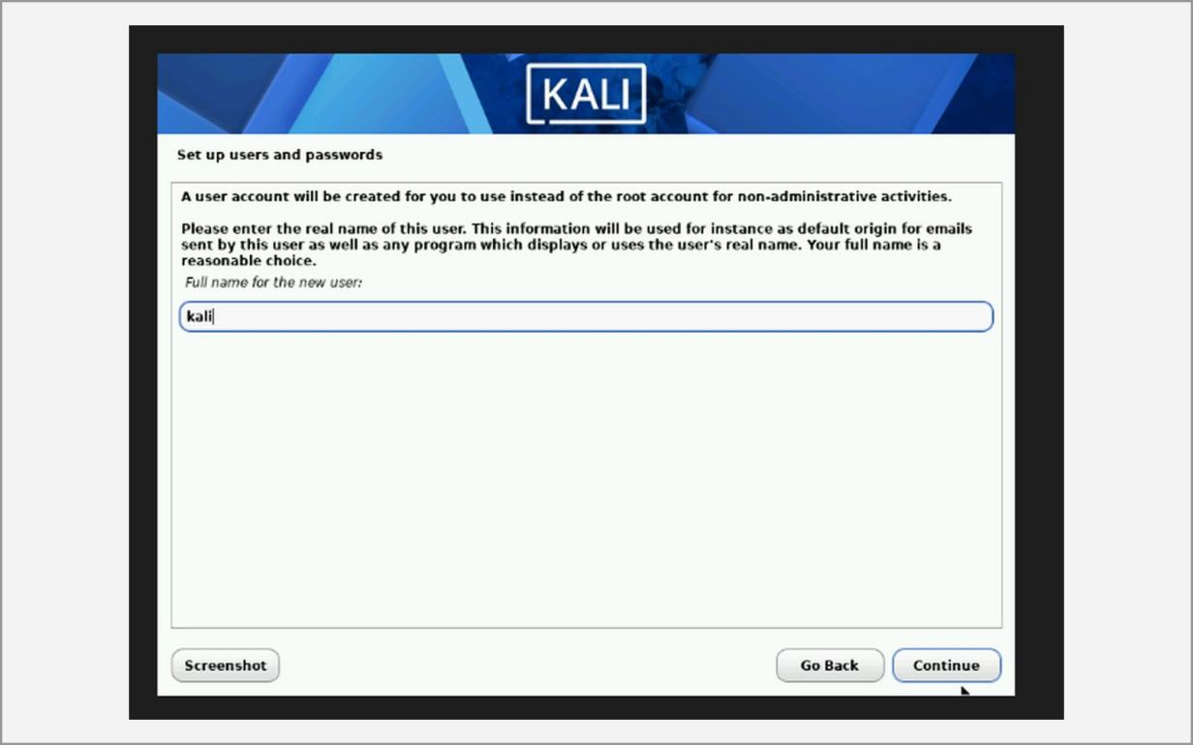
Fig. 1.13 – Create the user account
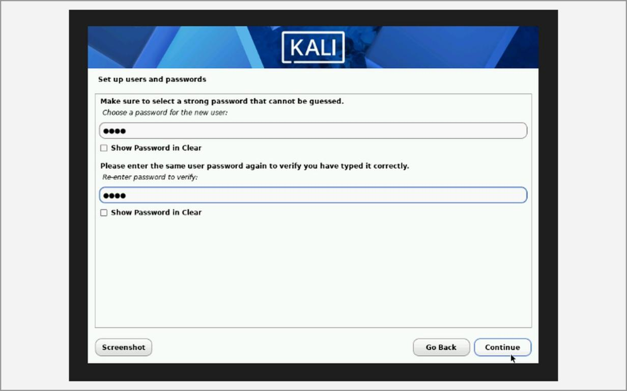
Fig. 1.14 – Set the password
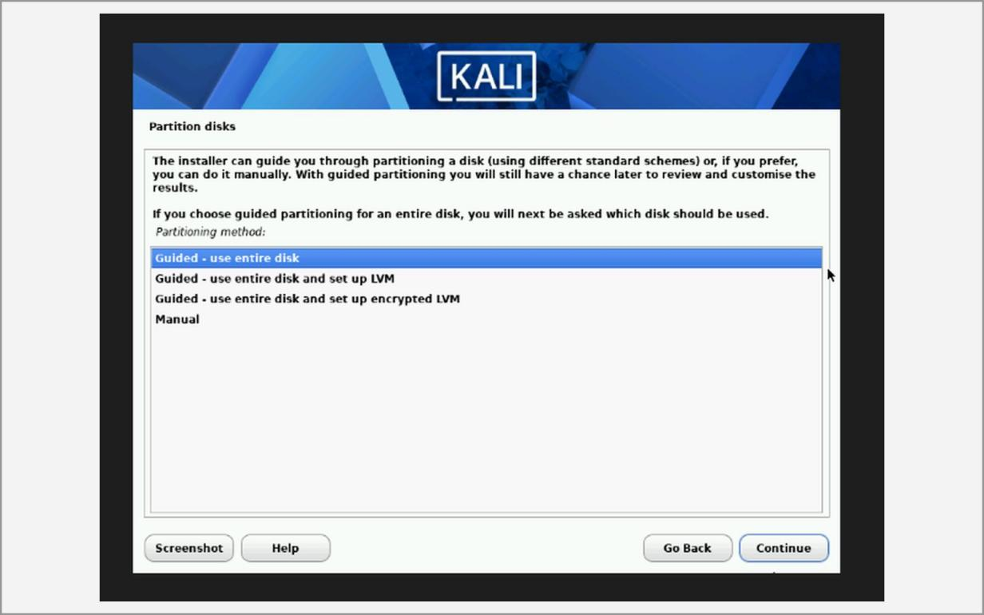
Fig. 1.15 – Partitioning method – guided, entire disk
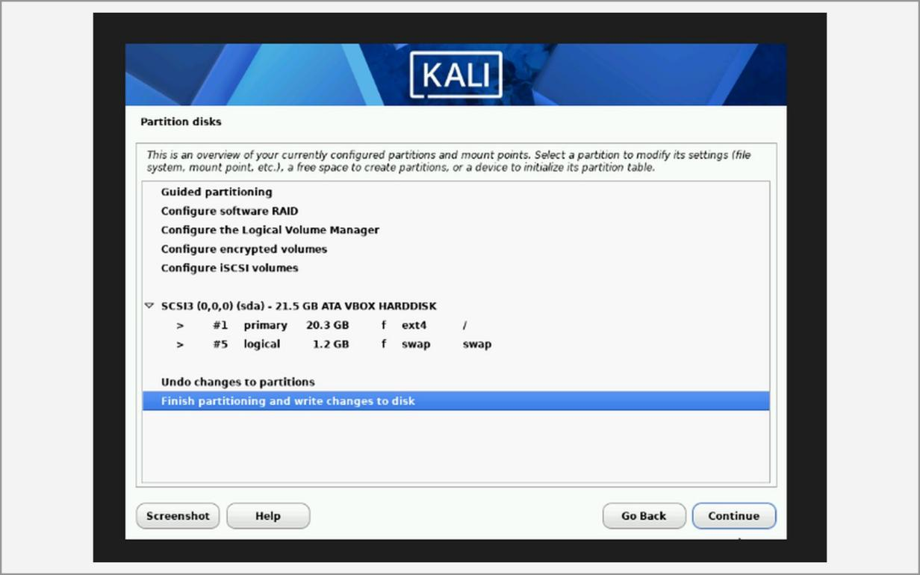
Fig. 1.16 – Finish partitioning and write changes to disk
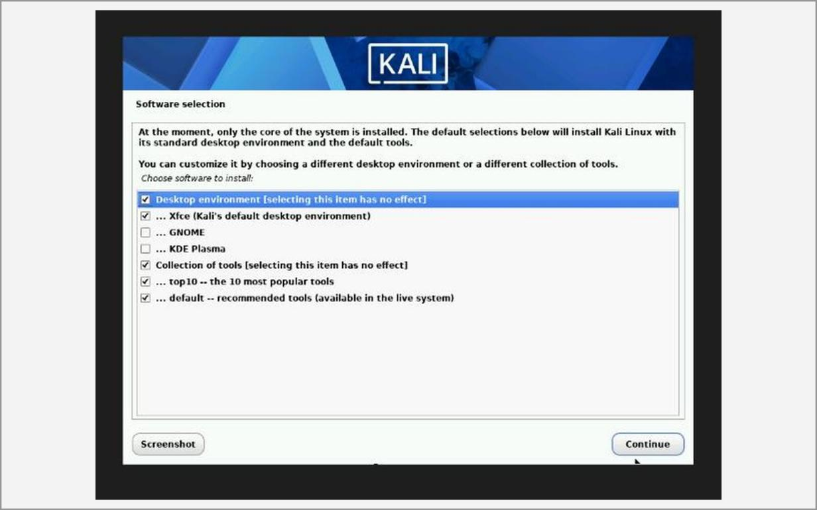
Fig. 1.17 – Software selection
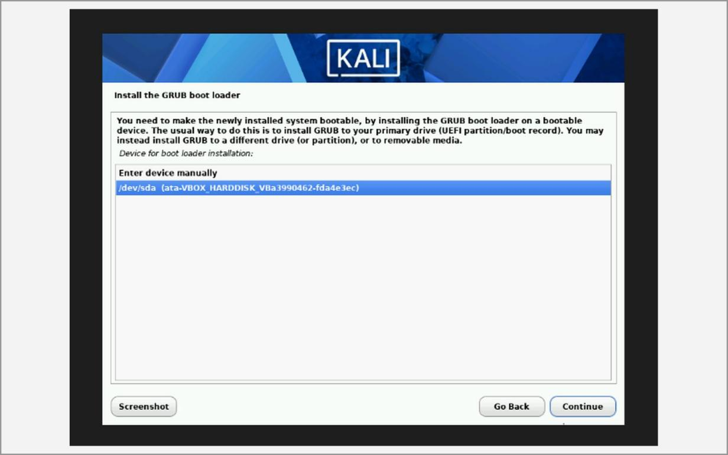
Fig. 1.18 – Install the GRUB boot loader
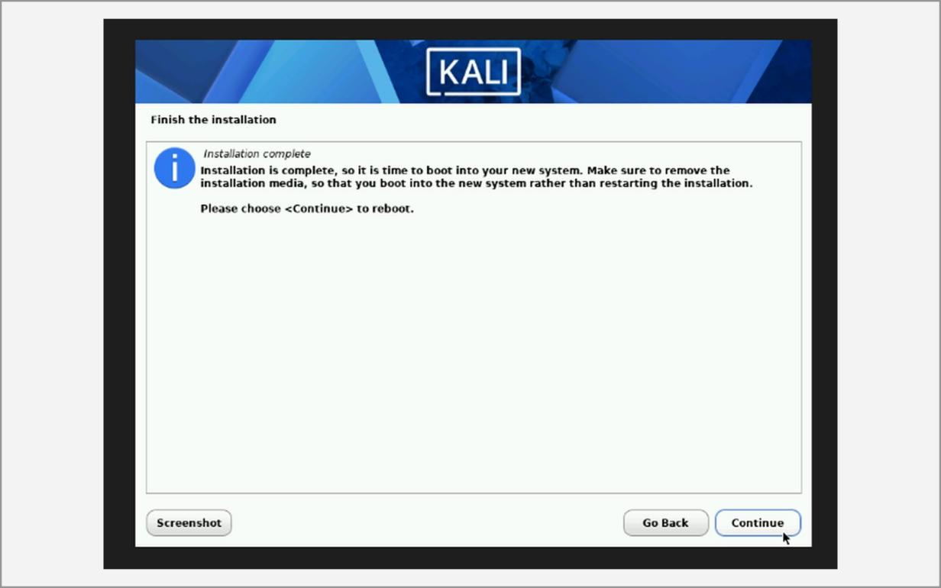
Fig. 1.19 – Installation complete
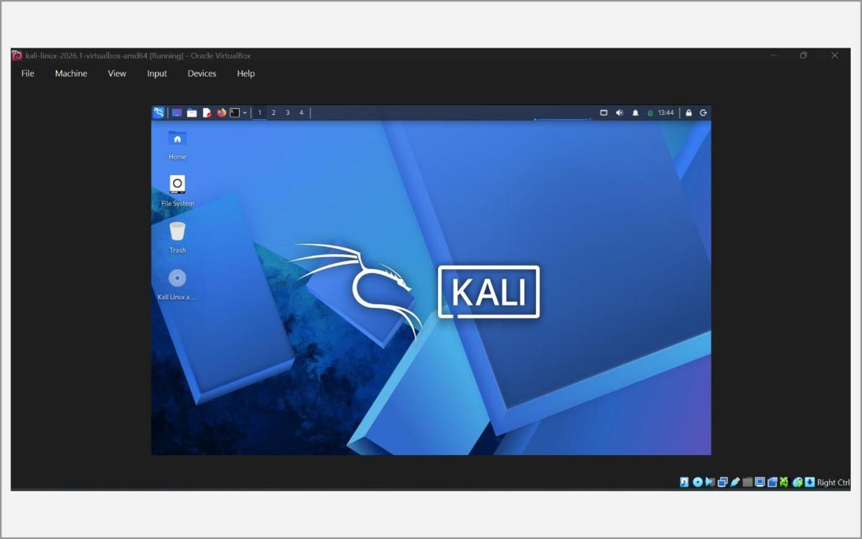
Fig. 1.20 – Kali Linux desktop after first login
C. Metasploitable 2
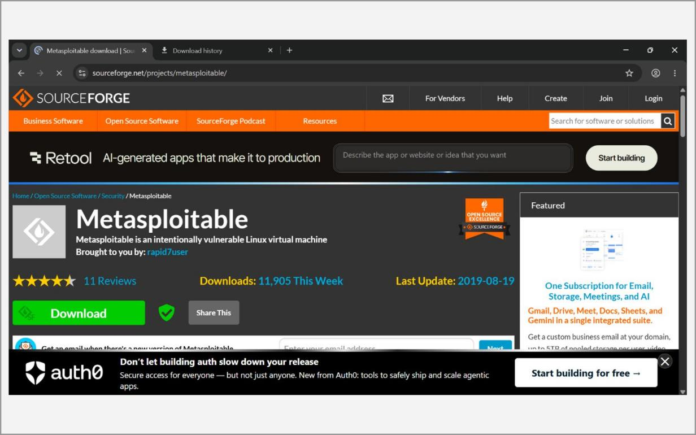
Fig. 1.21 – Metasploitable 2 download page
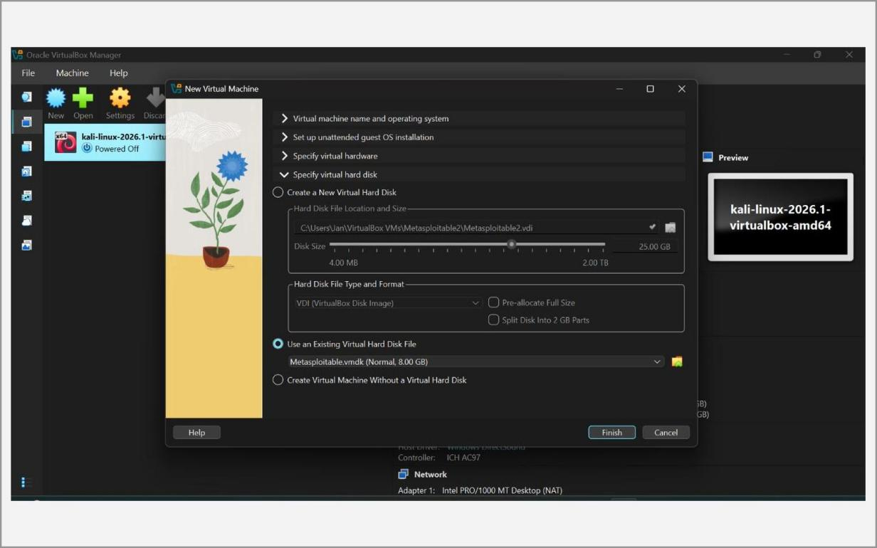
Fig. 1.22 – Using the existing virtual hard disk (Metasploitable.vmdk)
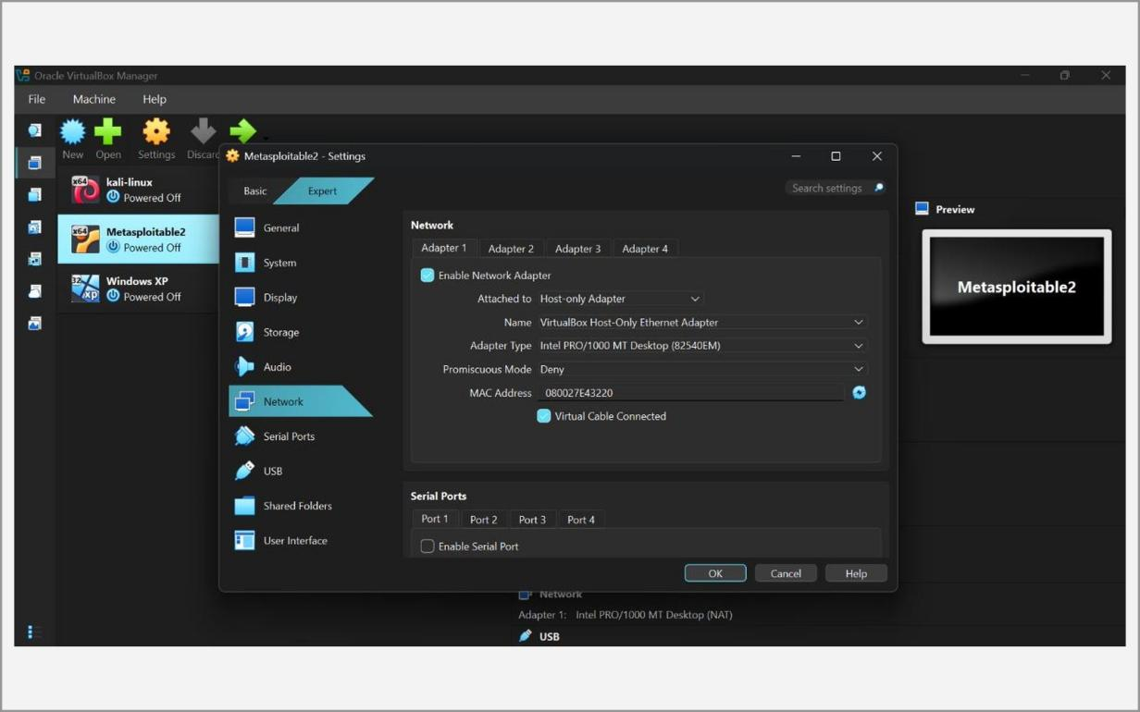
Fig. 1.23 – Metasploitable2 network settings – Adapter 1
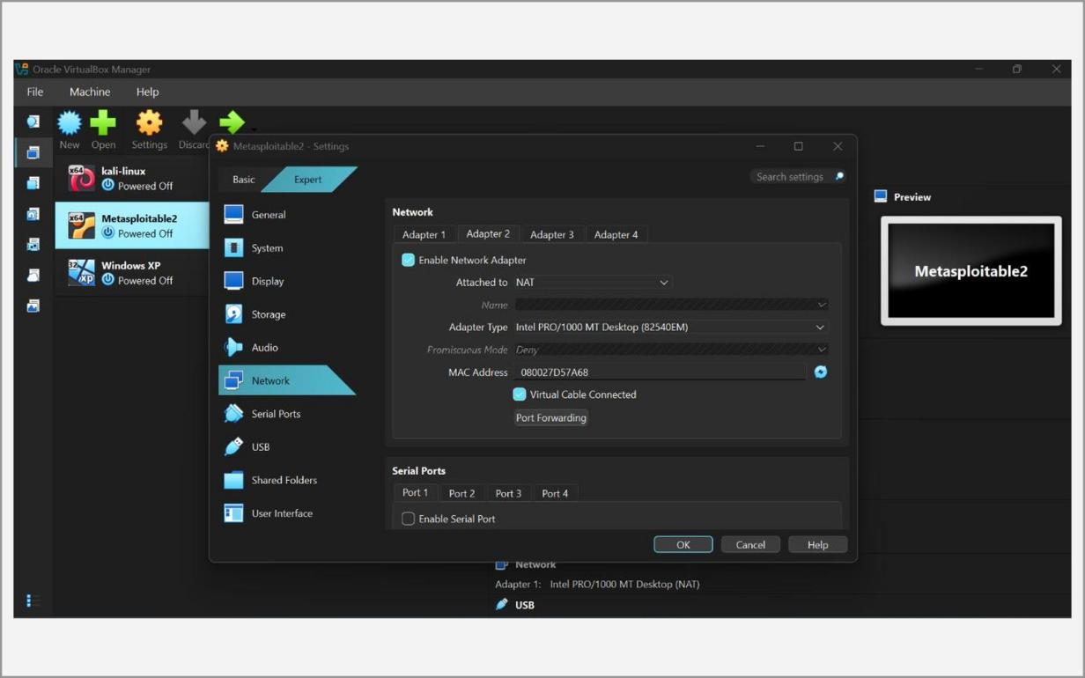
Fig. 1.24 – Metasploitable2 network settings – Adapter 2 (NAT)
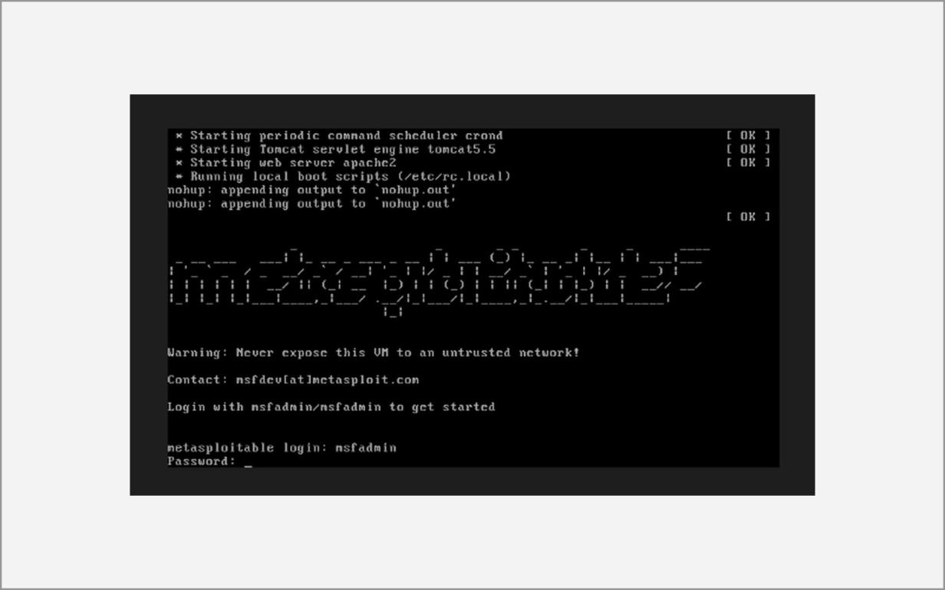
Fig. 1.25 – Metasploitable 2 boot and login prompt
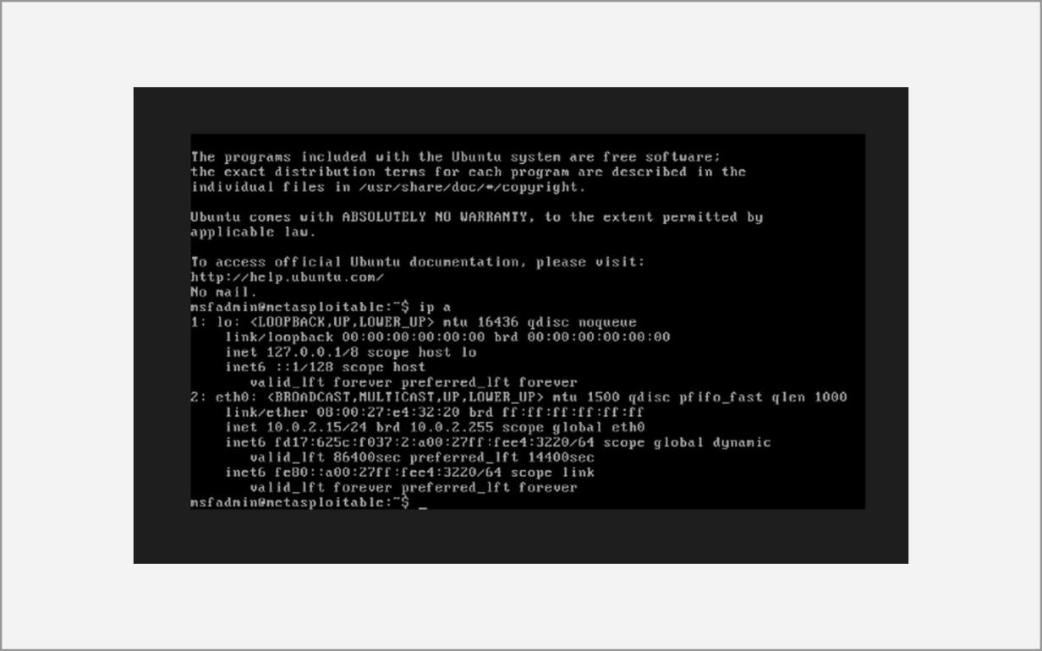
Fig. 1.26 – Output of ip a on Metasploitable 2
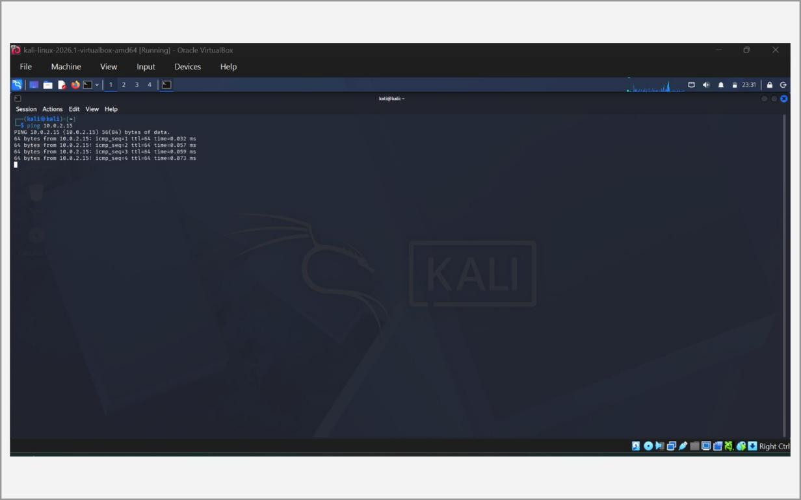
Fig. 1.27 – Connectivity test – ping from Kali Linux
D. Windows XP
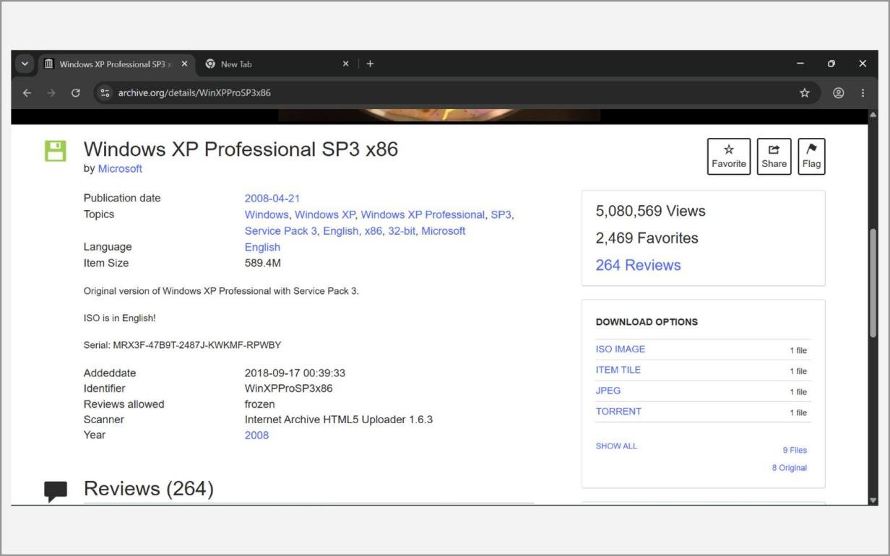
Fig. 1.28 – Windows XP SP3 ISO download page
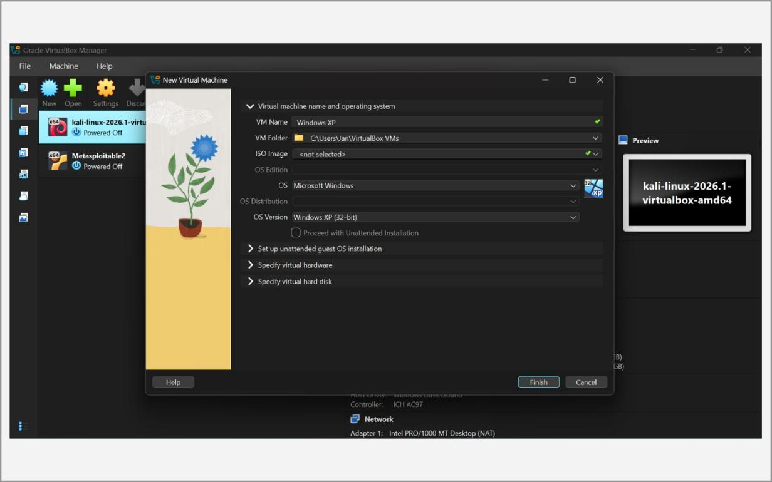
Fig. 1.29 – Creating the Windows XP virtual machine
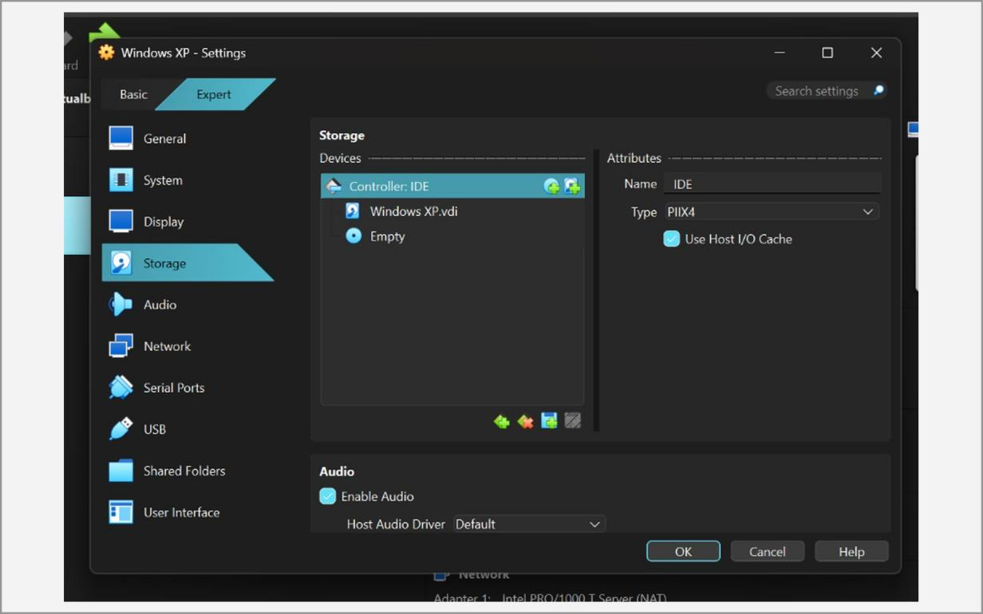
Fig. 1.30 – Attaching the Windows XP ISO (Settings → Storage)
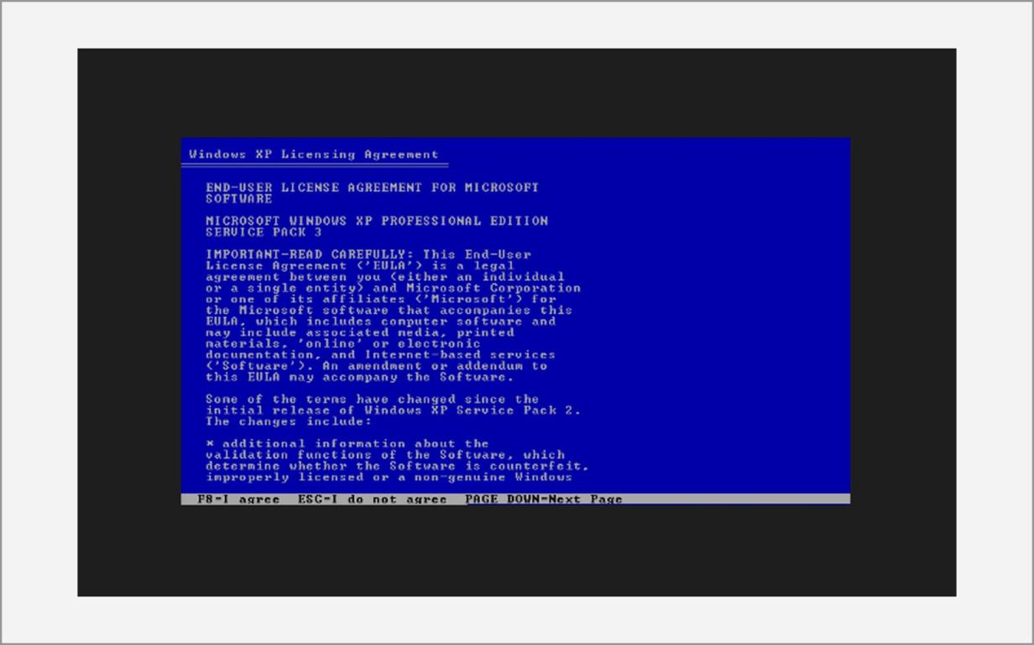
Fig. 1.31 – Windows XP licence agreement
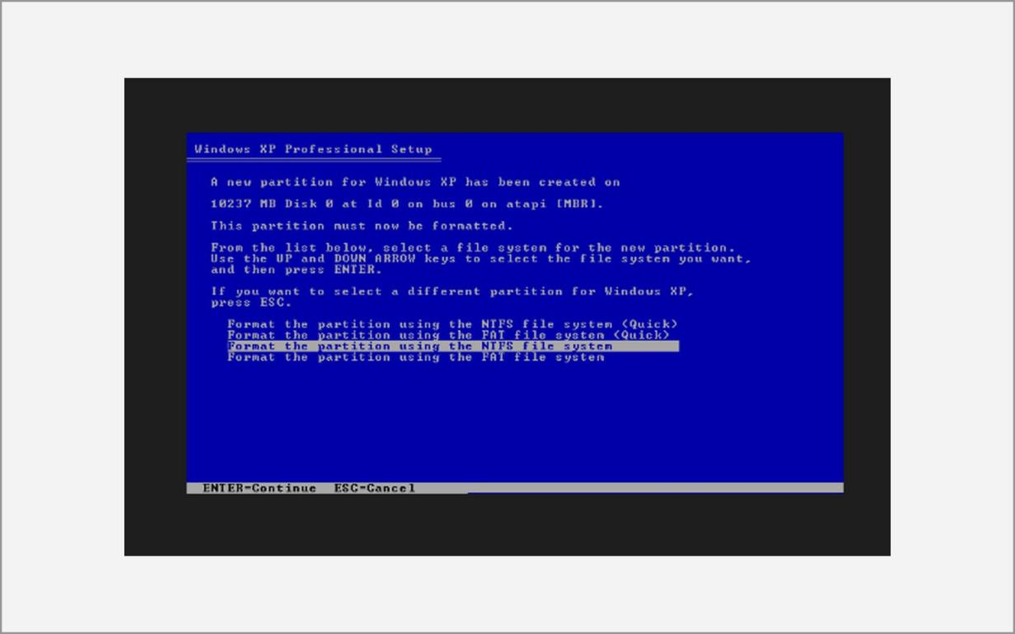
Fig. 1.32 – Formatting the partition with NTFS (Quick)
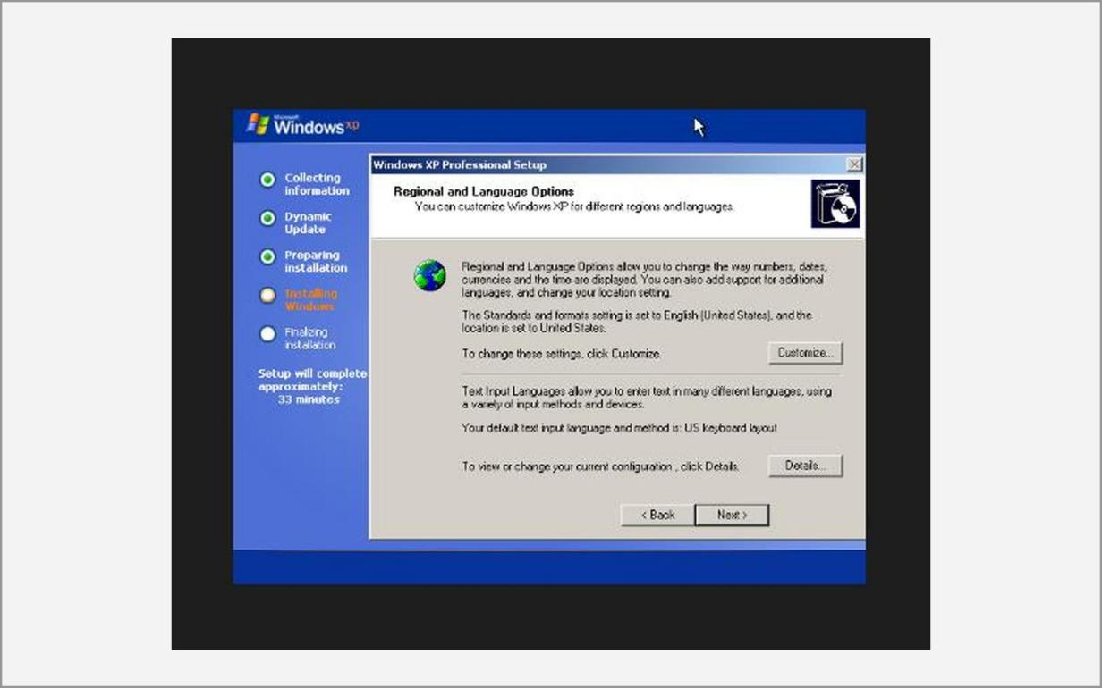
Fig. 1.33 – Regional and language options
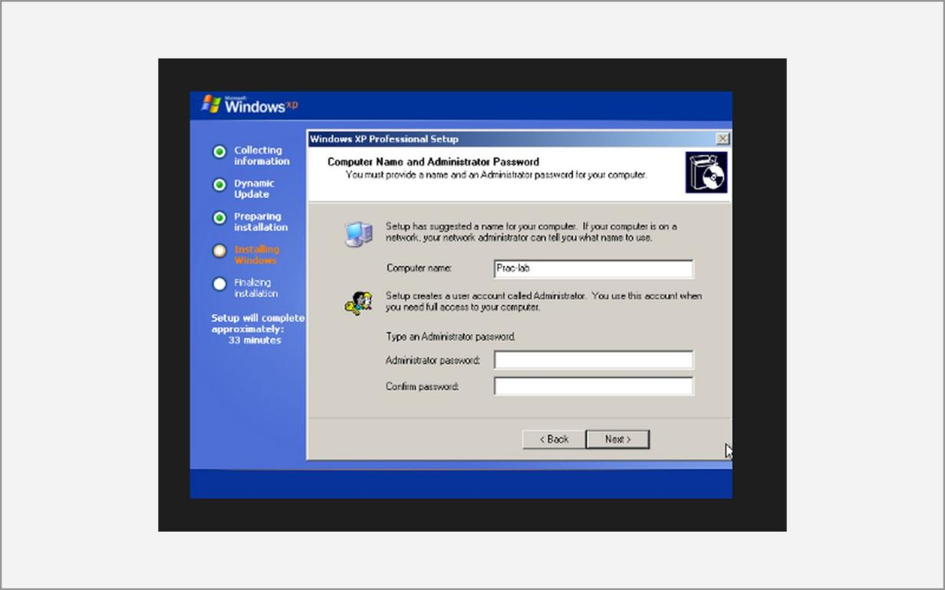
Fig. 1.34 – Computer name and administrator password
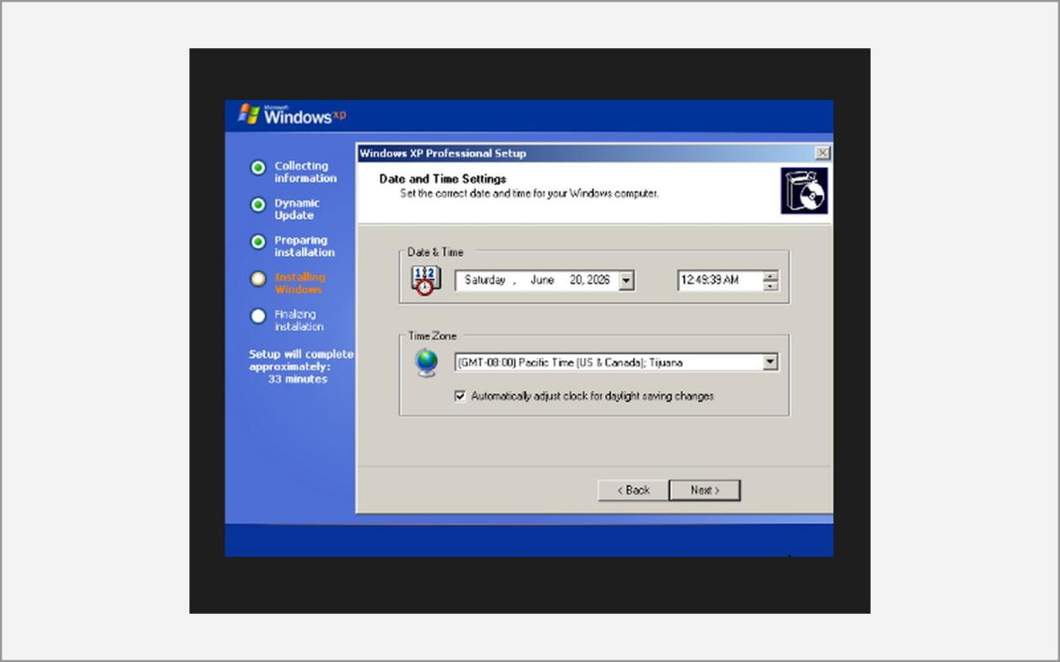
Fig. 1.35 – Date and time settings
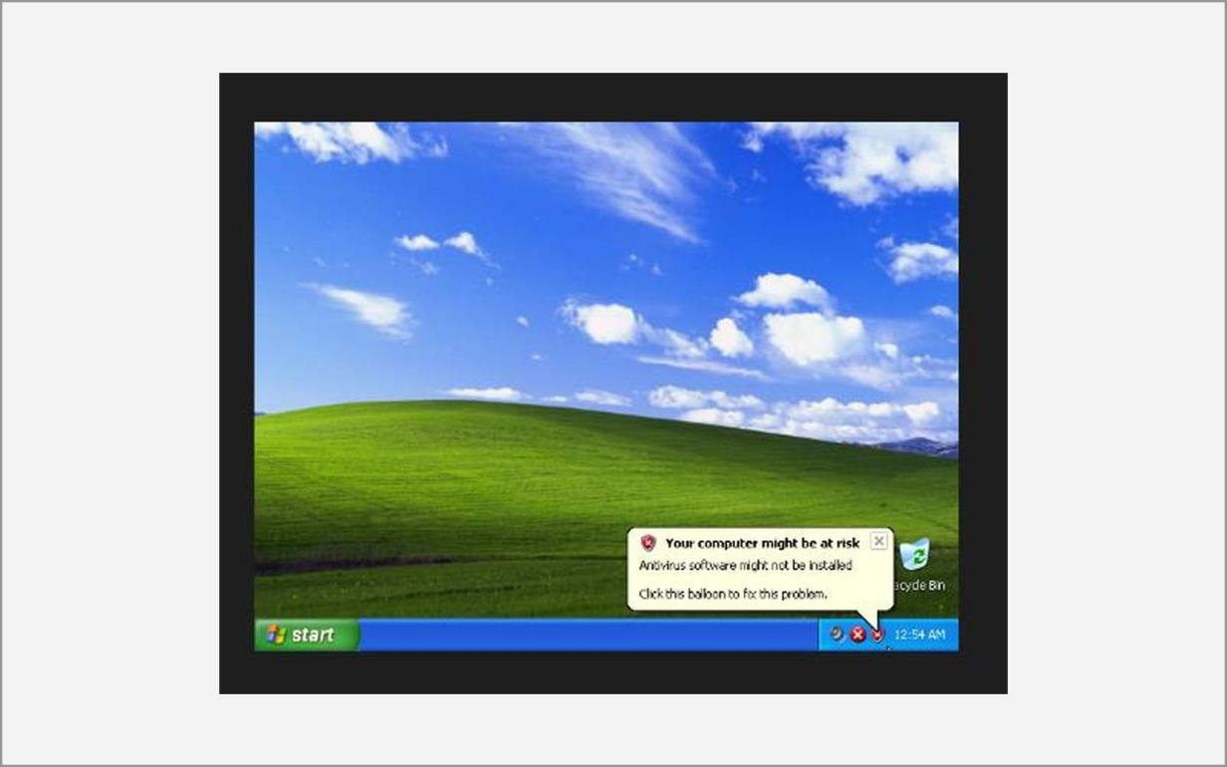
Fig. 1.36 – Windows XP desktop
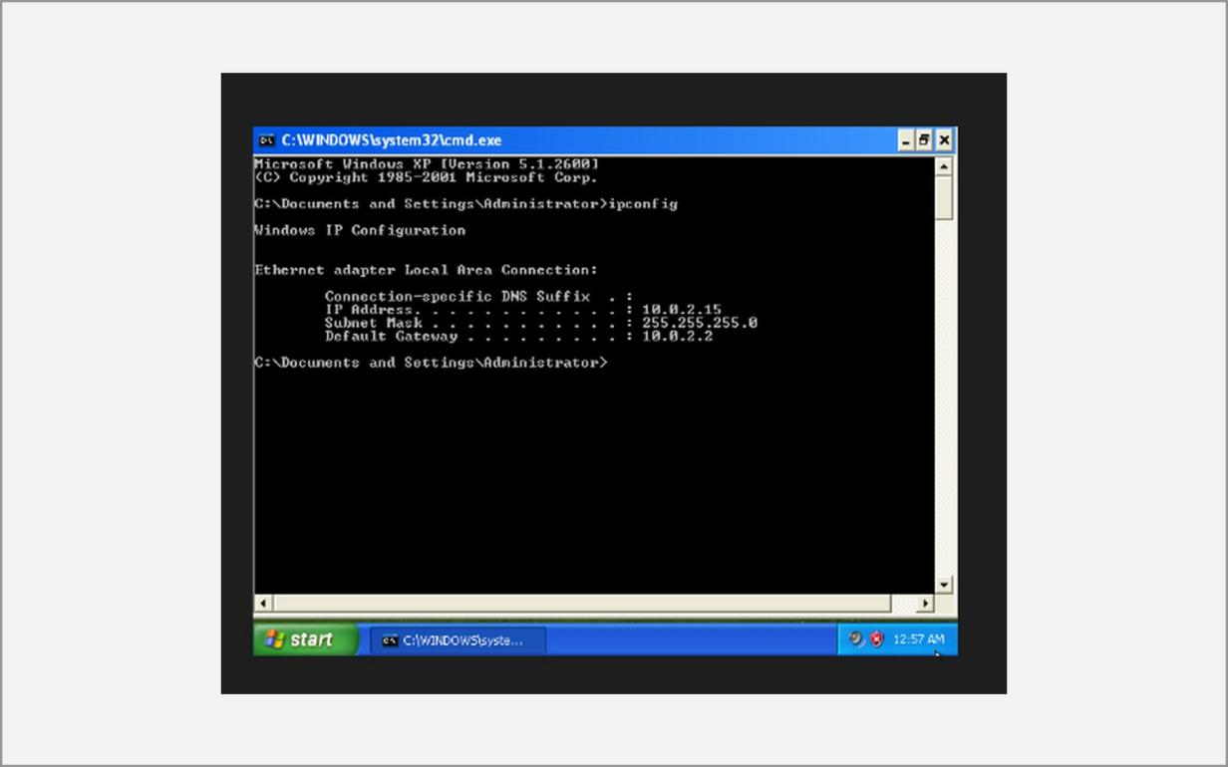
Fig. 1.37 – ipconfig output on Windows XP
Learning Outcomes:
• Installed and configured Oracle VirtualBox and understood how a type-2 hypervisor shares host hardware among isolated guest machines.
• Created Kali Linux, Metasploitable 2 and Windows XP virtual machines, choosing suitable operating-system type, memory, virtual disk (VDI) and storage settings for each.
• Learned the differences between NAT, Bridged and Host-Only networking and why a Host-Only network keeps vulnerable machines separate from the production network.
• Completed the Kali Linux graphical installation, including language, location, keyboard, user account, disk partitioning, software selection and GRUB boot-loader steps.
• Verified connectivity between attacker and target machines using ip a, ipconfig and ping, which is the pre-condition for every later experiment.
• Understood why intentionally vulnerable machines must be kept in an isolated lab and why testing is done only on systems one owns or is authorised to test.
Ex. No. 2 Date: 01/07/2026 & 15/07/2026
Practice the basics of reconnaissance
Objective:
The aim of this experiment is to practise the first phase of an ethical-hacking engagement, reconnaissance (also called footprinting), and to learn how a Windows host can be monitored for suspicious activity. Reconnaissance means collecting as much information as possible about a target before any attack is attempted. It is either passive, where the target is never contacted directly, or active, where packets are sent to the target.
In this experiment Sysmon is used to record detailed system activity on Windows; theHarvester and Sublist3r are used to gather e-mail addresses, host names, IP addresses and sub-domains of a domain from public sources; WHOIS and nslookup are used to retrieve registration and DNS records; and Netdiscover is used to discover live hosts on the local network. Finally, all the findings are combined into a single domain profile, a process known as DNS mapping.
Tools:
• Sysmon v15.15 (Microsoft Sysinternals) – a Windows system service and driver that logs process creation, network connections, file-creation-time changes, driver and DLL loading and registry changes to the Windows Event Log. The community configuration file sysmonconfig.xml (SwiftOnSecurity) defines which events are recorded.
• theHarvester 4.10 – an open-source intelligence (OSINT) tool that collects e-mails, sub-domains, host names, IP addresses and employee names of a domain from search engines, certificate-transparency logs and other public data sources.
• Netdiscover 0.21 – an active/passive ARP reconnaissance tool that finds live hosts on a local network and reports their IP address, MAC address and the network-card vendor.
• WHOIS 5.6 – a command-line client that queries registration databases for the registrar, creation and expiry dates, name servers and owner details of a domain or IP address.
• nslookup (dnsutils) – a DNS query tool used to resolve host names and to read A, MX, NS and PTR records.
• Sublist3r – a Python OSINT tool that enumerates the sub-domains of a domain using search engines and online services.
• Oracle VirtualBox, Kali Linux and the Windows Event Viewer – the platform on which the above tools are run and the viewer for Sysmon events.
Methodology:
Introduction
Sysmon (System Monitor) runs as a service from boot and writes its events to Applications and Services Logs → Microsoft → Windows → Sysmon → Operational. Defenders use these logs to detect malware, lateral movement and persistence, because they show which process started which other process, with its full command line and hashes.
DNS (Domain Name System) translates human-readable names such as example.com into IP addresses. Important record types are A (IPv4 address), AAAA (IPv6 address), MX (mail servers), NS (authoritative name servers), TXT (text such as SPF policy) and PTR (reverse lookup). WHOIS and DNS records are public, so reading them is passive reconnaissance.
Netdiscover works at layer 2: it sends ARP requests (“who has this IP address?”) and listens for ARP replies. Because ARP is not routed, it only discovers hosts in the same broadcast domain, which is why the VirtualBox adapter must be changed from NAT to Bridged Adapter before scanning the real LAN.
A. Sysmon (System Monitor) – Windows
1. Download Sysmon from the Microsoft Sysinternals Suite and extract the ZIP file.
2. Download the configuration file sysmonconfig.xml (SwiftOnSecurity sysmon-config) into the same folder.
3. Open PowerShell / Command Prompt as Administrator, change to the Sysmon folder and install the service:
sysmon.exe -accepteula -i
4. Load the custom monitoring rules and display the active configuration:
sysmon.exe -c sysmonconfig.xml
sysmon.exe -c
5. Other commands: show help / version, uninstall without confirmation:
sysmon.exe -?
sysmon.exe -u force
6. Open Event Viewer → Applications and Services Logs → Microsoft → Windows → Sysmon → Operational to watch process creation, network connections and file events in real time.
B. theHarvester – e-mails, sub-domains, hosts and IPs
sudo apt update
sudo apt install theharvester
theHarvester --version
theHarvester -h
1. Run theHarvester against the target domain (-d domain, -b data source, -l result limit, -q quiet DNS):
theHarvester -d microsoft.com -b all -l 300 -q
C. Netdiscover – live host discovery on the LAN
sudo apt update
sudo apt install netdiscover
netdiscover -h
1. In VirtualBox open Settings → Network and change Attached to from NAT to Bridged Adapter so the VM sits on the real LAN.
2. Scan the network with ARP requests (default interface, a given range, a given interface, passive mode):
sudo netdiscover
sudo netdiscover -r 192.168.1.0/24
sudo netdiscover -i eth0
sudo netdiscover -i wlan0 -r 192.168.0.0/24
sudo netdiscover -p
D. WHOIS – domain and IP registration details
sudo apt install whois
whois --version
whois --help
whois google.com
whois 8.8.8.8
whois -h whois.verisign-grs.com example.com
E. nslookup – DNS records
sudo apt install dnsutils
nslookup example.com
nslookup -type=mx example.com
nslookup -type=ns example.com
nslookup example.com 8.8.8.8
nslookup 8.8.8.8
Note: The default lookup returns the A / AAAA records, -type=mx the mail servers, -type=ns the authoritative name servers, a trailing server address queries that DNS server, and an IP address performs a reverse lookup.
F. theHarvester – certificate-transparency and hackertarget sources
theHarvester -d example.com -b crtsh
theHarvester -d example.com -b crtsh,hackertarget -l 20
theHarvester -d example.com -b hackertarget
G. Sublist3r – sub-domain enumeration
sudo apt install sublist3r -y
sublist3r --help
sublist3r -d microsoft.com
sublist3r -d microsoft.com -o results.txt
cat results.txt
H. DNS mapping
1. Record the registrar and name servers from WHOIS.
2. Record the MX and NS records from nslookup.
3. Collect sub-domains and e-mails with theHarvester / Sublist3r.
4. Consolidate all findings into a single domain profile (registrar, name servers, mail servers, sub-domains, e-mails).
Screenshots:
A. Sysmon
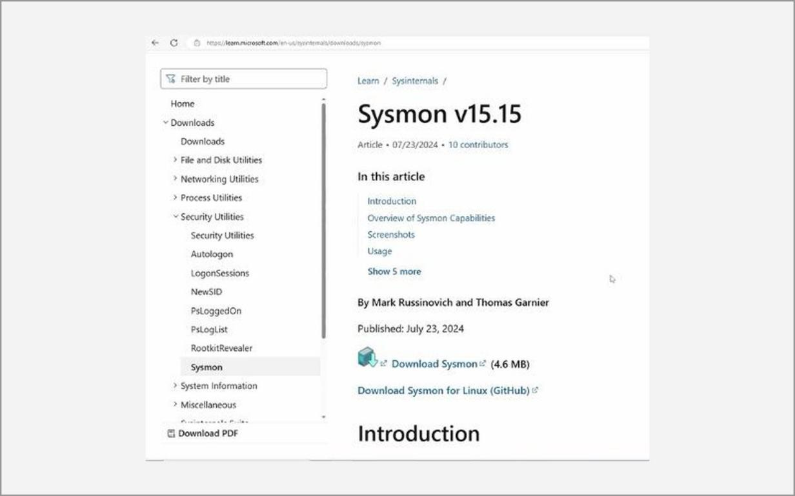
Fig. 2.1 – Sysmon download page (Sysinternals)
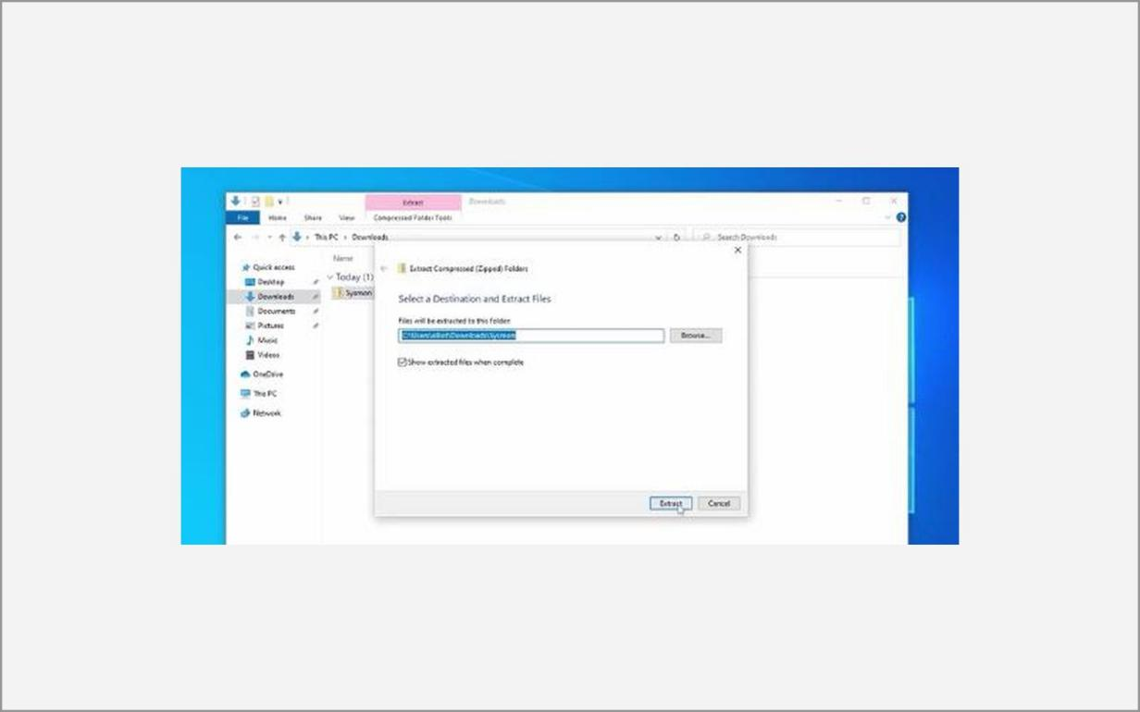
Fig. 2.2 – Extracting the Sysmon ZIP file
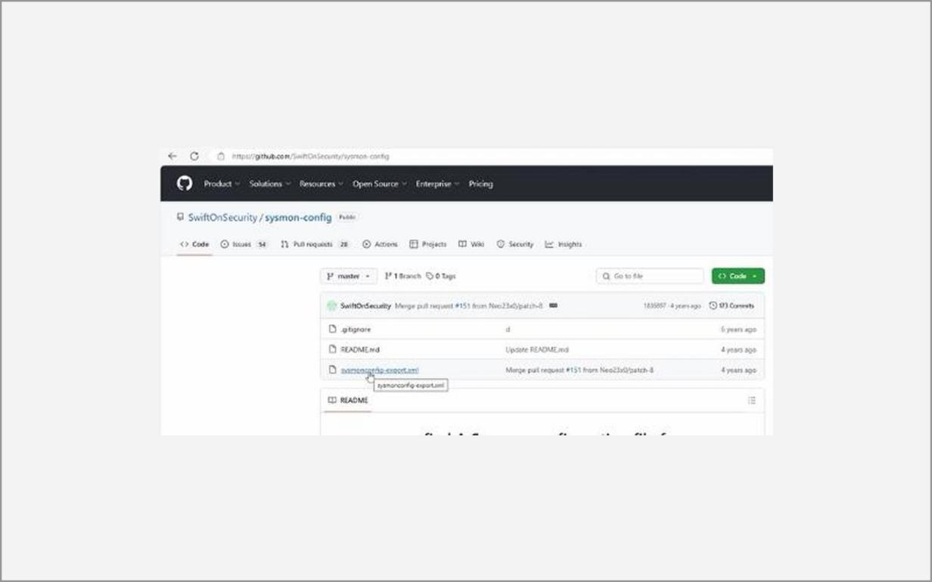
Fig. 2.3 – sysmonconfig.xml from the sysmon-config repository
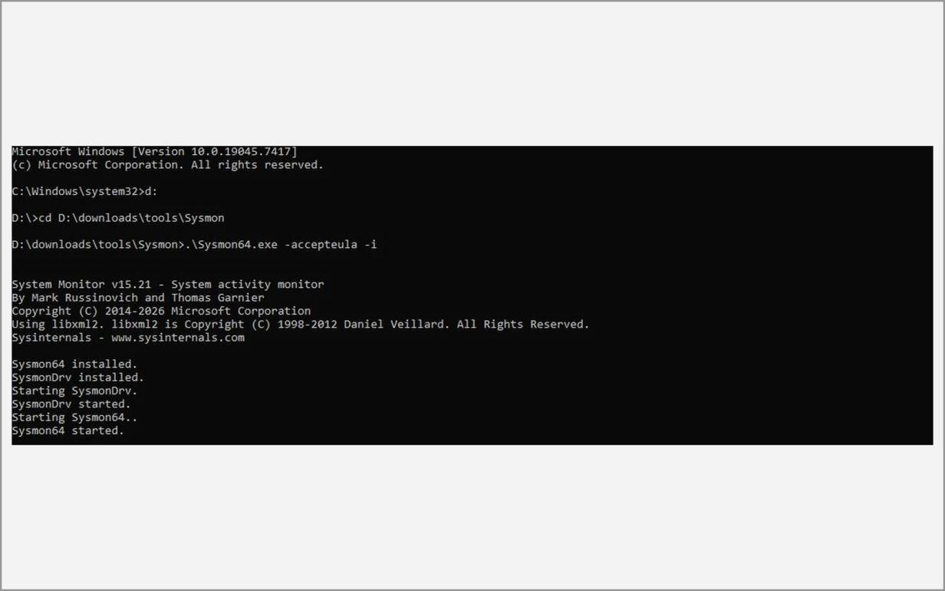
Fig. 2.4 – Installing Sysmon from an elevated shell
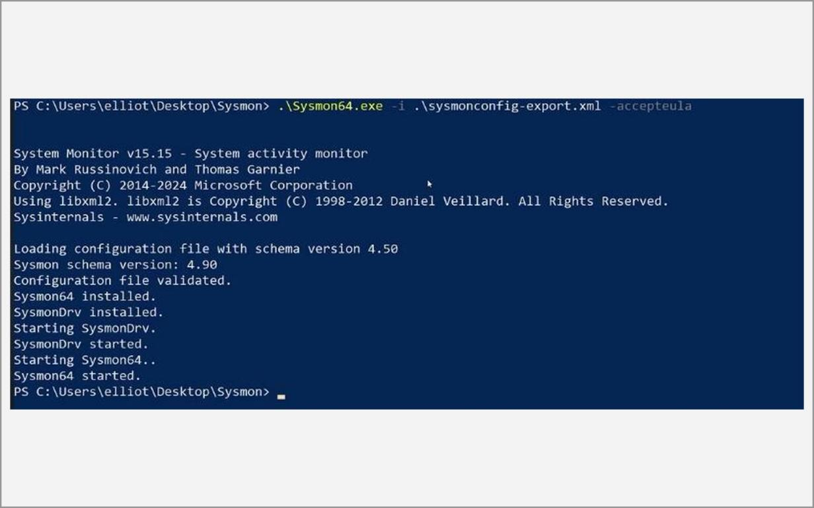
Fig. 2.5 – Sysmon installed with the configuration file
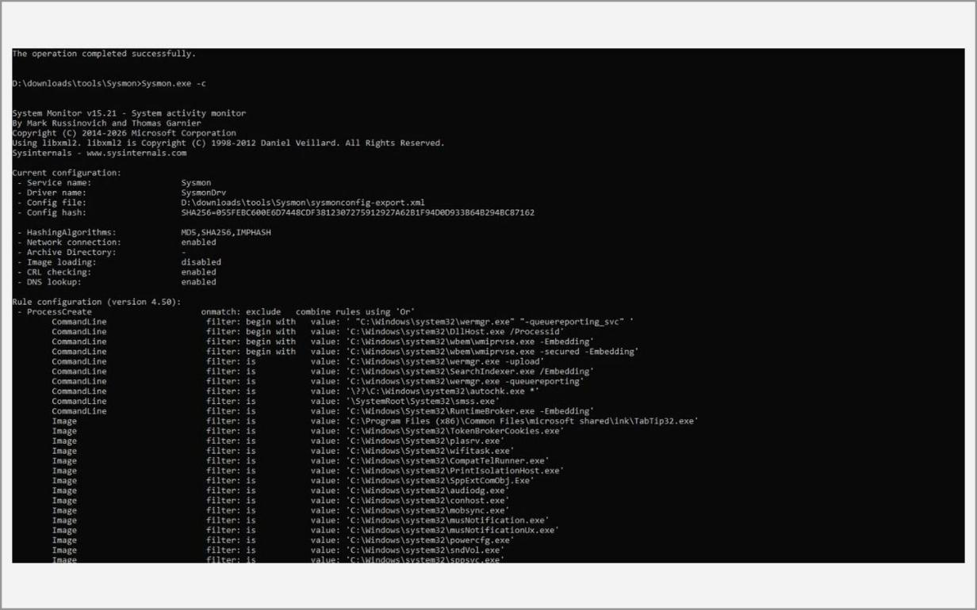
Fig. 2.6 – Active Sysmon configuration (sysmon.exe -c)
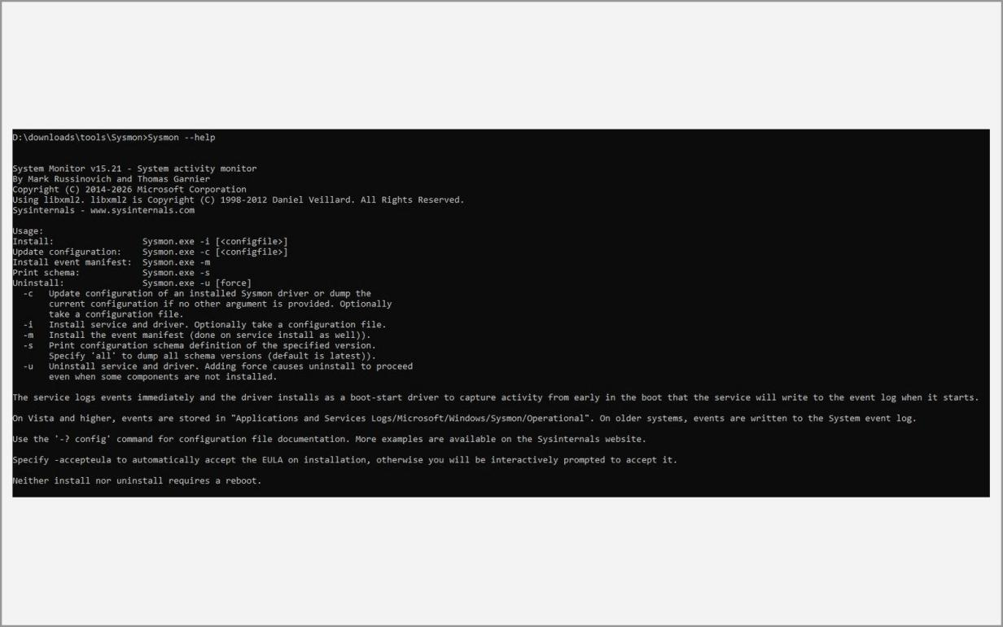
Fig. 2.7 – Sysmon help / version output
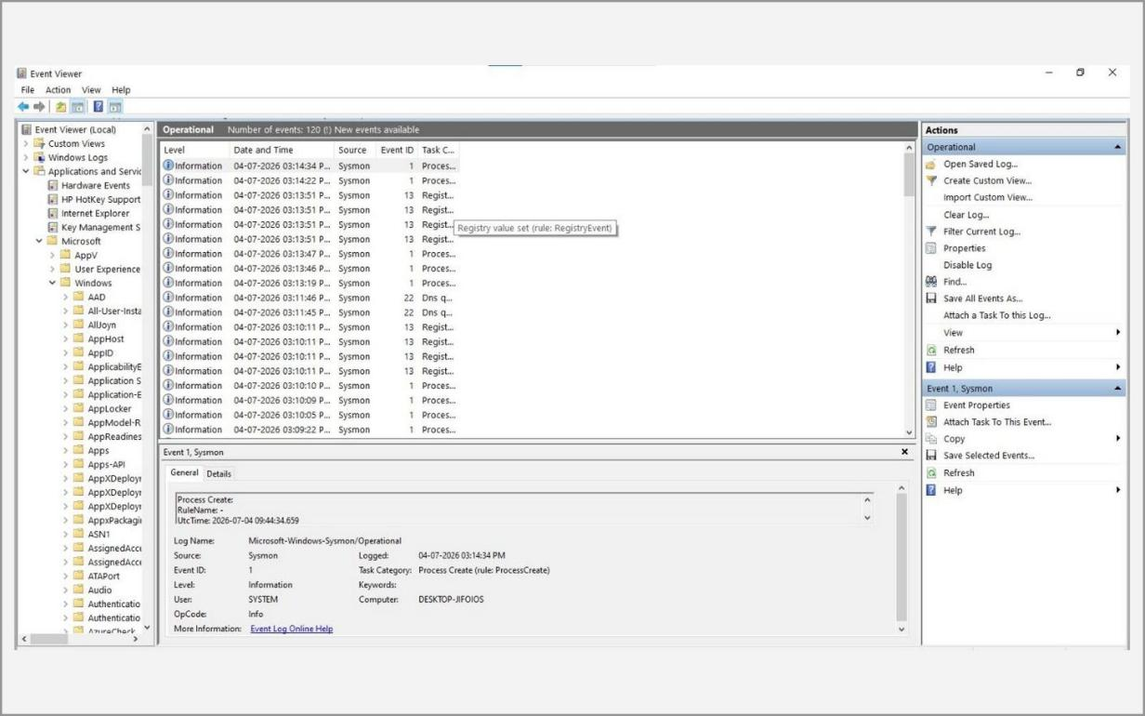
Fig. 2.8 – Sysmon events in Event Viewer
B. theHarvester
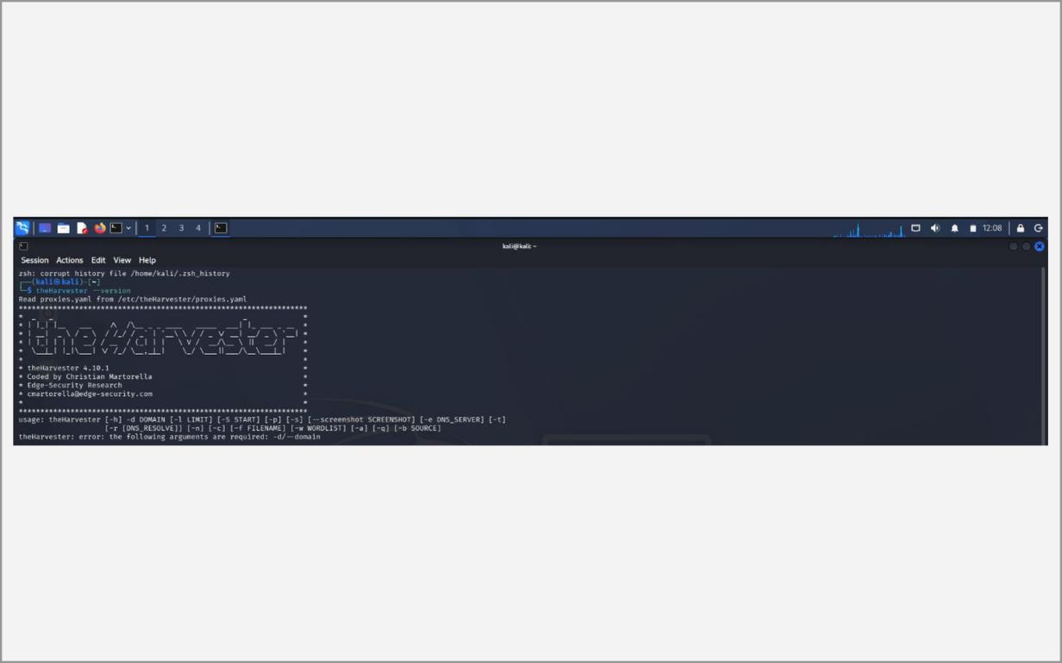
Fig. 2.9 – theHarvester version check
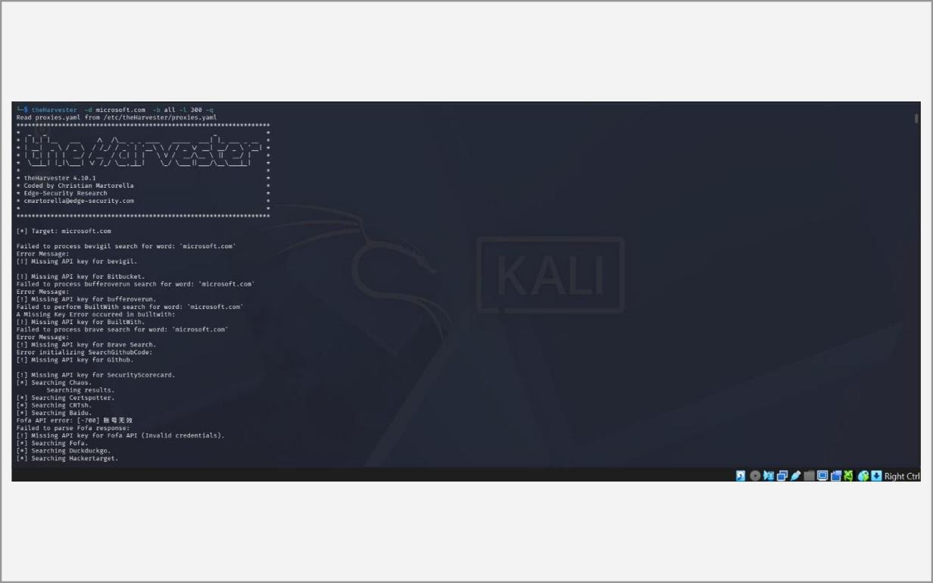
Fig. 2.10 – theHarvester -d microsoft.com -b all -l 300 -q (running)
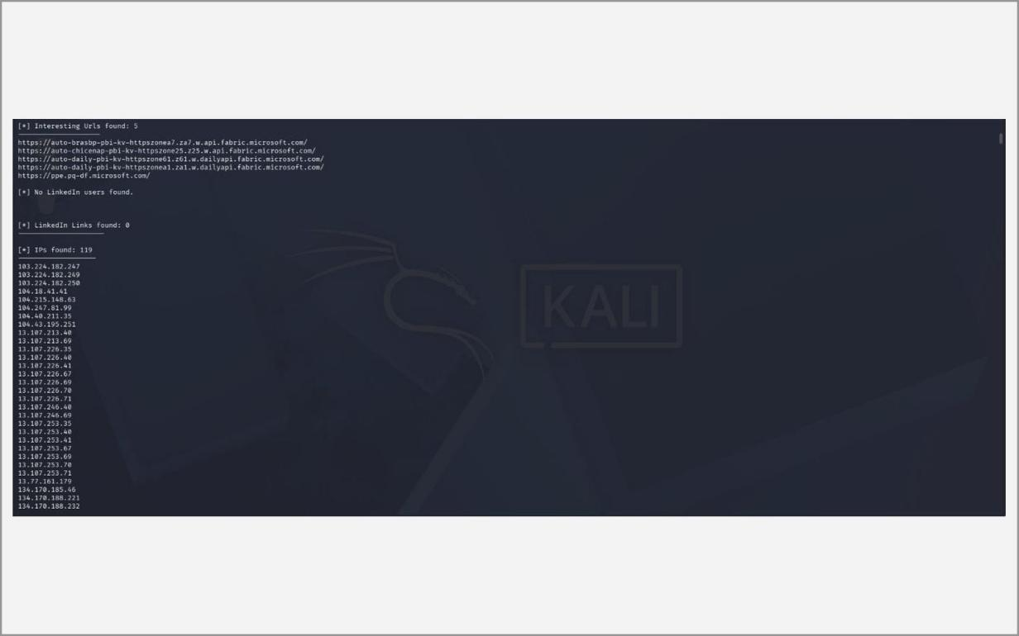
Fig. 2.11 – theHarvester – IP addresses found
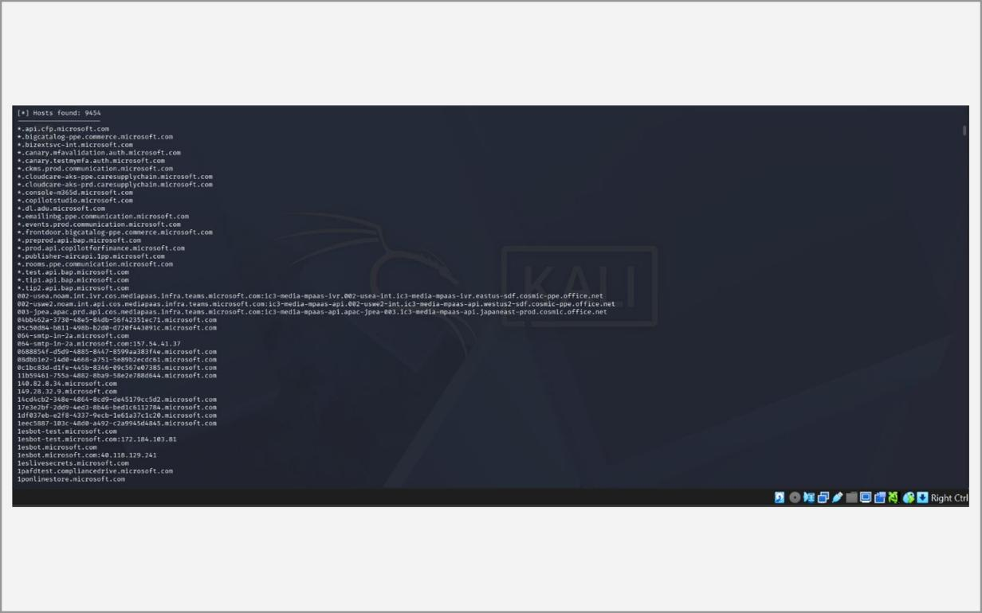
Fig. 2.12 – theHarvester – hosts found
C. Netdiscover
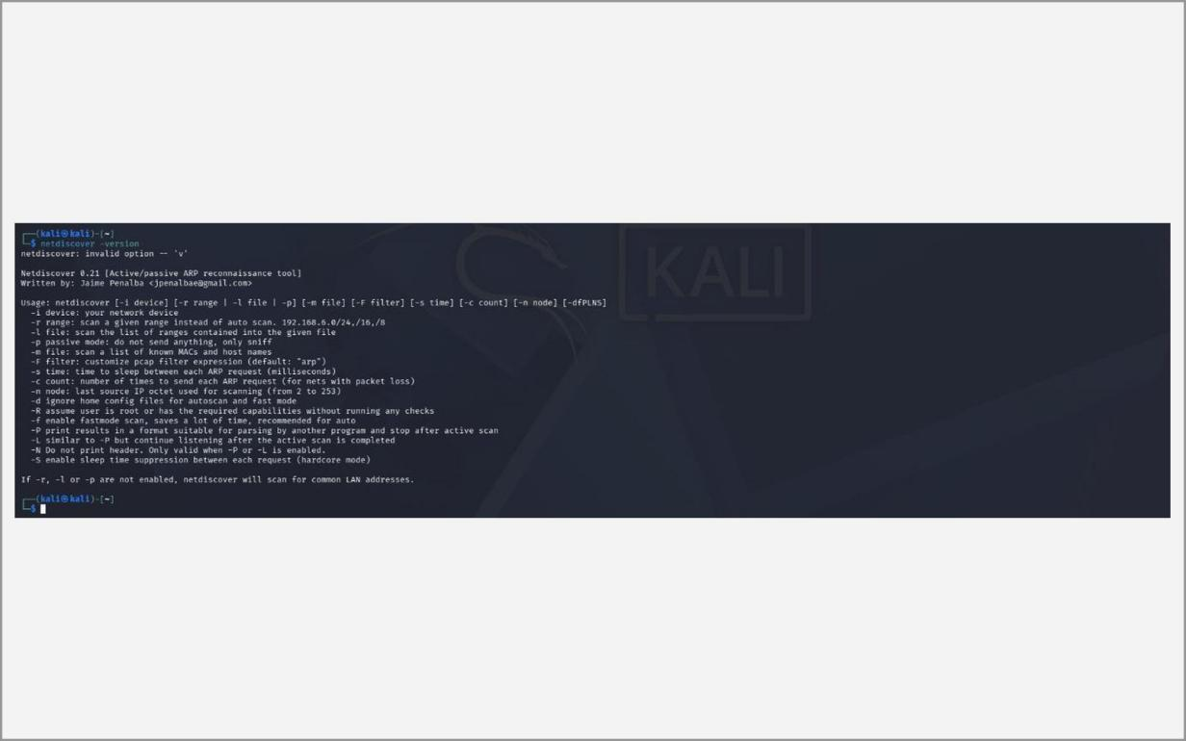
Fig. 2.13 – netdiscover help and version
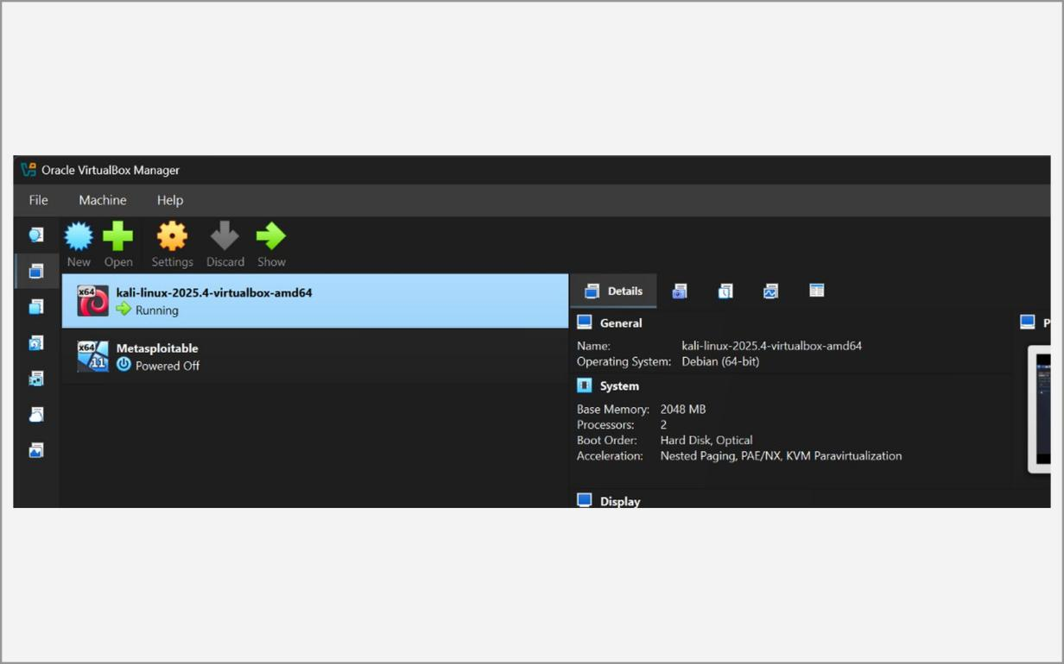
Fig. 2.14 – VirtualBox Manager – Kali VM running
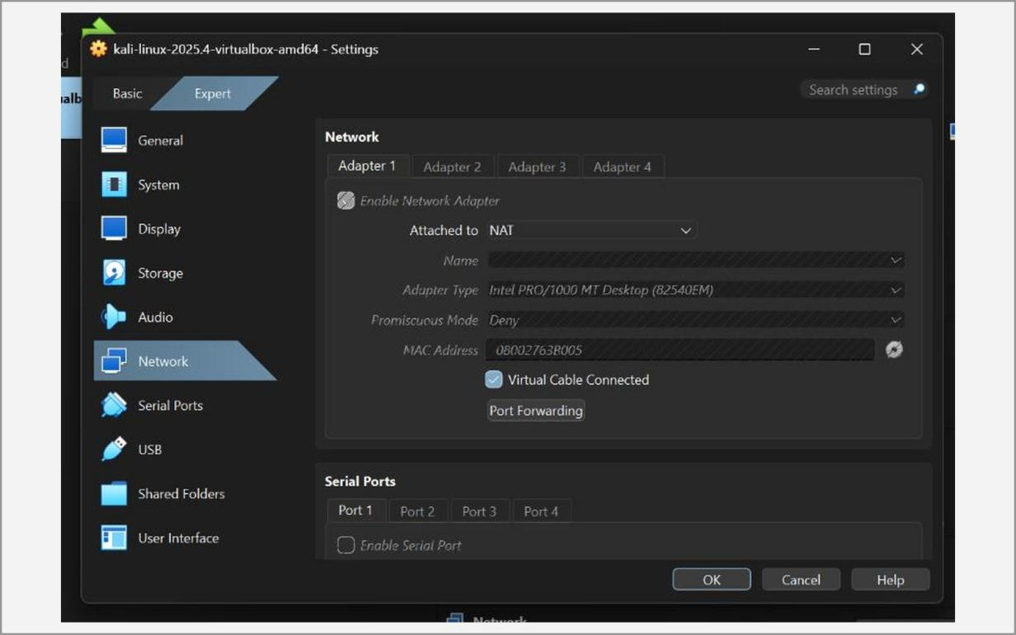
Fig. 2.15 – Network adapter attached to NAT (before)
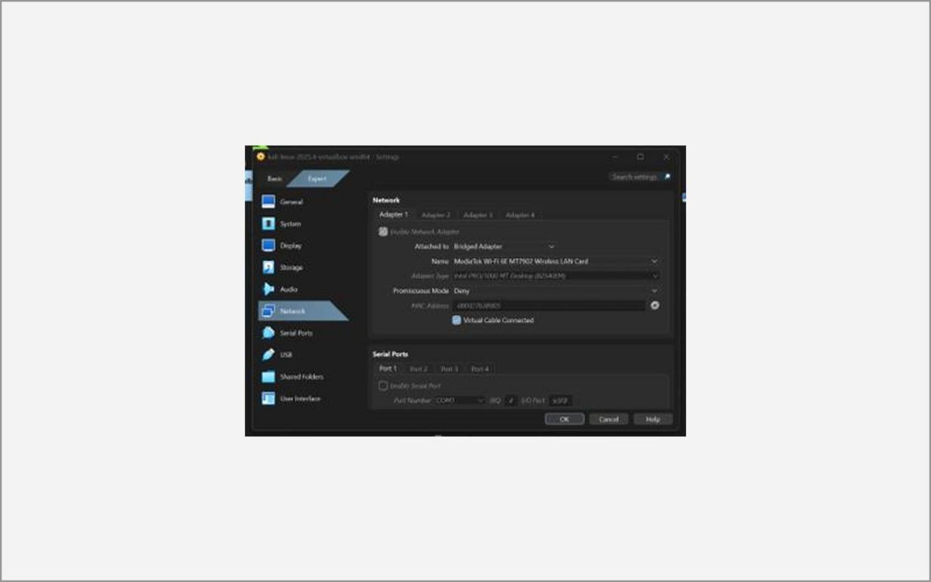
Fig. 2.16 – Network adapter changed to Bridged Adapter
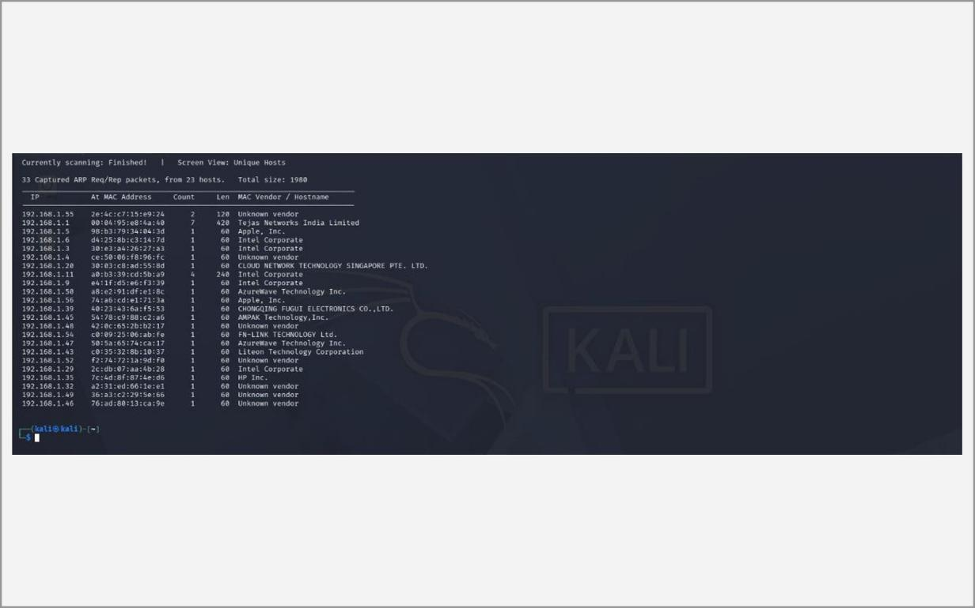
Fig. 2.17 – netdiscover – range scan result
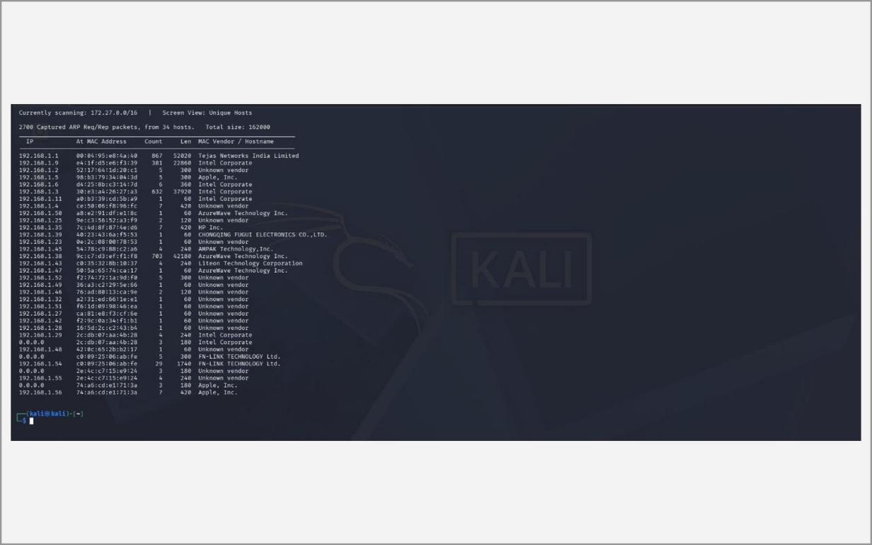
Fig. 2.18 – netdiscover – interface scan result
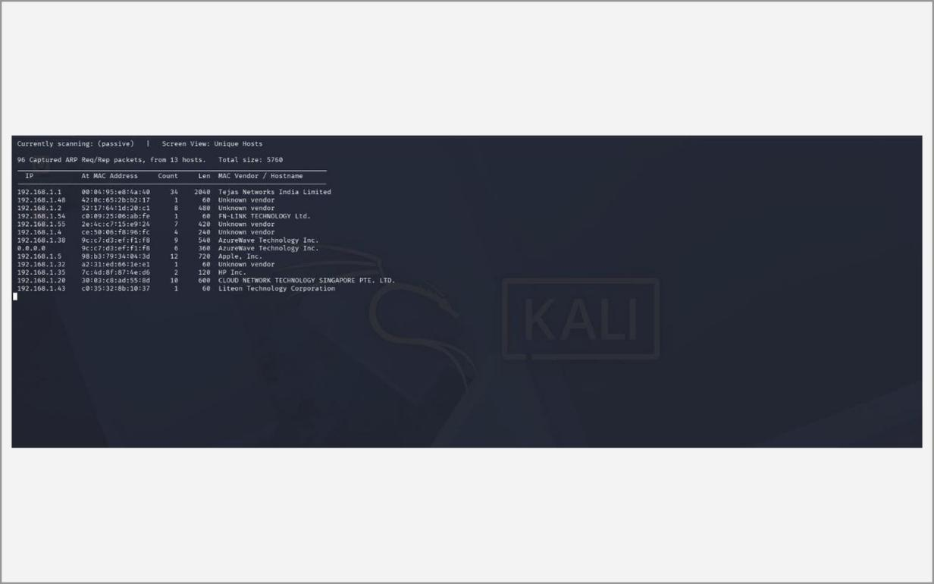
Fig. 2.19 – netdiscover – passive mode (-p)
D. WHOIS

Fig. 2.20 – whois --version
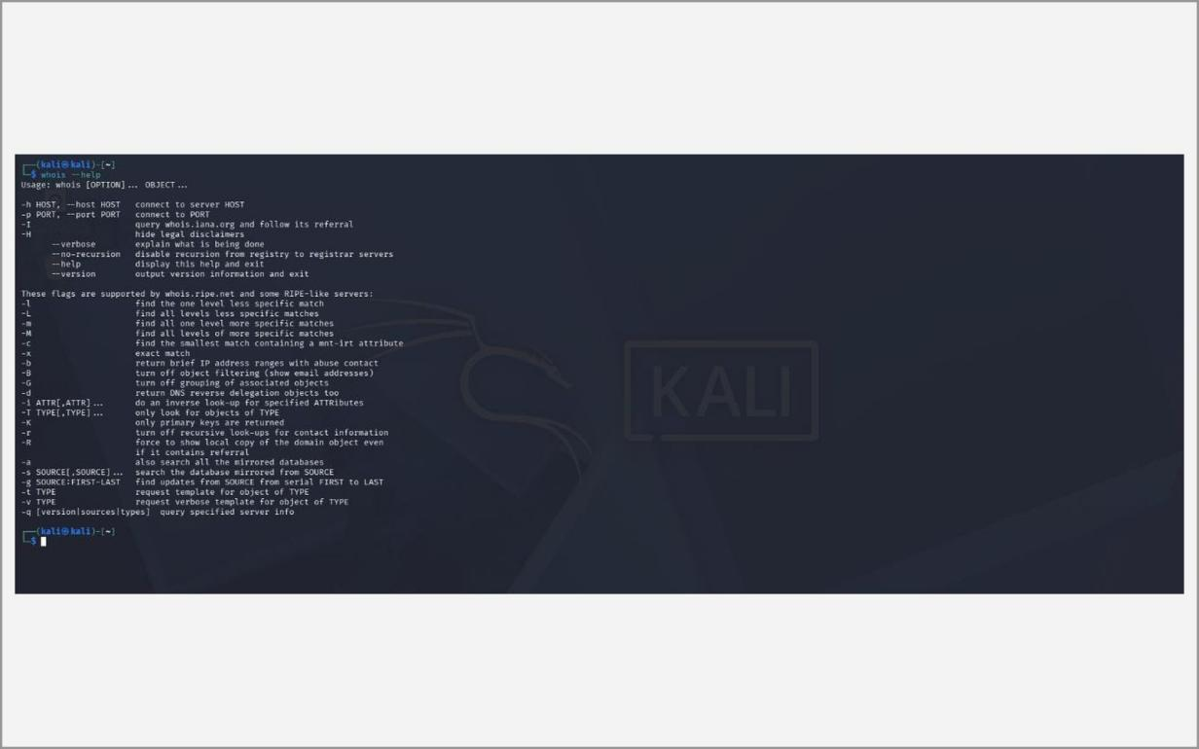
Fig. 2.21 – whois --help
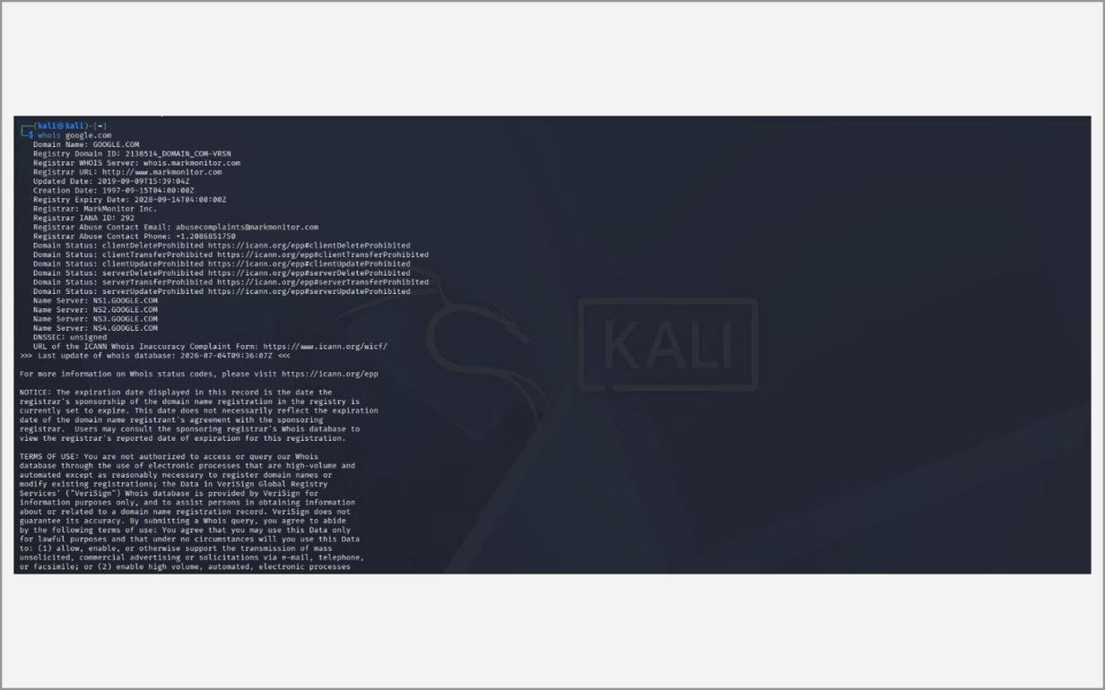
Fig. 2.22 – whois google.com
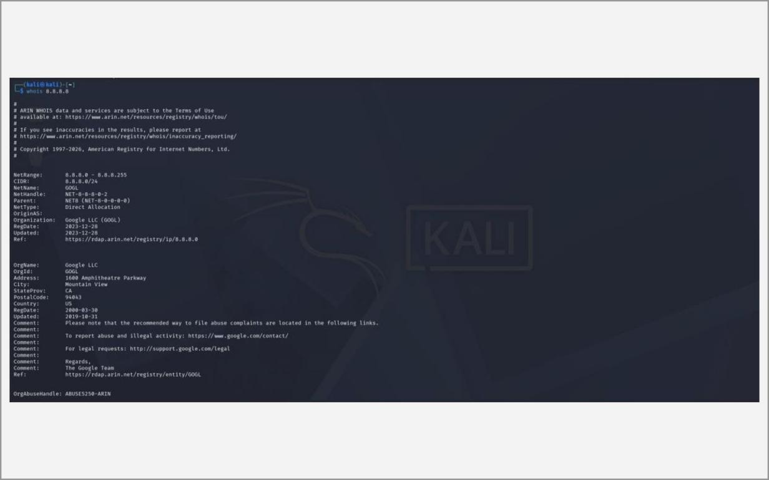
Fig. 2.23 – whois 8.8.8.8
E. nslookup
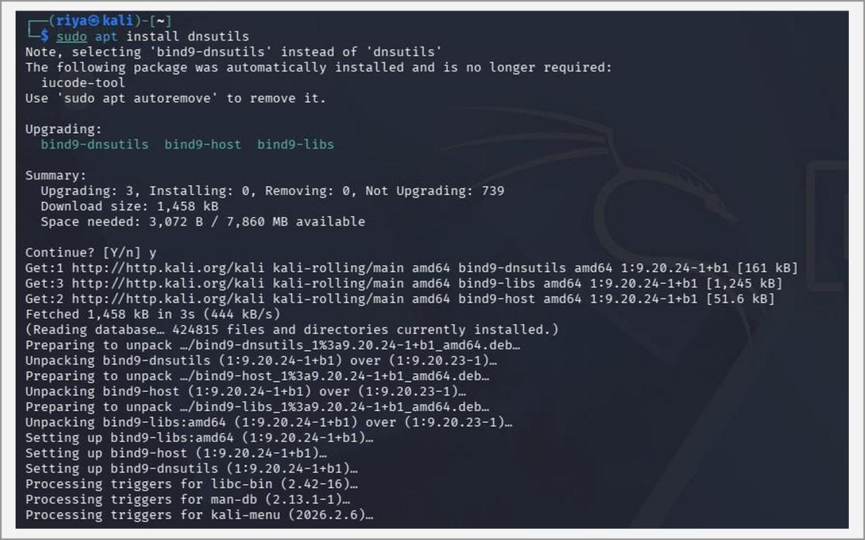
Fig. 2.24 – Installing dnsutils (nslookup)
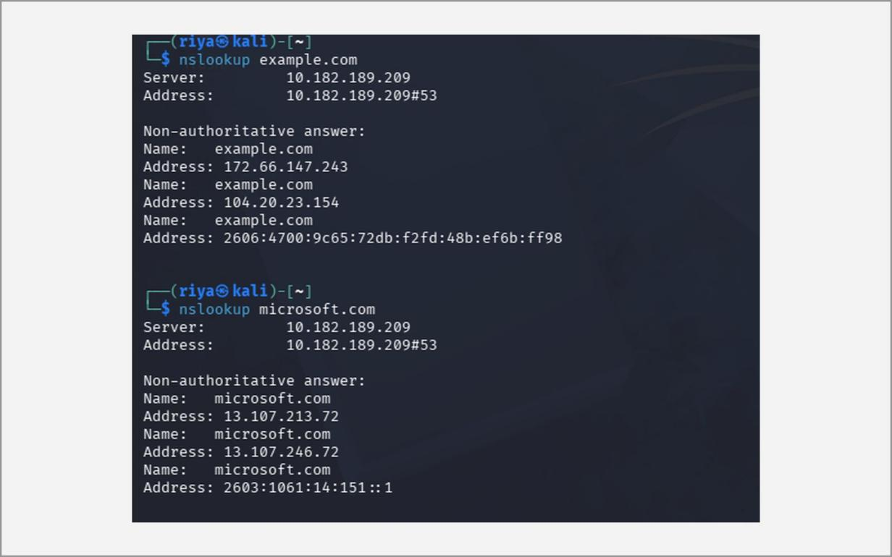
Fig. 2.25 – nslookup example.com / microsoft.com
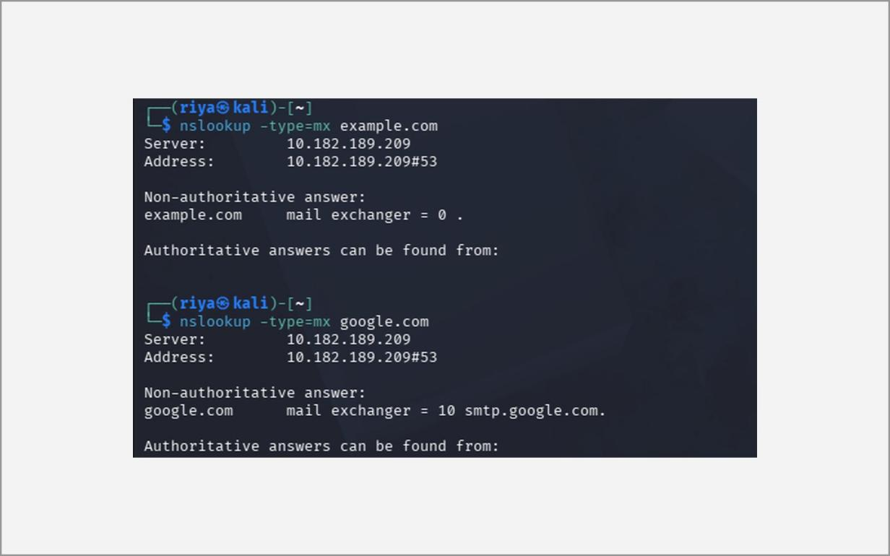
Fig. 2.26 – nslookup -type=mx (mail servers)
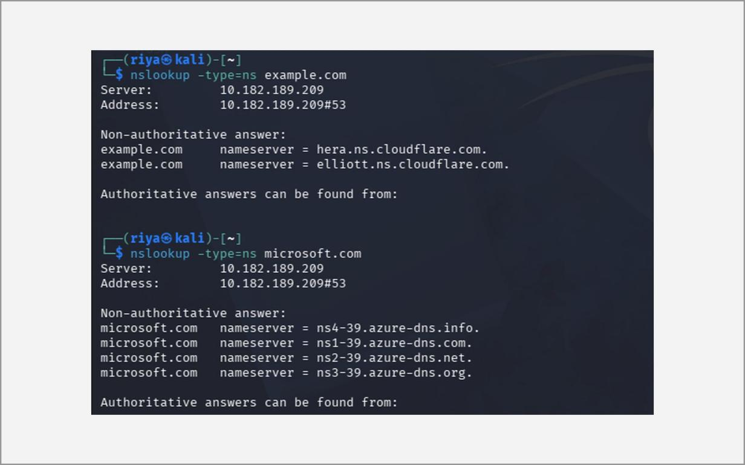
Fig. 2.27 – nslookup -type=ns (name servers)
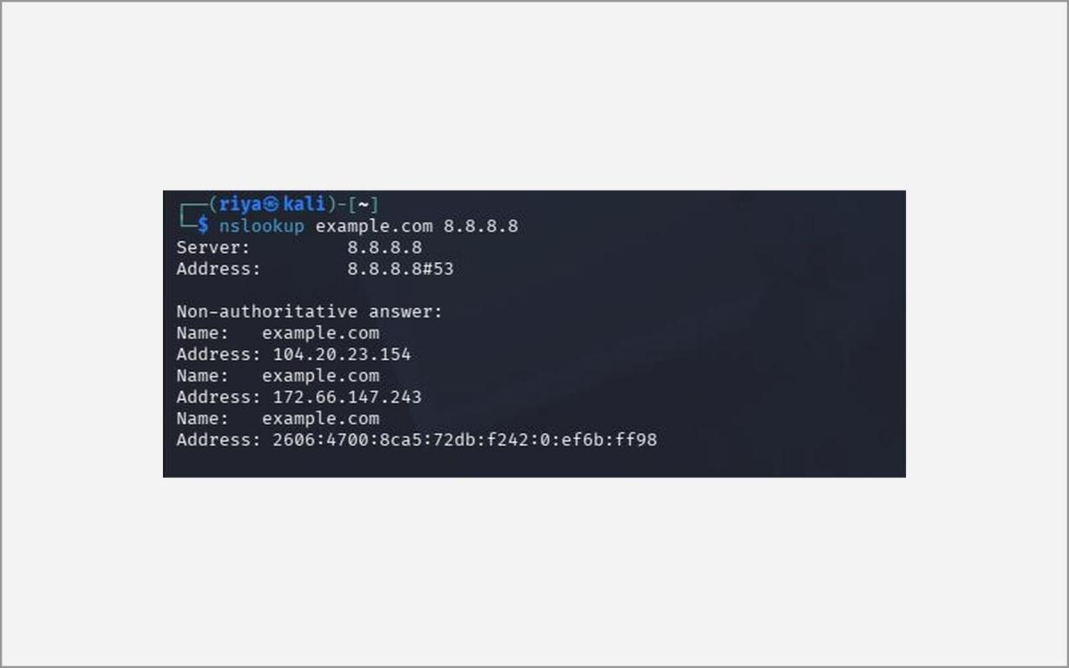
Fig. 2.28 – nslookup example.com 8.8.8.8
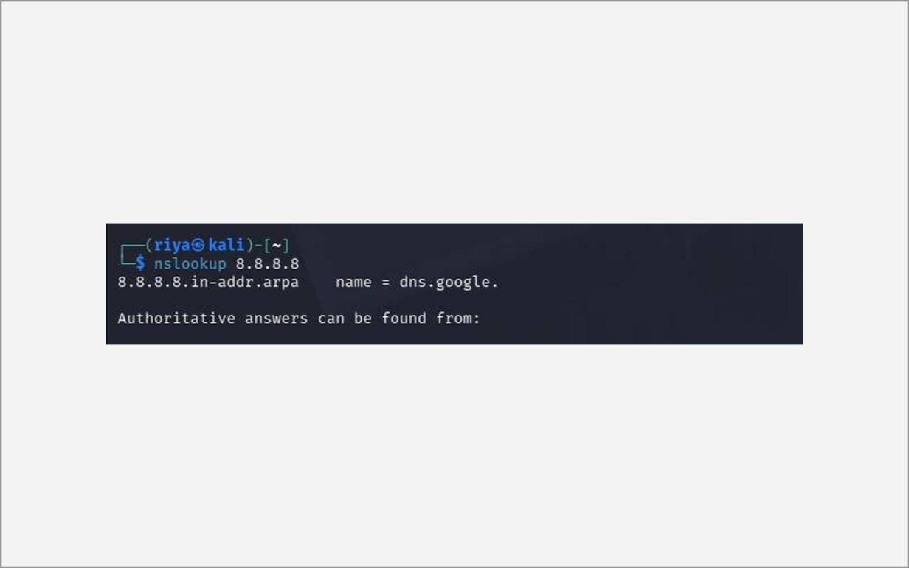
Fig. 2.29 – Reverse lookup of 8.8.8.8
F. theHarvester (crtsh / hackertarget)
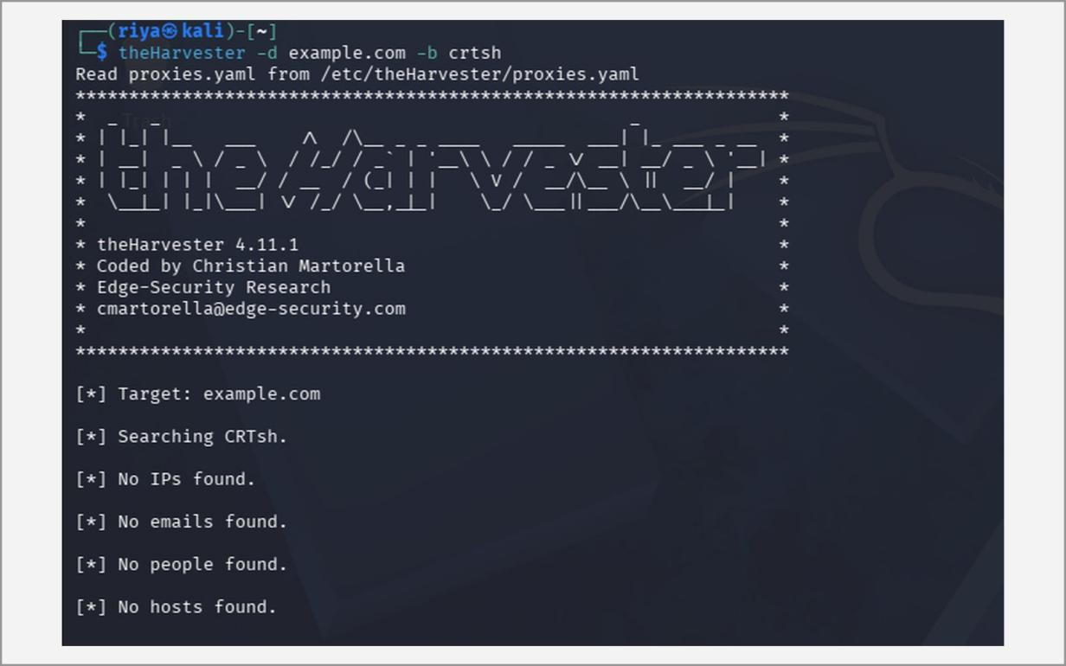
Fig. 2.30 – theHarvester -d example.com -b crtsh
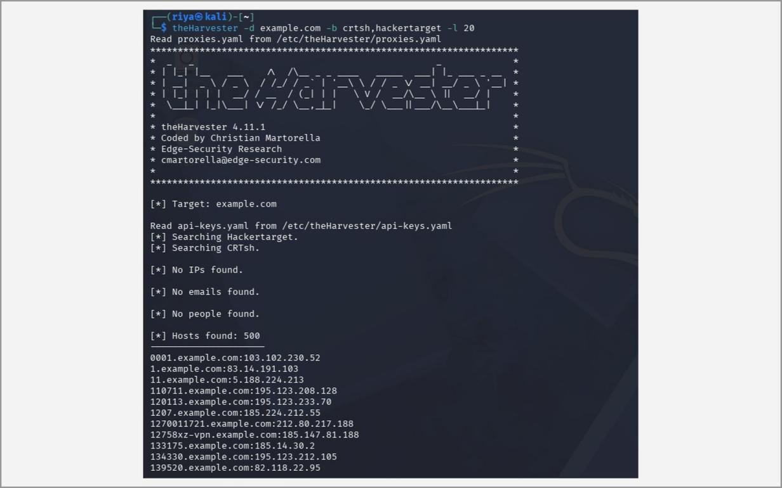
Fig. 2.31 – theHarvester -b crtsh,hackertarget -l 20
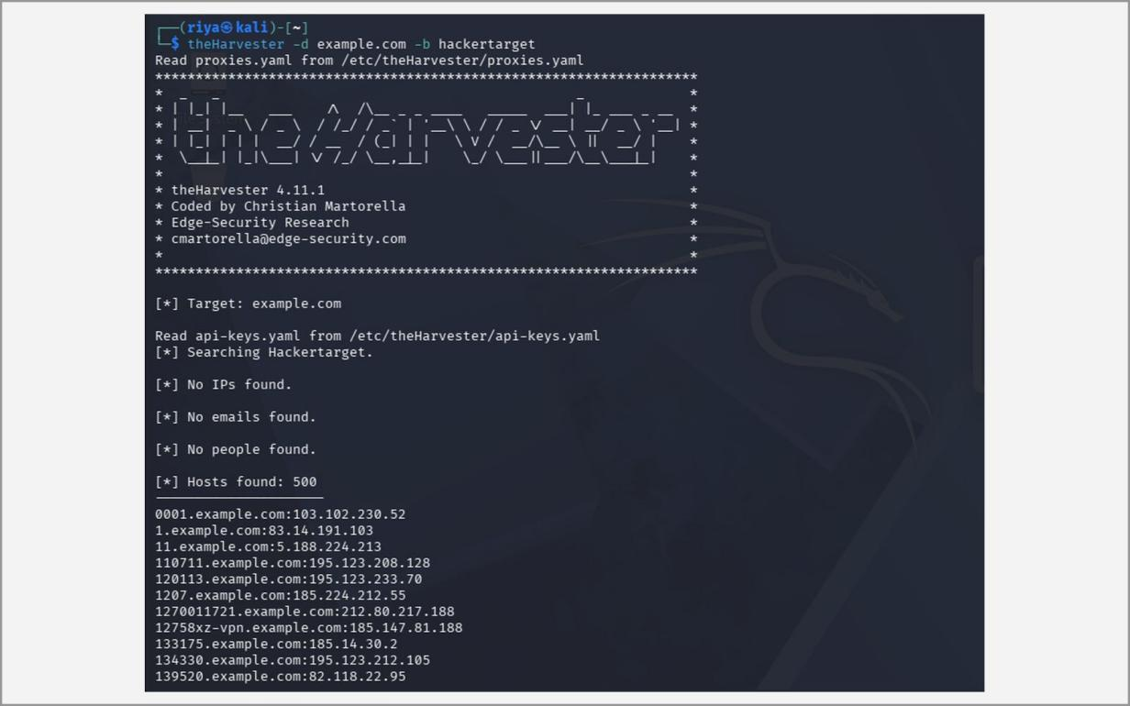
Fig. 2.32 – theHarvester -b hackertarget
G. Sublist3r
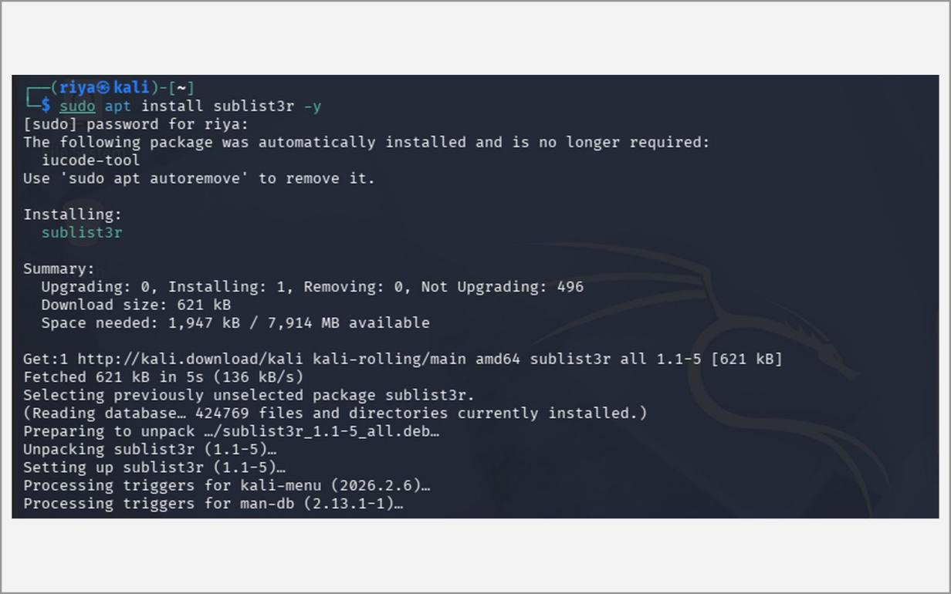
Fig. 2.33 – Installing Sublist3r
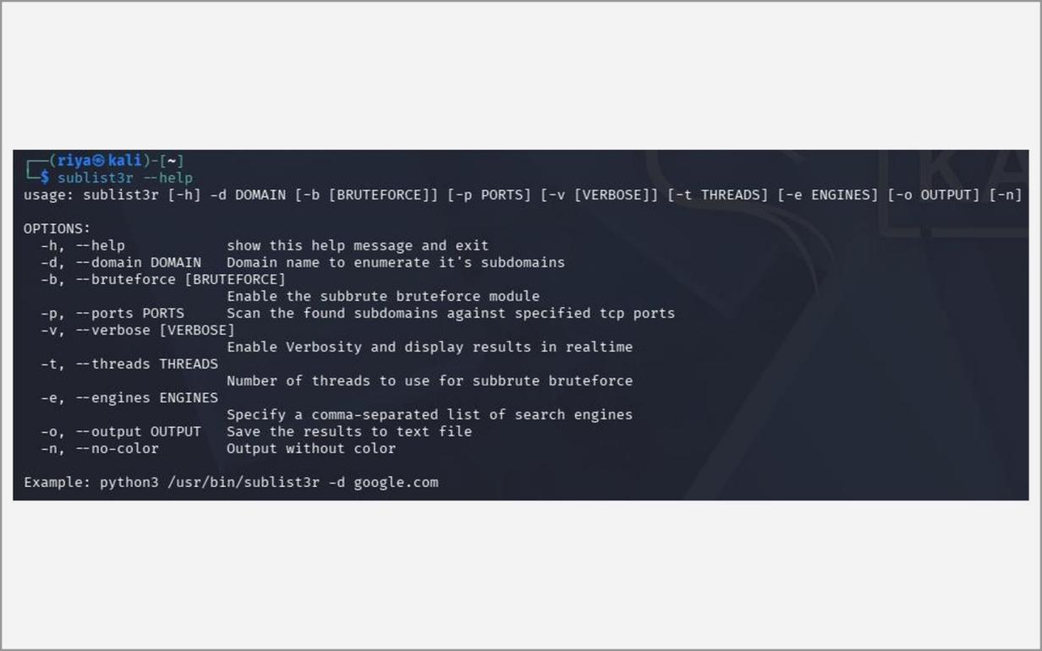
Fig. 2.34 – sublist3r --help
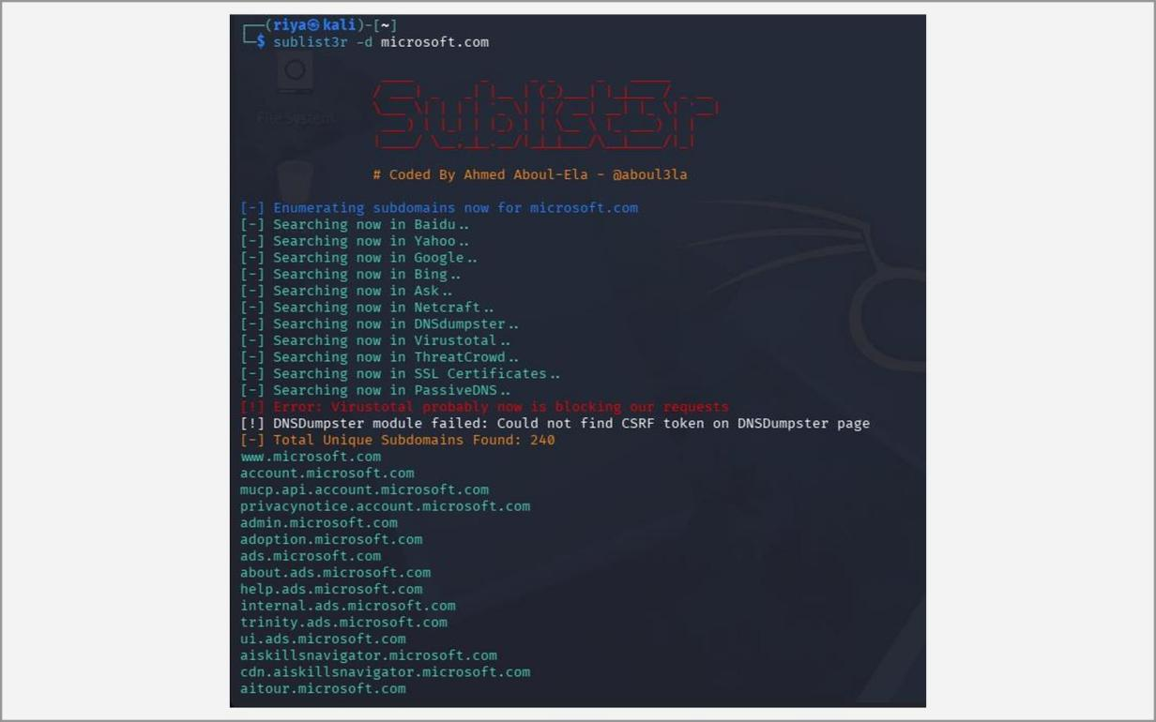
Fig. 2.35 – sublist3r -d microsoft.com
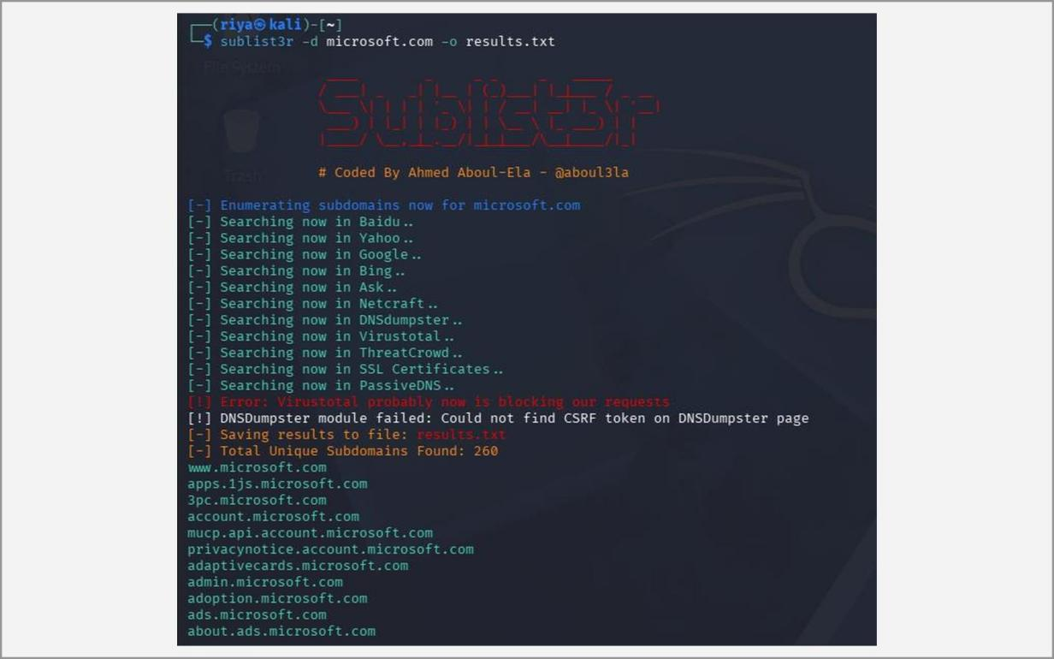
Fig. 2.36 – Saving results with -o results.txt
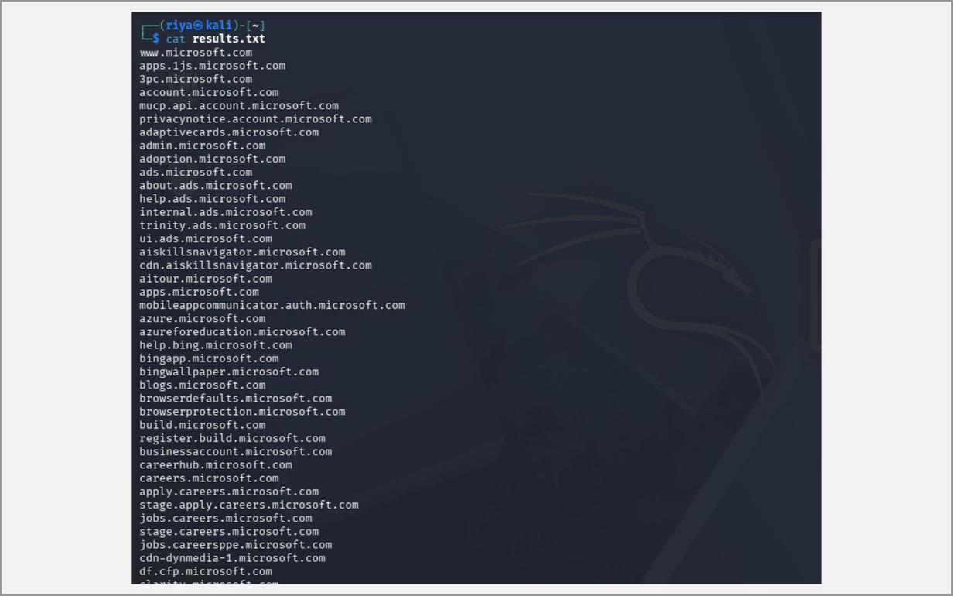
Fig. 2.37 – Viewing the saved sub-domains (cat results.txt)
H. DNS mapping
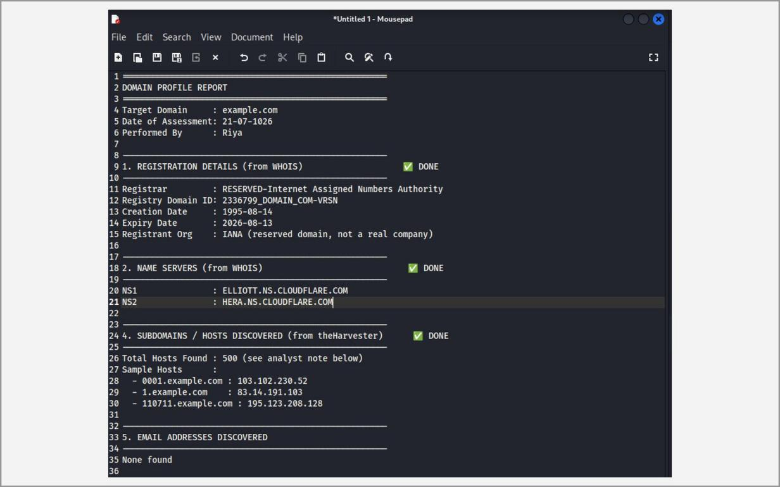
Fig. 2.38 – Consolidated domain profile for example.com
Learning Outcomes:
• Installed Sysmon with a configuration file and viewed process, network and file events in the Windows Event Viewer, understanding how defenders detect suspicious behaviour.
• Collected e-mail addresses, host names, IP addresses and sub-domains of a domain passively with theHarvester and Sublist3r.
• Retrieved registrar, creation and expiry dates, name servers and ownership data with WHOIS for both a domain and an IP address.
• Queried A, MX, NS and PTR records with nslookup and learned how to direct a query to a specific DNS server such as 8.8.8.8.
• Discovered live hosts, their IP and MAC addresses and the hardware vendors on a local network using active and passive ARP scans with Netdiscover.
• Combined WHOIS, DNS and OSINT results into a single domain profile and learned how an attacker builds a picture of a target’s external footprint before attacking.
Ex. No. 3 Date: 22/07/2026
Using FOCA / SearchDiggity tools, extract metadata and expanding the target list
Objective:
The aim of this experiment is to extract hidden metadata from public documents and to widen the list of possible targets using Open Source Intelligence (OSINT) techniques. Organisations routinely publish PDF, Word, Excel and PowerPoint files on their websites. These files silently carry metadata such as the author name, the computer user name, the software and its version, printer names and even folder paths, all of which help an attacker guess user names, operating systems and internal network layout.
FOCA is used to search for and download documents from a target domain and to analyse their metadata, and Google Dorking, the technique that SearchDiggity automates, is used to find exposed files and pages with advanced search operators. Both techniques are passive, because the information is taken from Google’s index and the downloaded public files, not from the target’s internal systems.
Tools:
• FOCA Open Source v3.4.7.1 (ElevenPaths) – “Fingerprinting Organizations with Collected Archives”, a Windows tool that discovers documents of a domain through search engines, downloads them and extracts and correlates their metadata to reveal users, software, printers, folders, hosts and domain structure.
• Microsoft SQL Server Express – the free database engine that FOCA uses to store project data.
• Google Search with advanced operators (Google Dorking) – site:, filetype:, intitle:, inurl:, intext:, quotes, minus and OR, the same operators that SearchDiggity runs automatically against Google and Bing.
• Web browser and Windows host – used to download FOCA and to run the dorks.
Methodology:
Introduction to FOCA
FOCA starts from a domain name. It asks search engines for files of selected types (doc, docx, pdf, ppt, xls and others) hosted on that domain, downloads them, and reads the metadata inside each file. After all files are analysed, FOCA correlates the results: a list of user names, the software and versions used to create documents, printers, local paths and a possible network map. Outdated software versions and valid user names are especially valuable for later attacks.
Introduction to Google Dorking
Google Dorking (Google Hacking) uses special operators to make Google return pages that the site owner never meant to expose, such as login pages, configuration files, directory listings and documents. Only Google’s own servers are queried, so the target never sees the search. The most common operators are site: (limit to one domain), filetype: (limit to a file type), intitle: (word in the page title), inurl: (word in the URL), intext: (word in the page body), quotation marks (exact phrase), a minus sign (exclude a word), OR (either term) and cache: (Google’s stored copy of a page).
A. Installing FOCA
1. Download the latest FOCA release from github.com/ElevenPaths/FOCA/releases.
2. Download Microsoft SQL Server Express (required by FOCA) and install it using the Basic option after accepting the licence.
3. Extract the FOCA ZIP file and run FOCA.exe.
B. Creating a project and extracting metadata
1. Create a new project: enter the project name, the target domain website and the folder where documents will be saved, then click Create.
2. Select the search engines (Google, Bing, DuckDuckGo) and file extensions (doc, docx, pdf, ppt, xls, odt …) and click Search All.
3. Select the discovered documents, right-click and choose Download All.
4. Right-click the downloaded documents and choose Extract All Metadata, then Analyze Metadata.
5. Review the Metadata, Network and Domains sections for users, software versions, printers, folders and hosts.
C. Google Dorking
1. Open Google in a browser and use the search operators below. They only query Google's index, so the target is never contacted (passive reconnaissance).
site:amazon.com
site:amazon.com gaming laptop
filetype:pdf site:owasp.org cybersecurity
site:owasp.org intitle:"SQL Injection"
site:docs.aws.amazon.com inurl:iam
site:developer.mozilla.org intext:"JavaScript"
Note: Common operators: site: (restrict to a domain), filetype: (file type), intitle: (word in page title), inurl: (word in URL), intext: (word in body), “ ” (exact phrase), – (exclude), OR (either term), cache: (cached copy).
Screenshots:
A. FOCA installation
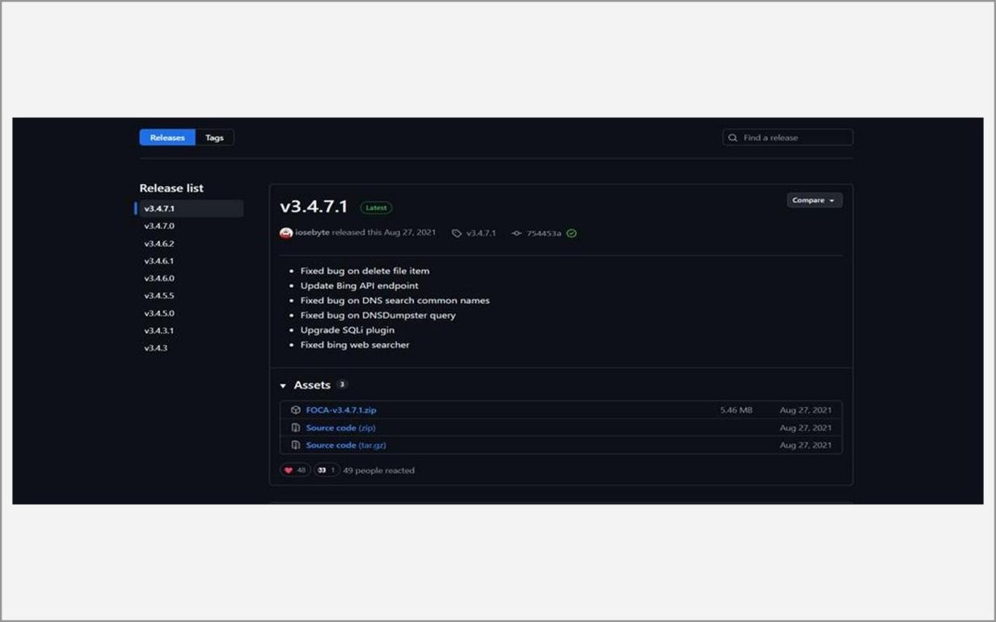
Fig. 3.1 – FOCA release page on GitHub
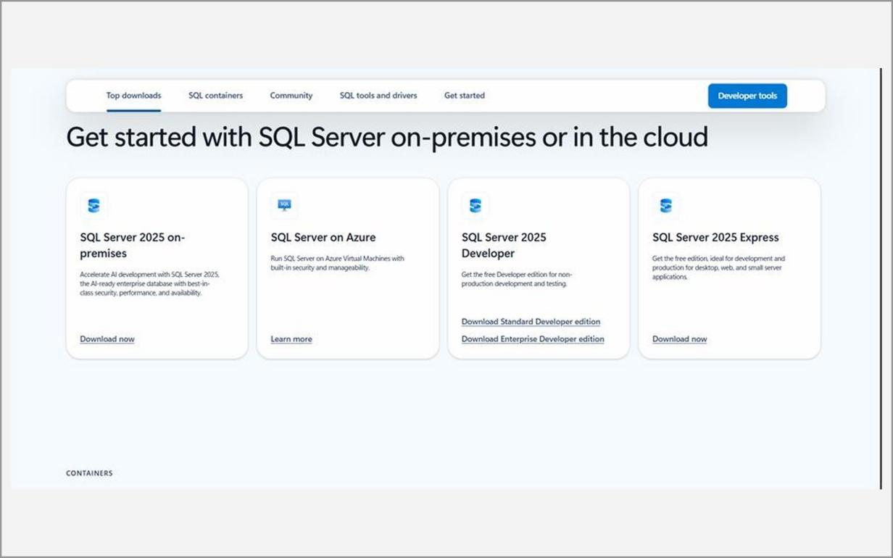
Fig. 3.2 – Microsoft SQL Server download page
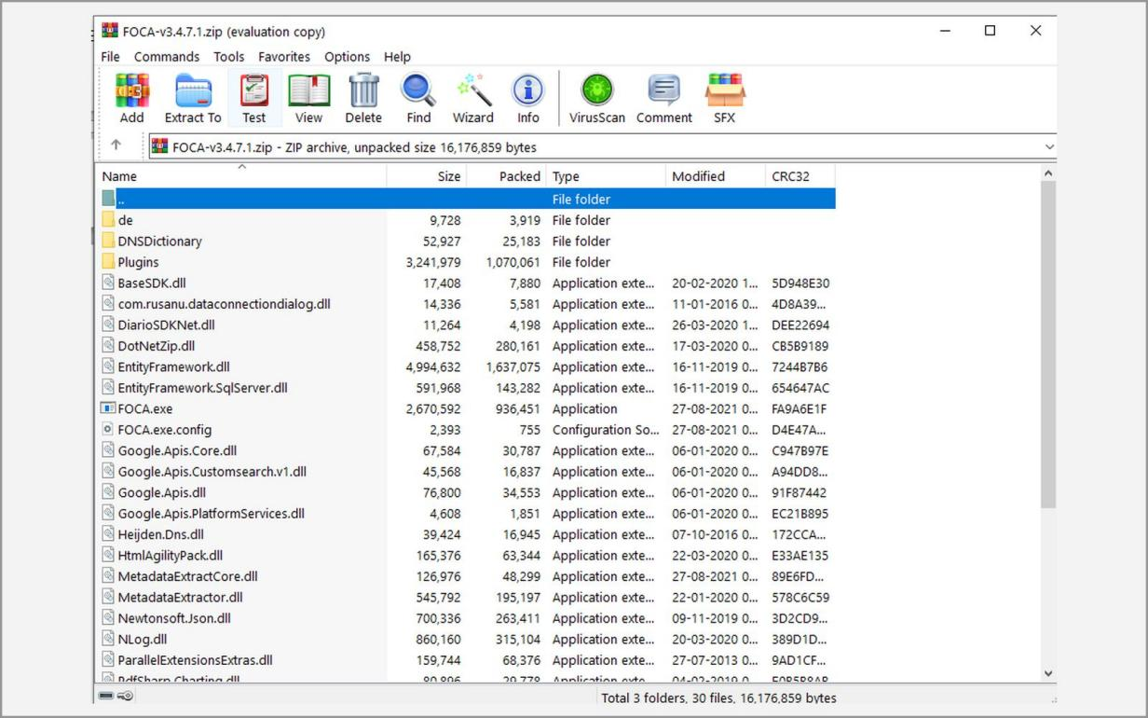
Fig. 3.3 – Extracted FOCA files (FOCA.exe)
B. FOCA project and metadata search
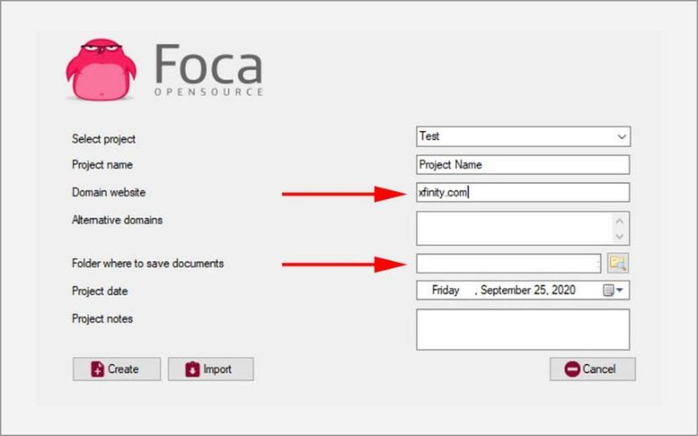
Fig. 3.4 – Creating a new FOCA project
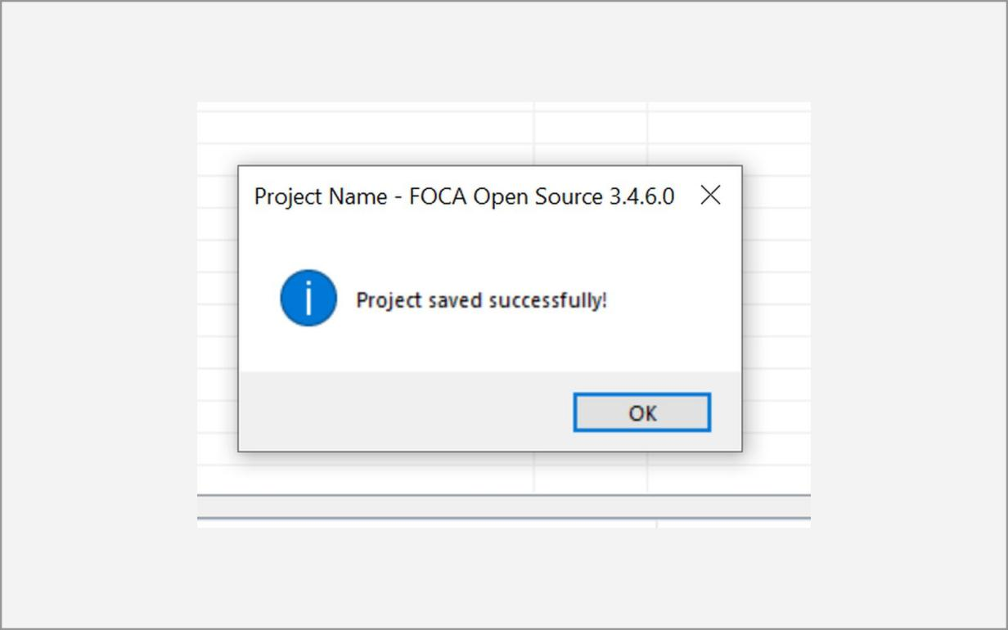
Fig. 3.5 – Project saved successfully
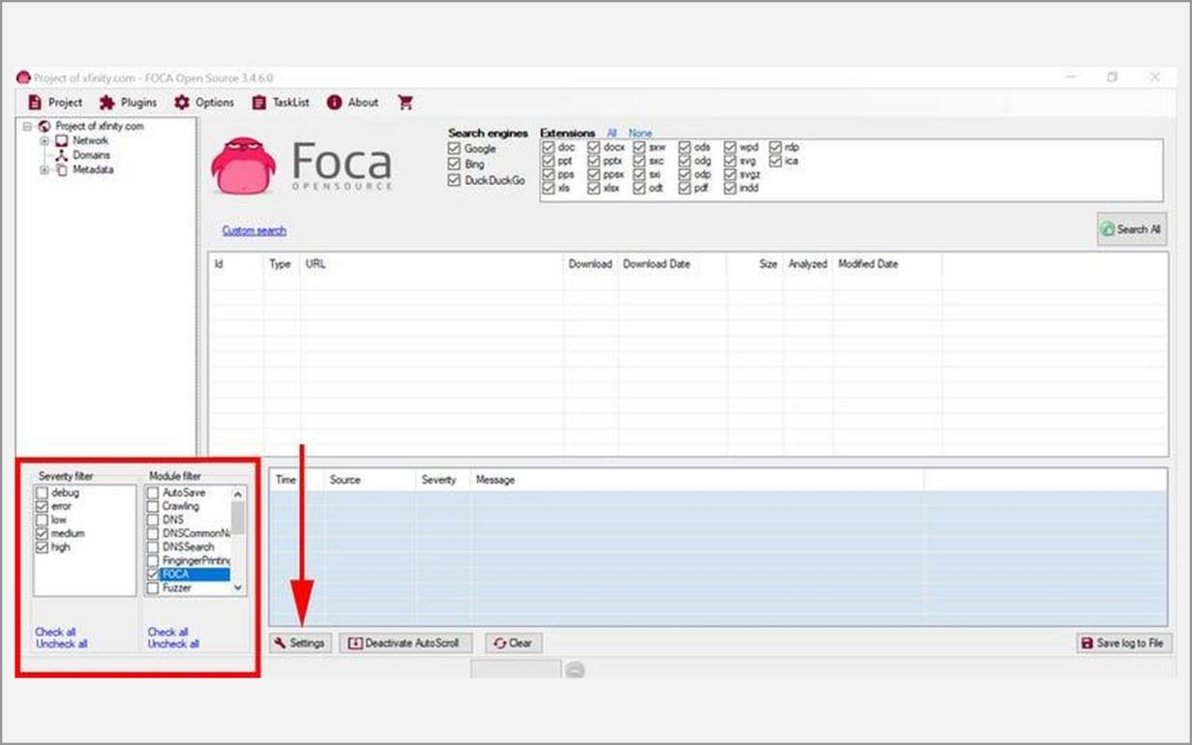
Fig. 3.6 – FOCA main window – search engines and extensions
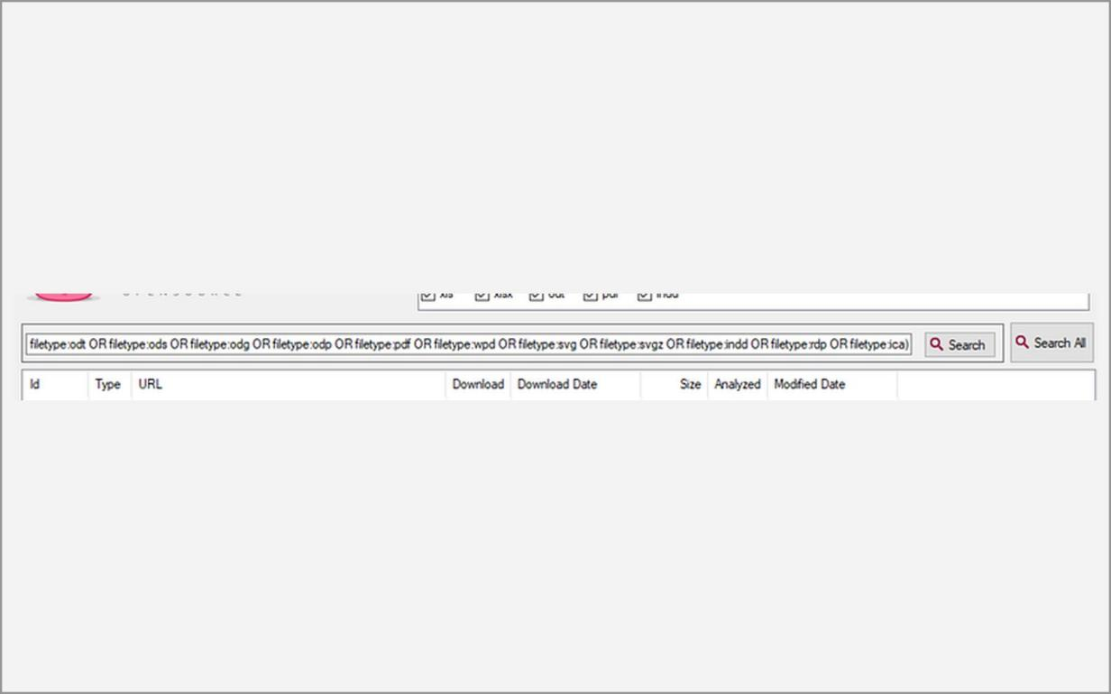
Fig. 3.7 – Documents found by Search All
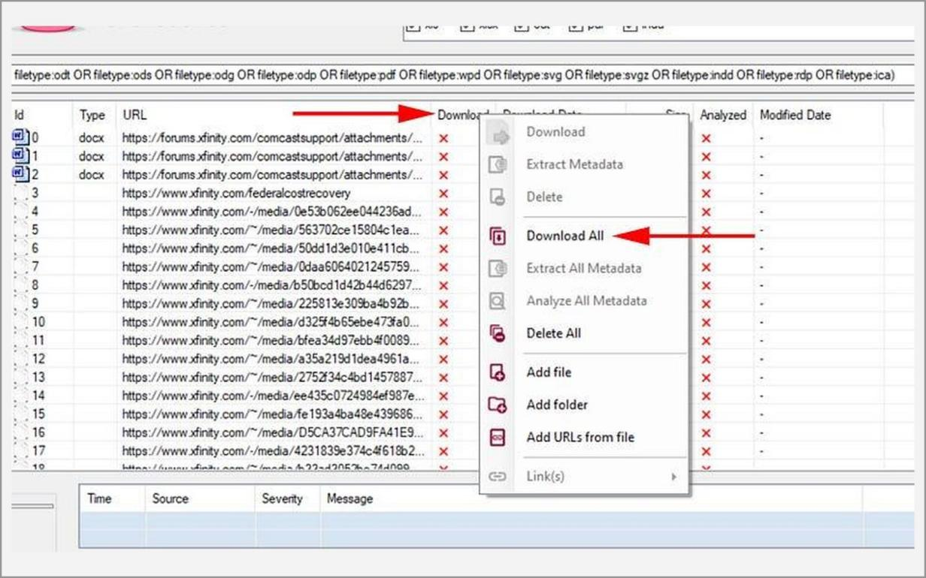
Fig. 3.8 – Right-click menu – Download All
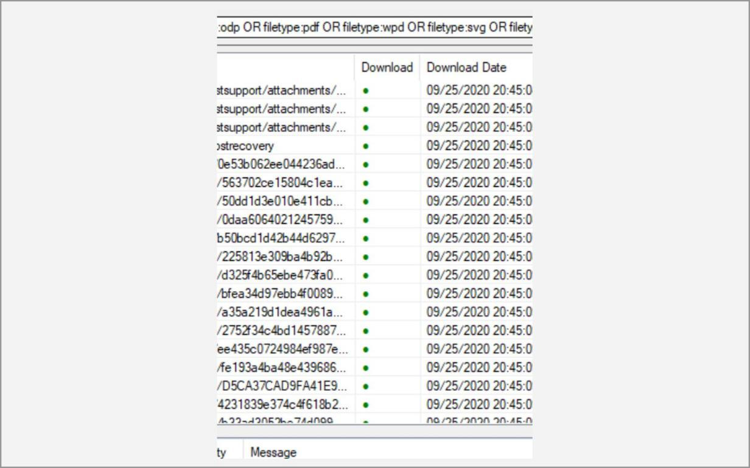
Fig. 3.9 – Documents downloaded
C. Google Dorking
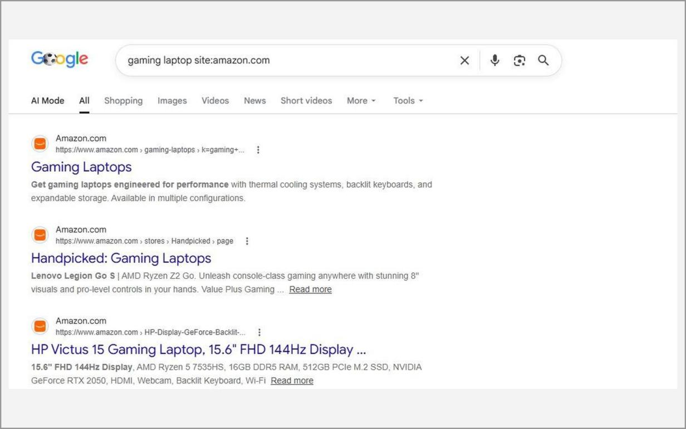
Fig. 3.10 – site: operator – site:amazon.com gaming laptop
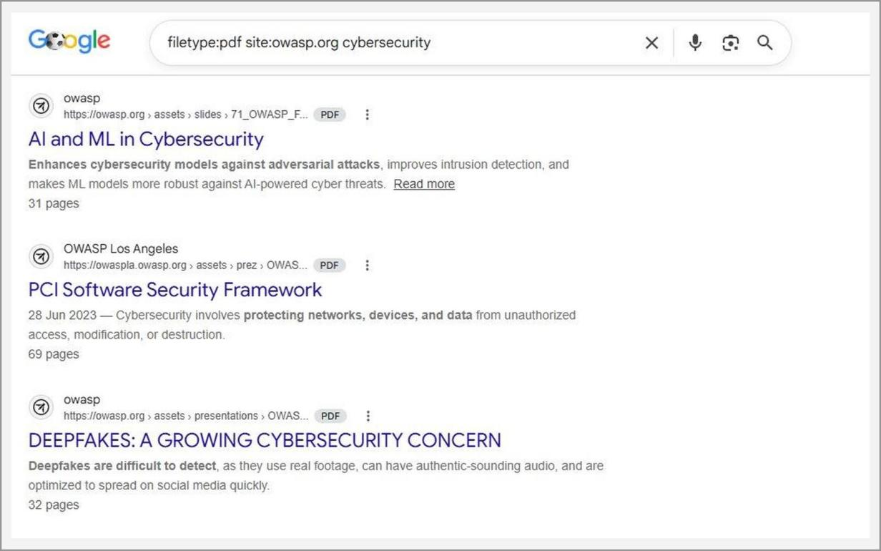
Fig. 3.11 – filetype: operator – filetype:pdf site:owasp.org cybersecurity
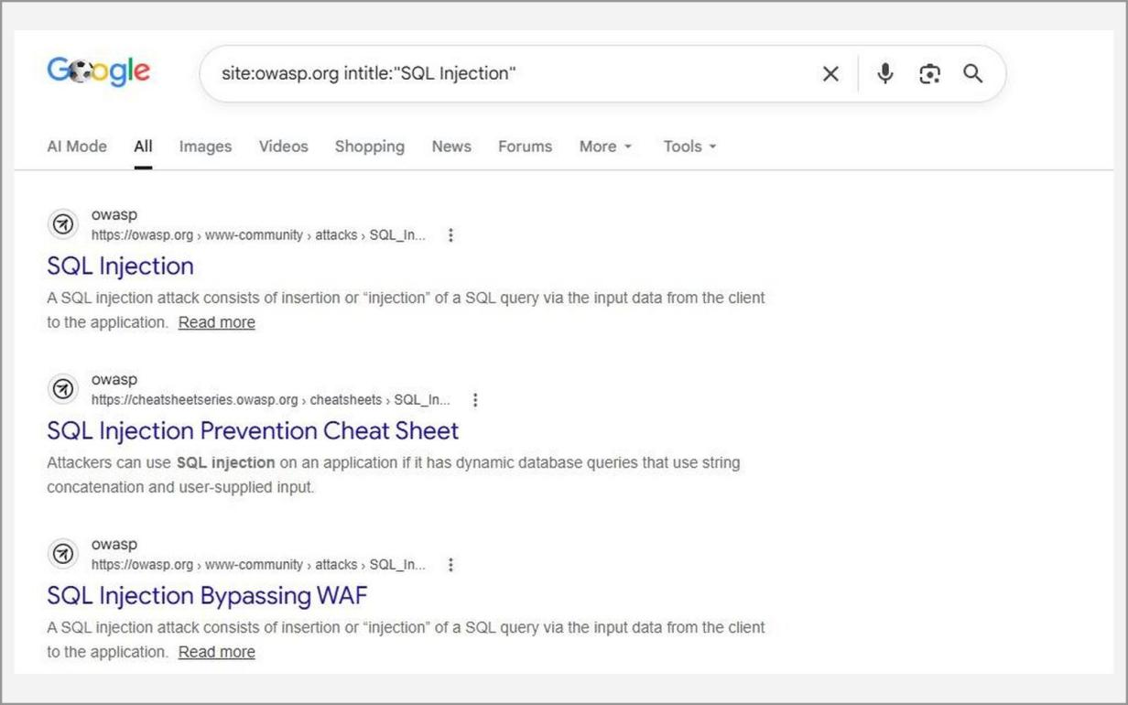
Fig. 3.12 – intitle: operator – site:owasp.org intitle:"SQL Injection"
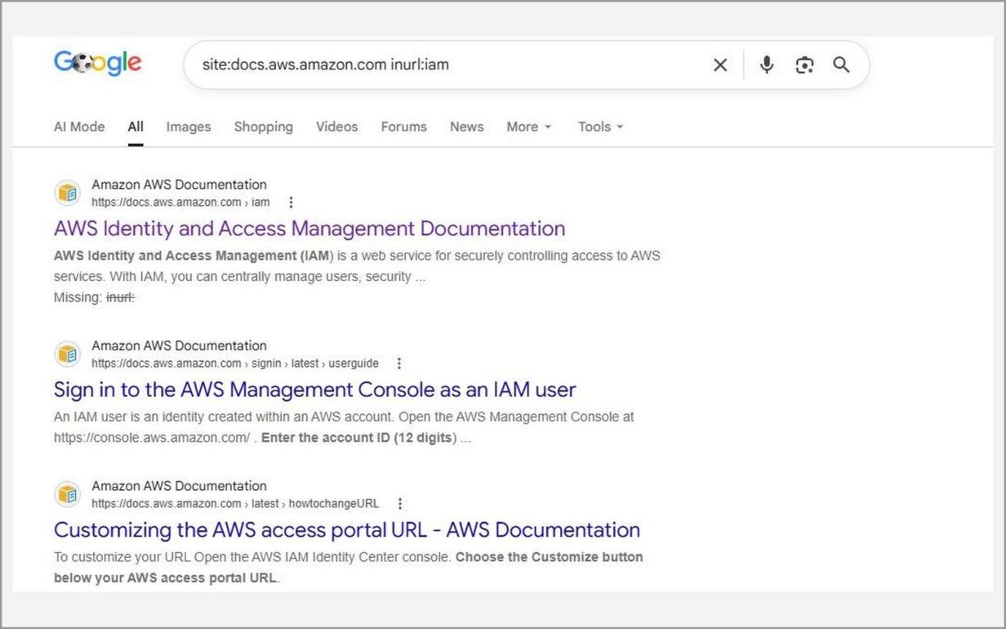
Fig. 3.13 – inurl: operator – site:docs.aws.amazon.com inurl:iam
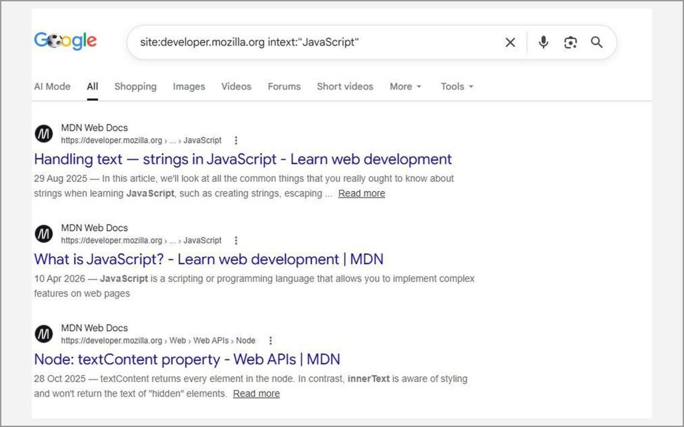
Fig. 3.14 – intext: operator – site:developer.mozilla.org intext:"JavaScript"
Learning Outcomes:
• Installed FOCA together with its SQL Server Express database and created a new project for a target domain.
• Searched for and downloaded public PDF, Office and OpenDocument files, then extracted and analysed their metadata to identify authors, software versions and internal paths.
• Used the site:, filetype:, intitle:, inurl: and intext: operators to find files and pages on a domain without contacting the target.
• Understood how harmless-looking public documents leak user names and infrastructure details that expand an attacker’s target list.
• Learned the defensive lesson: remove metadata from documents before publishing and regularly review what a domain exposes to search engines.
Ex. No. 4 Date: 29/07/2026
Aggregates information from the public databases using online free tools like Paterva’s Maltego
Objective:
The aim of this experiment is to aggregate information about a target from many public databases and to display it as a graph using Maltego, a tool from Paterva. Maltego is a link-analysis and data-mining platform. Instead of printing long lists of results, it represents each piece of information as an entity (a domain, a DNS name, an IP address, a netblock, an e-mail address, a person) and draws the relationships between them, so patterns that are hard to see in raw text become visible.
The experiment uses the free Community Edition to start from one domain and to expand it, step by step, into name servers, mail servers, IP addresses, network blocks and contact details. All data comes from public sources, so the technique is a form of passive reconnaissance.
Tools:
• Maltego Community Edition (CE) – the free edition of Maltego, pre-installed in Kali Linux. It limits the number of results returned per transform (12) and requires a free Maltego account.
• Transforms and the Transform Hub – small programs that take one entity as input and return related entities, for example “To DNS Name – NS”, “To DNS Name – MX”, “To IP Address [DNS]” and WHOIS-based transforms.
• Kali Linux virtual machine with internet access – the platform on which Maltego is run.
Methodology:
Introduction to Maltego
Maltego works with three basic ideas. An entity is a piece of information with a type, such as a Domain or an IPv4 Address. A transform is a query that converts one entity into other related entities by calling a public data source. A graph is the canvas on which entities are linked by lines that show the relationship found by the transform.
Because every result can be selected and used as the input of another transform, an investigator can walk from a domain to its name servers, from the name servers to IP addresses, and from the IP addresses to the netblock and autonomous system that host them. Several layouts (Block, Hierarchical, Organic) help in studying large graphs, and a graph can be saved and exported for a report.
1. Launch Maltego from Applications → Information Gathering → Maltego (or run maltego in a terminal) and accept the licence agreement.
2. Select Maltego CE (Free), log in with the registered Maltego account and choose “Open a blank graph and let me play around”.
3. From the Entity Palette (Infrastructure group) drag a Domain entity on to the graph and double-click it to set the Domain Name to the authorised training domain.
4. Right-click the domain → Run Transform and run transforms such as To DNS Name – NS (name servers), To DNS Name – MX (mail servers), To IP Address [DNS] and the WHOIS transforms for owner and e-mail addresses.
5. Select the new entities (for example the IP addresses) and run further transforms such as To Netblock and To AS Number to discover the hosting network. Maltego CE returns a limited number of results (12) per transform.
6. Change the layout (Block, Hierarchical, Organic) and use the Detail View and Entity List to examine each entity.
7. Save the graph (.mtgz) and export the entities / graph image for the report.
8. Analyse the graph to build the footprint of the target: name servers, mail servers, IP ranges, hosting provider and contact e-mails.
Note: Maltego only queries public data sources, so it is a passive technique; use it only on domains you are authorised to investigate.
Screenshots:
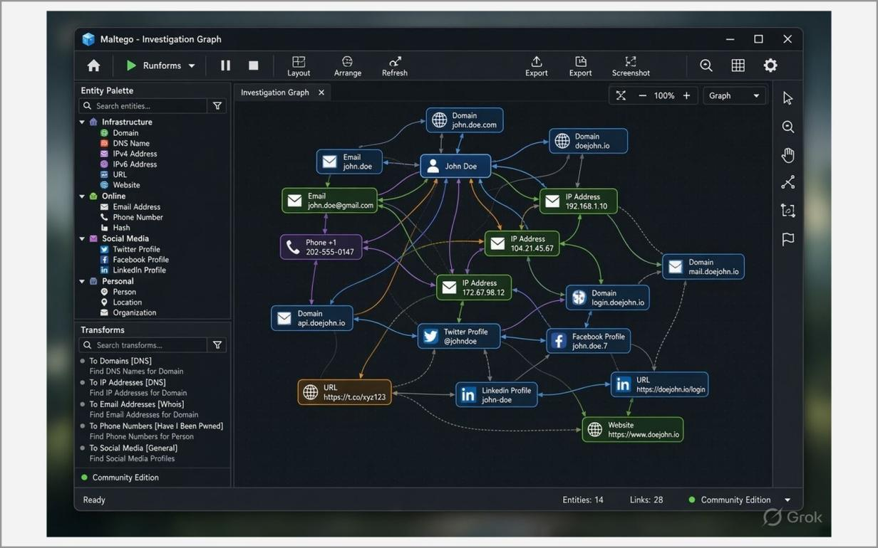
Fig. 4.1 – Illustrative layout of a Maltego graph
Learning Outcomes:
• Understood the Maltego concepts of entity, transform and graph and how data from many public sources is aggregated.
• Built a graph of a domain’s DNS, WHOIS and network relationships using the free Community Edition.
• Identified name servers, mail servers, IP ranges, hosting networks and contact e-mails that form part of a target’s footprint.
• Used different graph layouts and the detail view to inspect entities and their properties.
• Learned how visual link analysis reveals relationships that raw command-line output hides, and that only authorised targets should be investigated.
Ex. No. 5 Date: 12/08/2026
View and capture network traffic using Wireshark
Objective:
The aim of this experiment is to capture live network traffic with Wireshark and to analyse it packet by packet. Wireshark is the most widely used network-protocol analyser. It puts the network interface in capture mode, records every frame that reaches it, and dissects the frame layer by layer (Ethernet, IP, TCP/UDP and the application protocol) so that the exact bytes sent on the network can be read.
The experiment shows how to start a capture, generate ICMP, DNS and HTTP traffic, isolate the traffic of interest with display filters, follow a complete TCP conversation, and summarise a capture with the statistics tools. It also demonstrates why unencrypted protocols are dangerous, because anyone who can capture the packets can read them.
Tools:
• Wireshark – a free, open-source packet analyser, pre-installed in Kali Linux, with a graphical interface and the tshark command-line version.
• Kali Linux virtual machine – the capturing machine. Metasploitable 2 and Windows XP act as the machines that it talks to.
• Command-line tools ping, nslookup and curl, and a web browser – used to generate ICMP, DNS and HTTP traffic.
Methodology:
Introduction to packet capture
Every piece of data on a network travels in packets. Each packet is wrapped in several headers: Ethernet carries the MAC addresses, IP carries the source and destination IP addresses, TCP or UDP carries the port numbers, and the application protocol (such as HTTP or DNS) carries the actual request or reply. Wireshark shows these layers in its Packet Details pane and the raw bytes in its Packet Bytes pane.
A capture filter limits what is recorded, while a display filter limits what is shown from an existing capture. Useful display filters include icmp (ping), dns, http, tcp.port == 80 and ip.addr == <address>. The TCP three-way handshake (SYN, SYN-ACK, ACK) that begins every TCP connection can be seen at the start of the conversation, and Follow TCP Stream rebuilds the whole conversation as readable text.
1. Start Wireshark with root privileges so it can capture on the network interface:
sudo wireshark
2. From the start screen select the active interface (for example eth0) and click Start capturing packets (blue shark-fin icon).
3. Generate traffic from the Kali terminal / browser:
ping <Metasploitable-IP>
nslookup example.com
curl http://<Metasploitable-IP>
4. Apply display filters in the filter bar to isolate traffic:
icmp
dns
http
tcp.port == 80
ip.addr == 192.168.56.101
5. Select a packet and study the three panes: Packet List (summary), Packet Details (layer by layer – Ethernet, IP, TCP/UDP, application) and Packet Bytes (raw hex/ASCII).
6. Right-click a TCP packet → Follow → TCP Stream to reconstruct a complete conversation (observe the TCP three-way handshake: SYN, SYN-ACK, ACK).
7. Use Statistics → Protocol Hierarchy and Statistics → Conversations to summarise the traffic.
8. Stop the capture and save it as a .pcapng file (File → Save As).
Note: Capture only on networks you own or are authorised to monitor; unencrypted protocols such as HTTP and FTP expose credentials in clear text.
Screenshots:
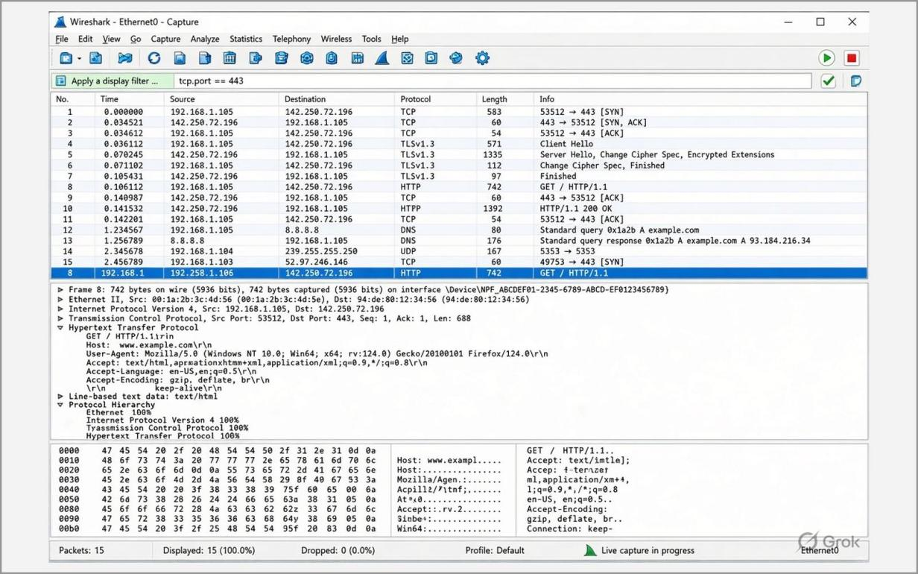
Fig. 5.1– Illustrative layout of a Wireshark capture
Learning Outcomes:
• Captured live network traffic on an interface and saved the capture in .pcapng format for later analysis.
• Used display filters to isolate ICMP, DNS, TCP and HTTP packets from a busy capture.
• Examined packet headers layer by layer and followed TCP streams, including the TCP three-way handshake.
• Used Statistics → Protocol Hierarchy and Conversations to summarise the traffic in a capture.
• Recognised that clear-text protocols such as HTTP and FTP expose their contents to anyone who can sniff the network, and that capture must be done only on networks one is authorised to monitor.
Ex. No. 6 Date: 09/09/2026
Scan the target using tools like Nessus
Objective:
The aim of this experiment is to scan authorised lab targets and discover what is running on them and which weaknesses they have. Scanning is the second phase of ethical hacking and follows reconnaissance. Three tools are used, each at a different level: Nmap discovers live hosts, open ports, running services, their versions and the operating system; Nikto examines a web server for outdated software, dangerous files and missing security headers; and Nessus performs an automated vulnerability assessment using thousands of checks and reports the findings by severity with their CVE references.
Unlike the passive tools of the earlier experiments, these tools send packets to the target, can be seen in its logs and can disturb fragile services. They must therefore be used only against systems that the tester owns or is explicitly authorised to test, which in this course means the virtual lab machines (Metasploitable 2 and DVWA).
Tools:
• Nmap 7.99 – the Network Mapper, a free tool for host discovery, port scanning, service/version detection, OS fingerprinting and scripting.
• Nikto 2.5 – an open-source web-server scanner that checks for over six thousand dangerous files and outdated server and software versions and reports misconfigurations.
• Nessus Essentials (Tenable) – the free edition of the Nessus vulnerability scanner, limited to 16 IP addresses, which reports findings classified as Critical, High, Medium, Low and Info.
• Metasploitable 2 and DVWA (Damn Vulnerable Web Application) – the authorised, intentionally vulnerable targets.
• cve.org and the National Vulnerability Database – used to look up the CVE entries and CVSS scores of the findings.
• Kali Linux and Windows hosts, with VirtualBox providing the lab network.
Methodology:
Introduction to host and service discovery
Host discovery finds which systems on a network are alive. Port scanning then finds which of the 65,535 TCP ports of a host accept connections: a port is reported as open (a service answers), closed (the host answers but no service listens) or filtered (a firewall hides the port). Each open port is a possible entry point. Version detection (-sV) and OS detection (-O) turn this list into a profile of the target, which is used to choose exploits in later experiments.
A SYN (stealth) scan, -sS, sends only the first packet of the TCP handshake and never completes the connection, so it is faster and less likely to be logged by the application; it needs root privileges. The aggressive scan, -A, combines OS detection, version detection, default scripts and traceroute.
Introduction to vulnerability assessment
Vulnerability assessment is the systematic process of identifying, classifying and prioritising weaknesses. Nessus compares what it finds on a target with a continuously updated plugin database. Each finding has a severity: Critical (complete compromise or remote code execution), High (unauthorised data access or privilege escalation), Medium (needs special conditions), Low (minor misconfiguration or information disclosure) and Info (non-vulnerable details gathered during discovery). Findings carry CVE identifiers, which are public numbers that identify known vulnerabilities, and a CVSS score for their impact.
Note: Only scan targets you own or are explicitly authorised to test – here the isolated lab virtual machines.
A. Nmap – host and service discovery
sudo apt update
sudo apt install nmap -y
nmap -h
1. Syntax: nmap [scan type] [options] <target>. Find the lab network range with ip a.
2. Host discovery (ping scan, no port scan):
nmap -sn 10.0.2.0/24
3. Port scanning – top 1000 ports, selected ports and SYN (stealth) scan:
nmap 8.8.8.8
nmap -p 22,80,443,587 scanme.nmap.org
sudo nmap -sS 192.168.56.10
4. OS detection (-O) – the OS guess is reported with an accuracy percentage:
sudo nmap -O 10.49.154.234
5. Service / version detection and combined scans:
nmap -sV 10.49.154.234
sudo nmap -sS -sV -O 10.49.154.234
sudo nmap -A 10.49.154.234
B. Nikto – web server vulnerability scanner
sudo apt install nikto -y
nikto -Version
1. Run a basic scan against the web server of the training target (-h host, -p port, -ssl, -o file, -Format, -Tuning):
nikto -h 192.168.56.10
nikto -h <URL> -o report.txt
2. Interpret each “+” line: server-header disclosure, outdated software, interesting/default files and missing security headers.
C. Nessus Essentials – vulnerability assessment
1. Download the Nessus installer (.msi) from tenable.com/downloads/nessus, accept the licence and install it; verify the service (Nessus runs as the Tenable Nessus service).
net start "Tenable Nessus"
2. Register at tenable.com to receive a free Nessus Essentials activation code (limit of 16 IP addresses).
3. Open https://localhost:8834, accept the self-signed certificate warning, choose Nessus Essentials, enter the activation code and create the administrator account.
4. Wait for the plugin feed to download and compile (15–45 minutes).
5. My Scans → New Scan → Basic Network Scan. Give it a name, enter the target IP (Metasploitable / DVWA) in Targets, click Save and then the Launch (play) icon.
6. When the scan completes, open the Vulnerabilities tab. Severity levels: Critical, High, Medium, Low and Info.
7. Open a Critical / High finding, note the CVE number under See Also / References and look it up on cve.org or nvd.nist.gov for its CVSS score, impact and patch recommendation.
Screenshots:
A. Nmap
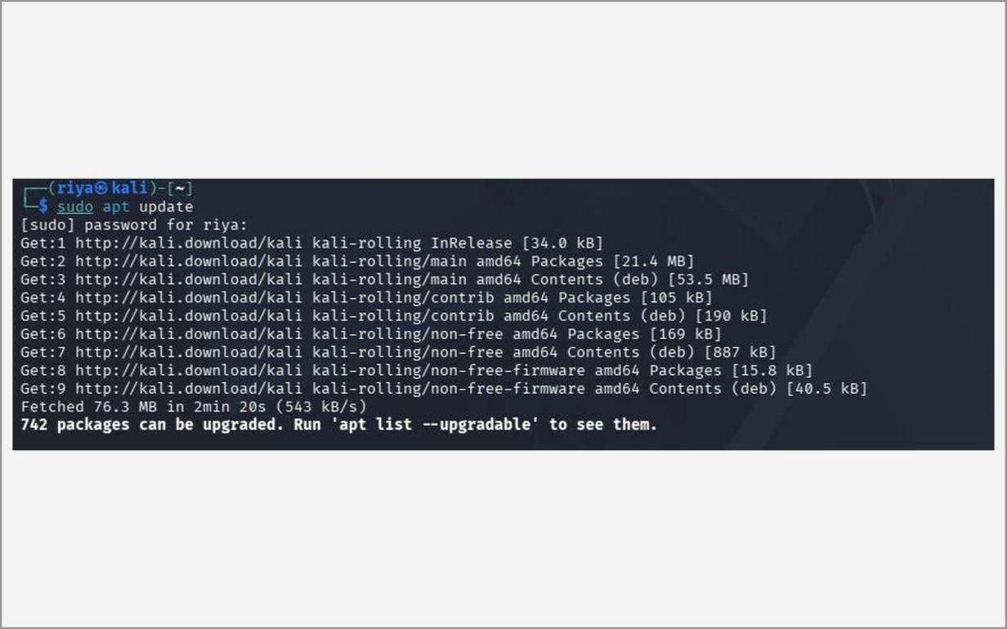
Fig. 6.1 – Updating the package list
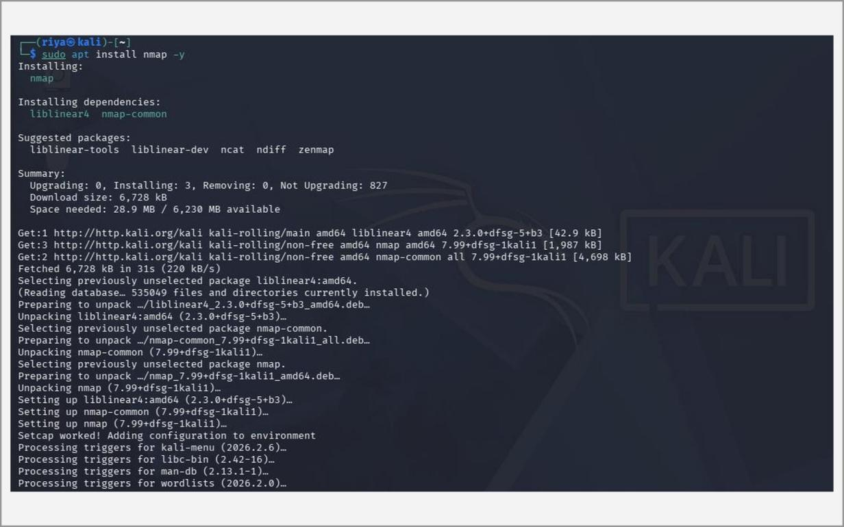
Fig. 6.2 – Installing Nmap
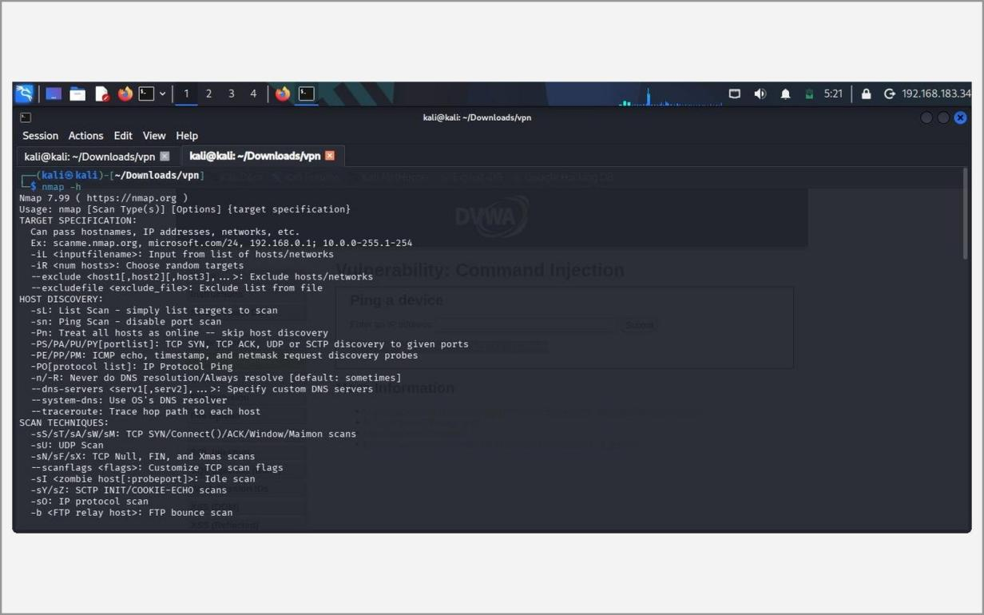
Fig. 6.3 – Nmap help – options and syntax
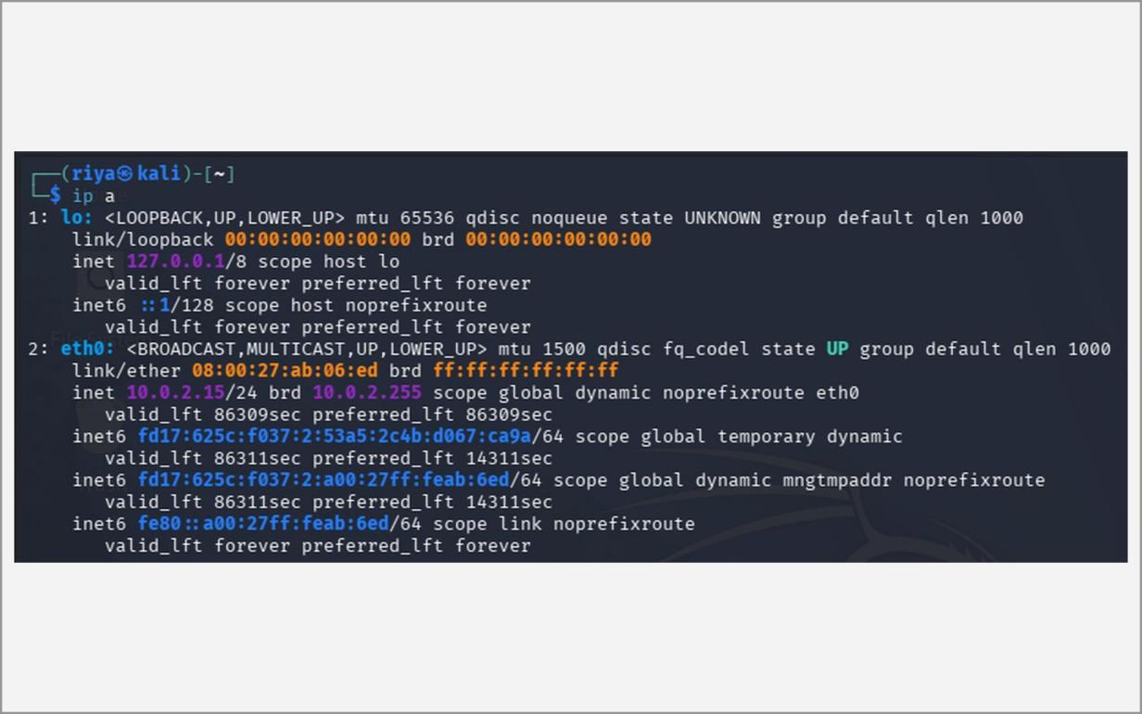
Fig. 6.4 – ip a – identifying the lab network range
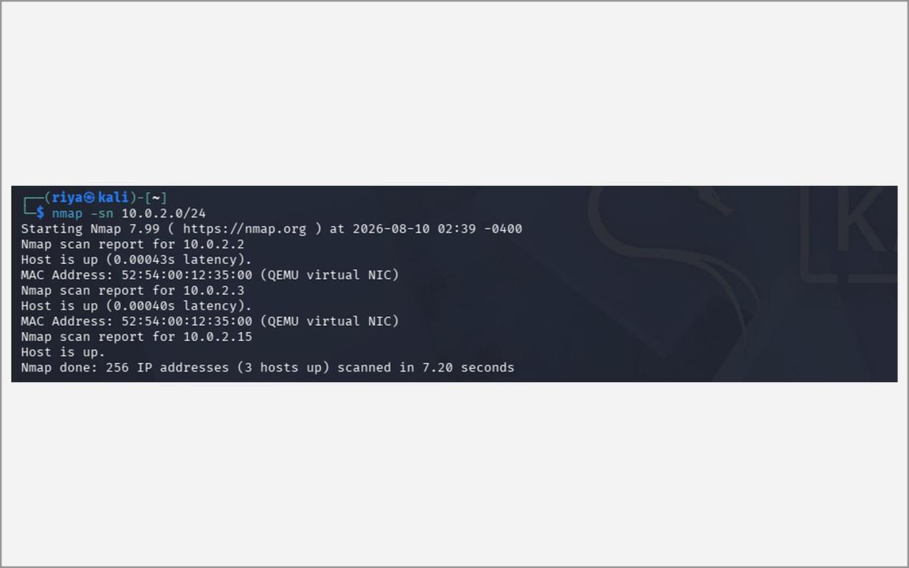
Fig. 6.5 – Host discovery – nmap -sn 10.0.2.0/24
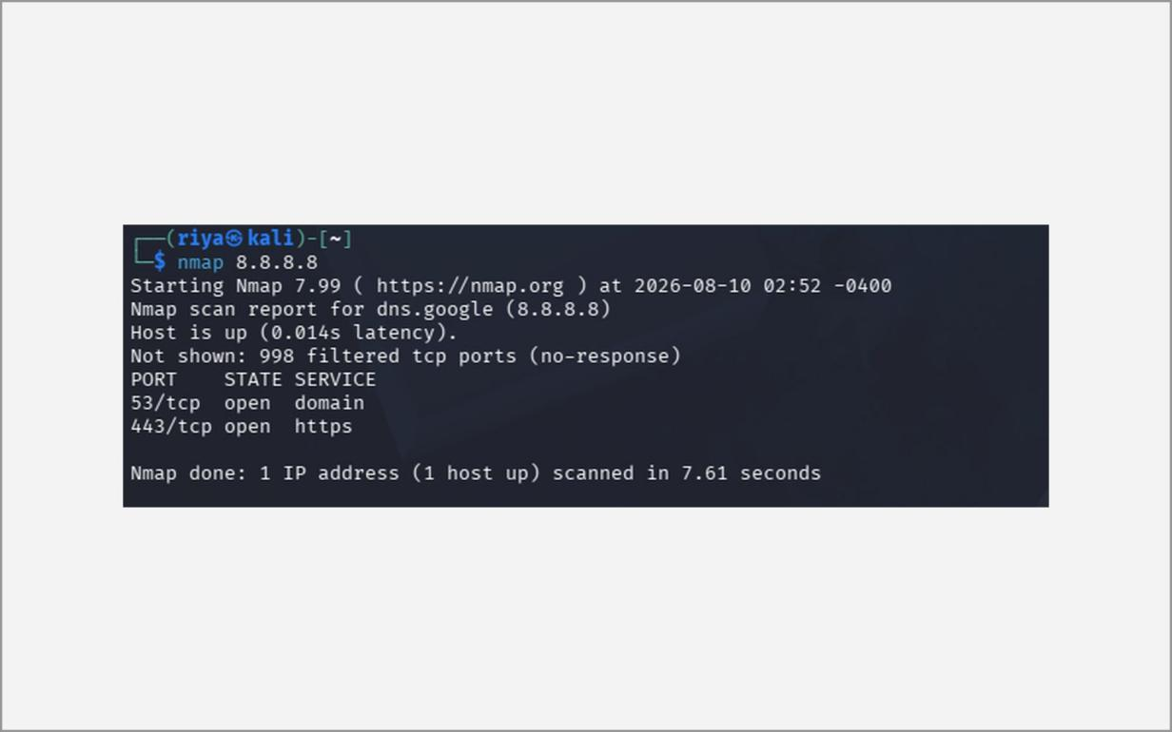
Fig. 6.6 – Port scan – nmap 8.8.8.8
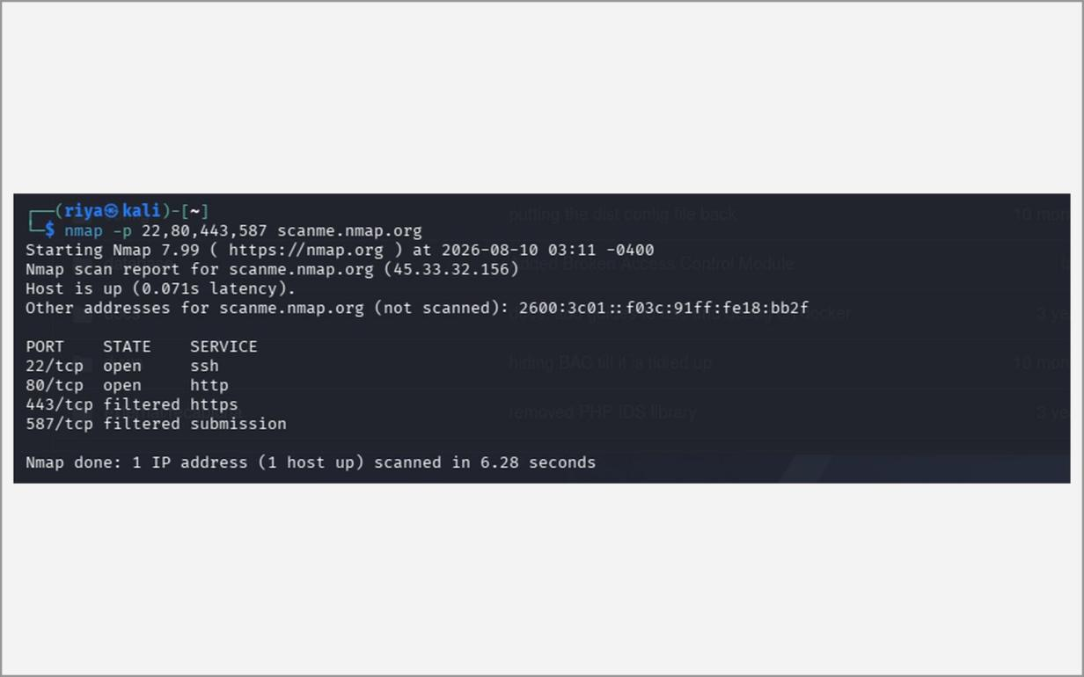
Fig. 6.7 – Port scan of selected ports
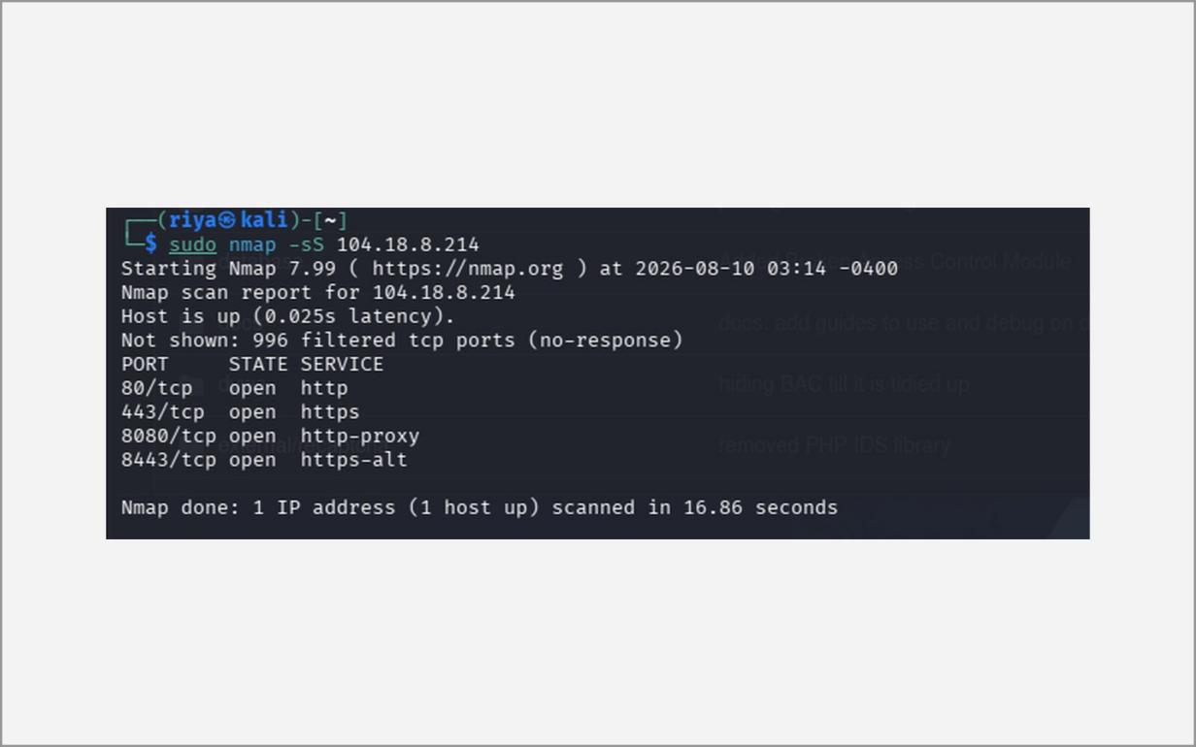
Fig. 6.8 – SYN (stealth) scan – nmap -sS
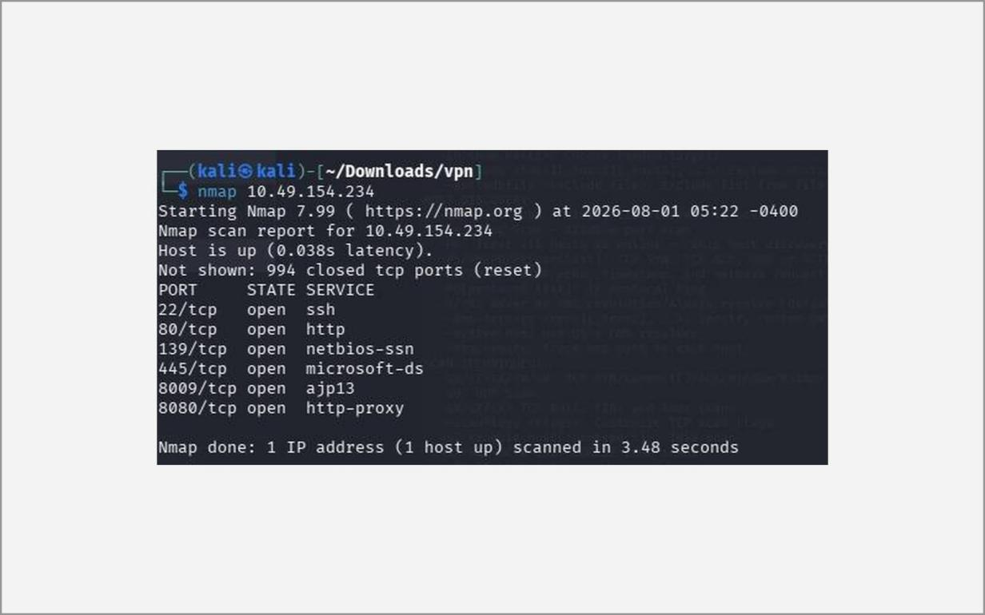
Fig. 6.9 – Default scan of the target 10.49.154.234
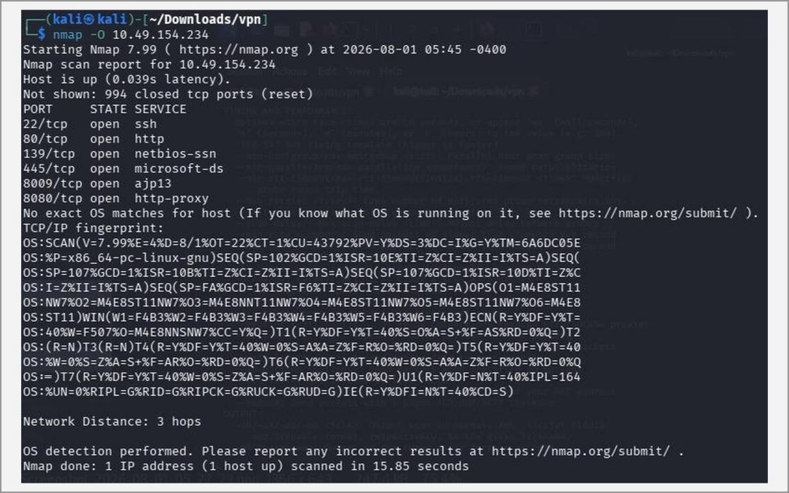
Fig. 6.10 – OS detection – nmap -O
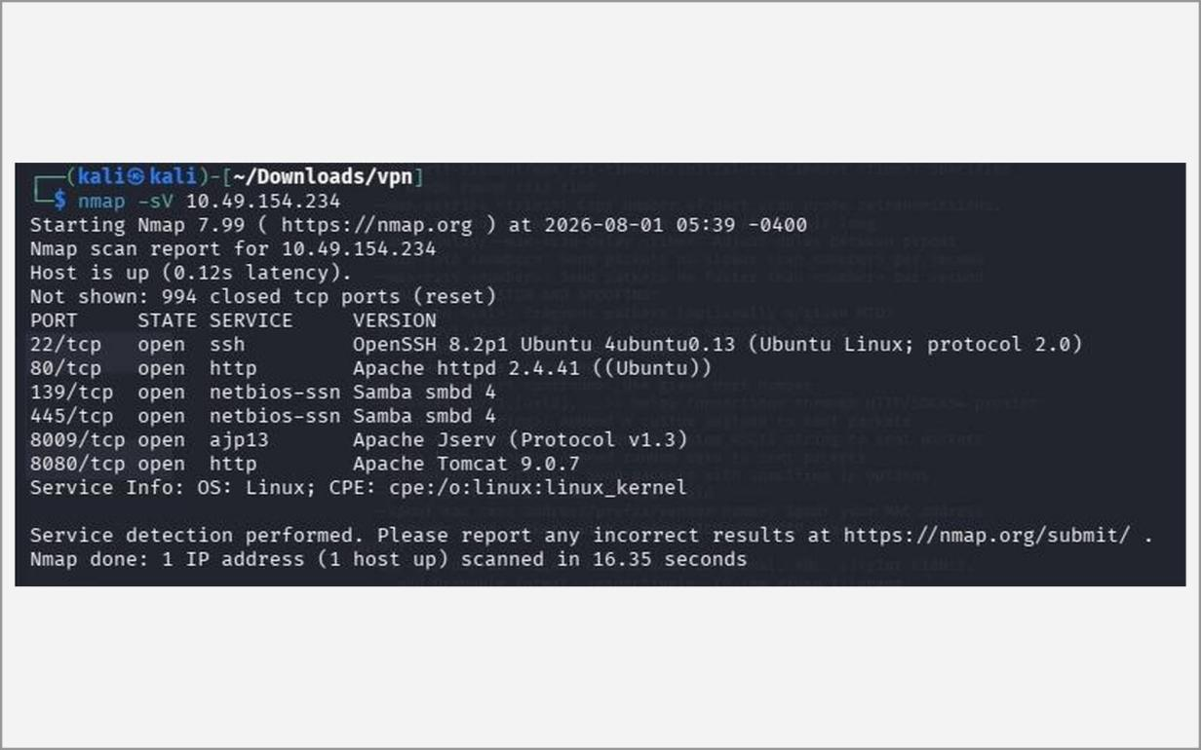
Fig. 6.11 – Service and version detection – nmap -sV
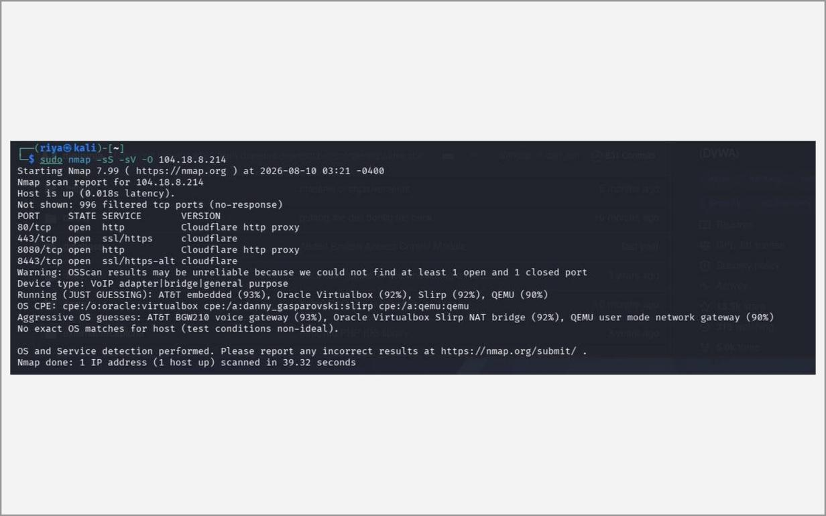
Fig. 6.12 – Combined scan – nmap -sS -sV -O
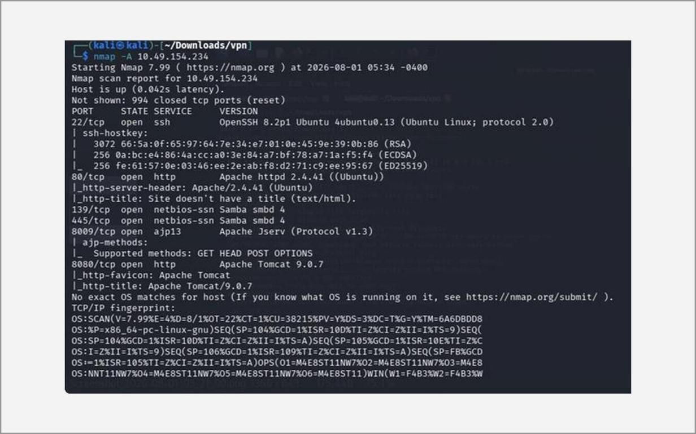
Fig. 6.13 – Aggressive scan – nmap -A
B. Nikto
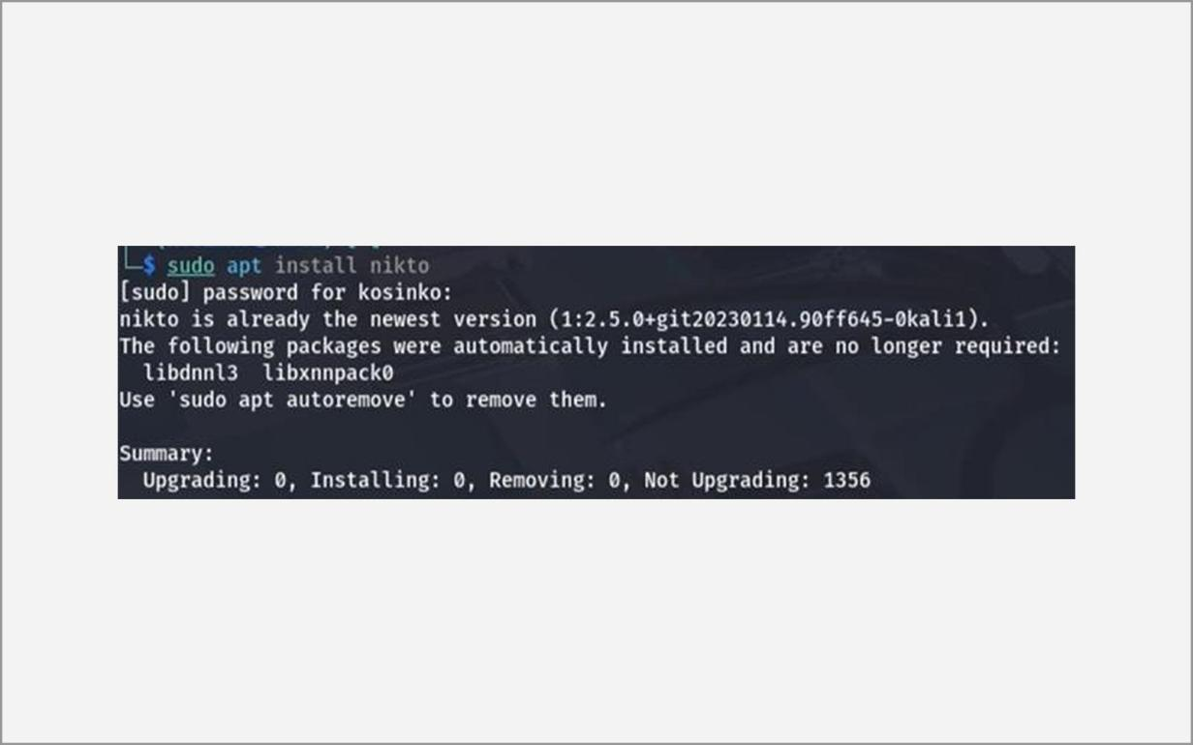
Fig. 6.14 – Installing / verifying Nikto
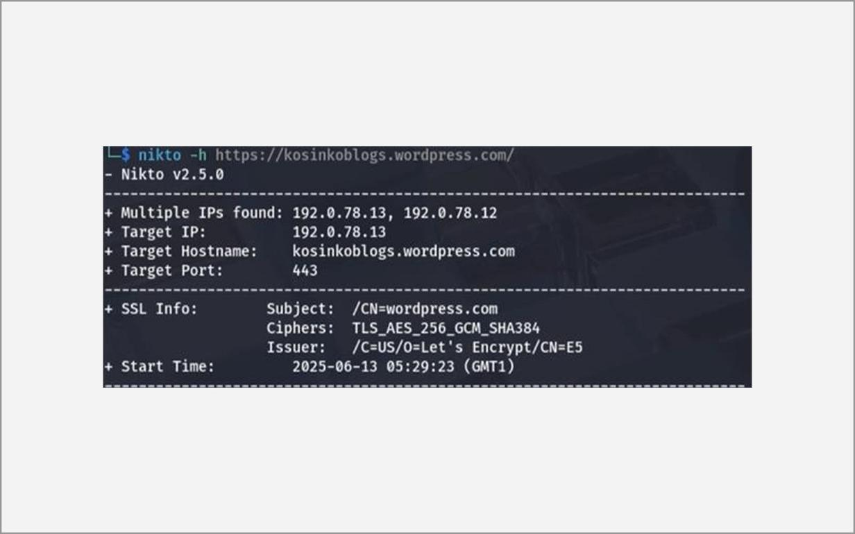
Fig. 6.15 – Nikto scan – target details and start time
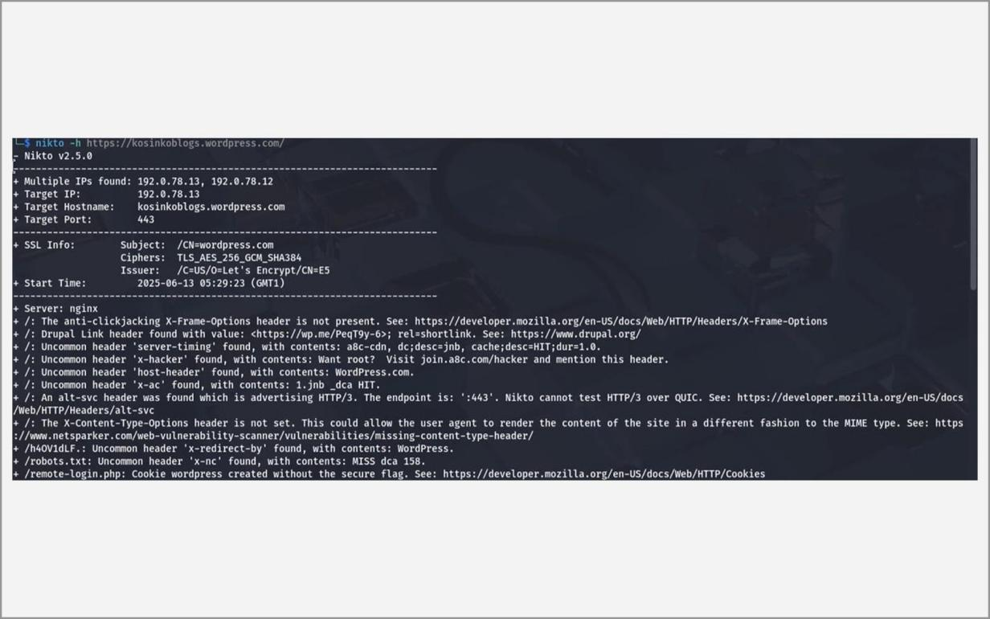
Fig. 6.16 – Nikto scan – findings and summary
C. Nessus
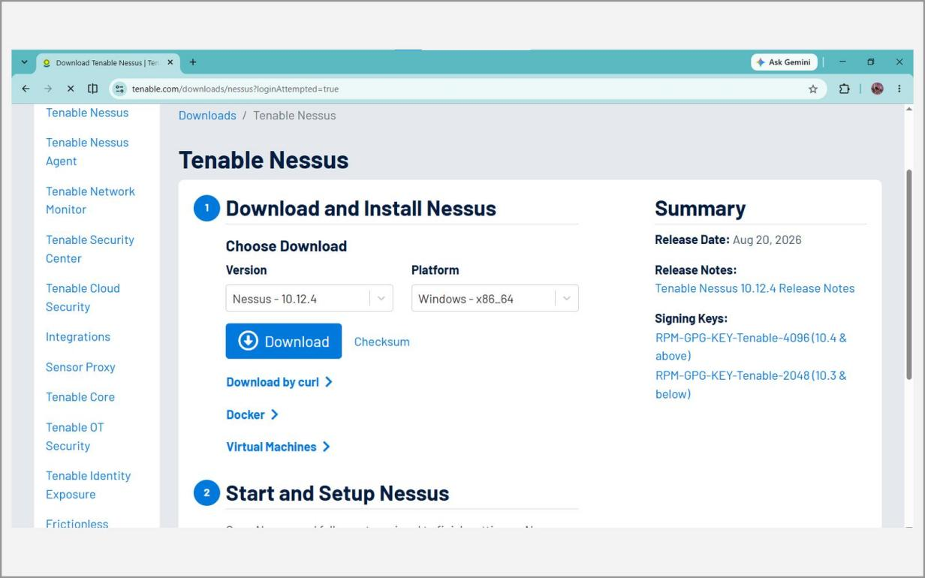
Fig. 6.17 – Nessus download page (tenable.com)
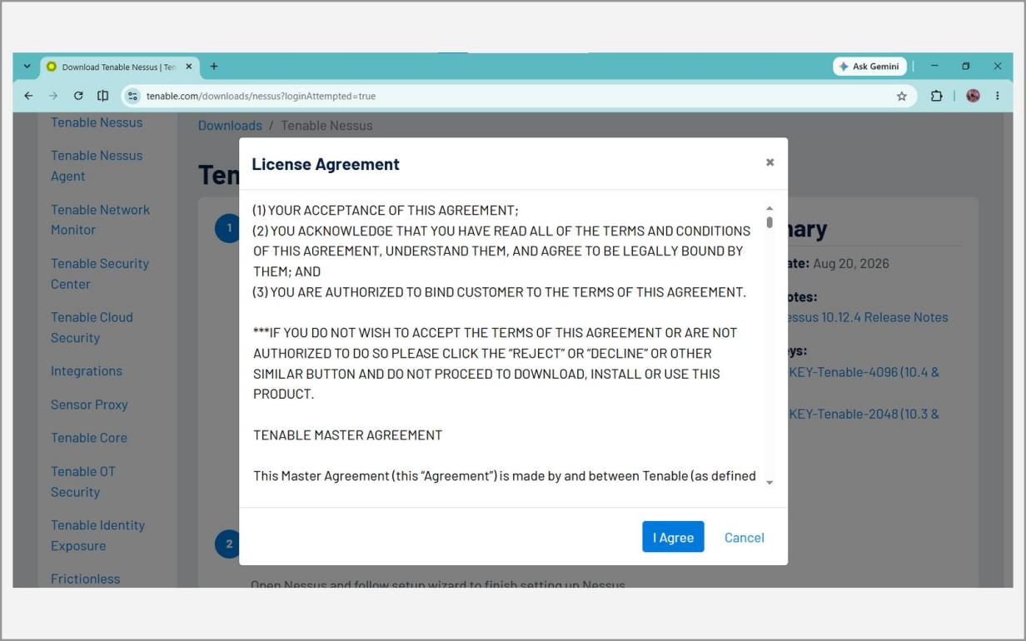
Fig. 6.18 – Nessus licence agreement
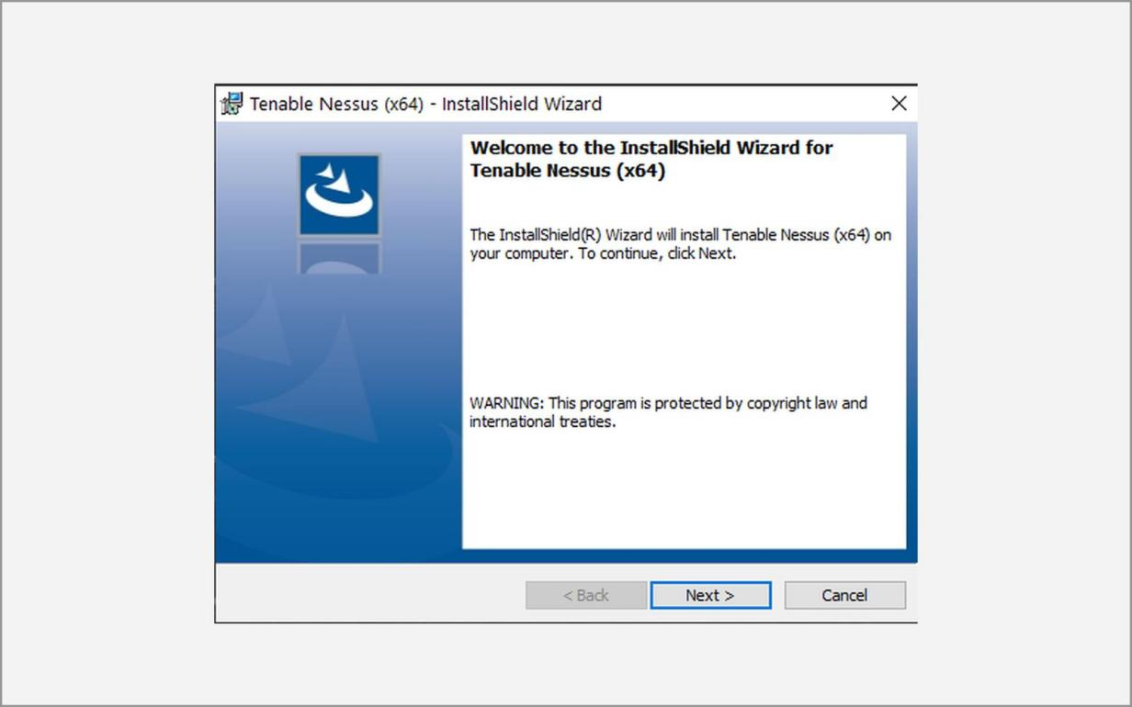
Fig. 6.19 – Tenable Nessus installation wizard
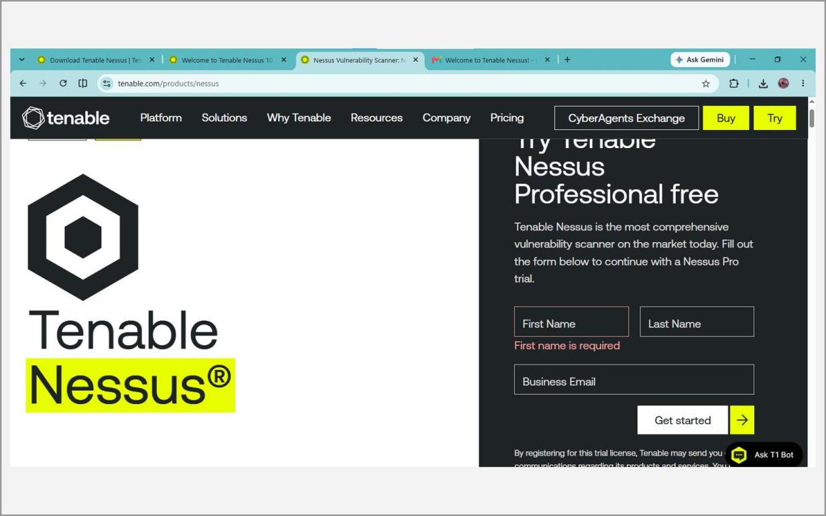
Fig. 6.20 – Requesting a Nessus Essentials activation code
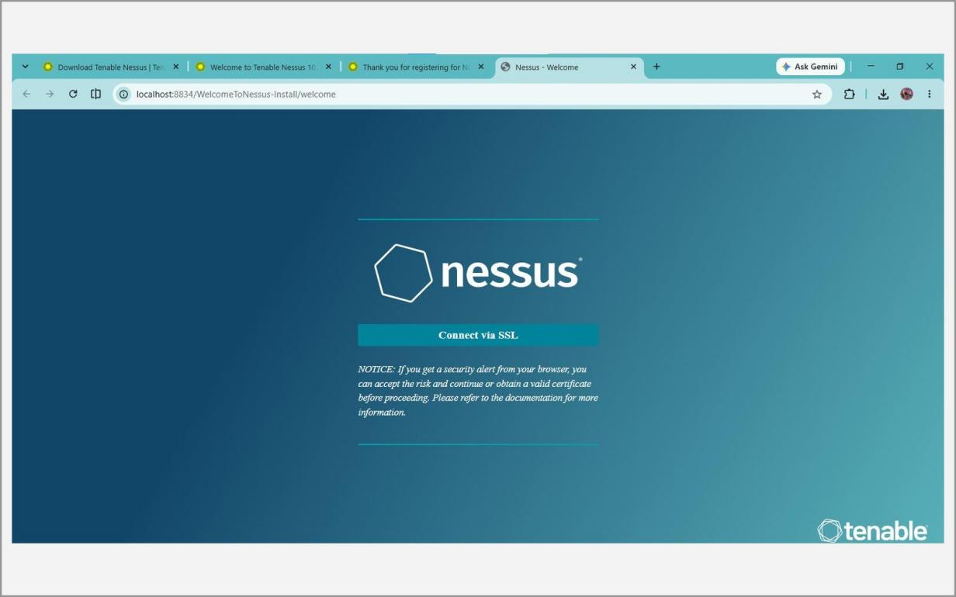
Fig. 6.21 – Nessus web interface – https://localhost:8834
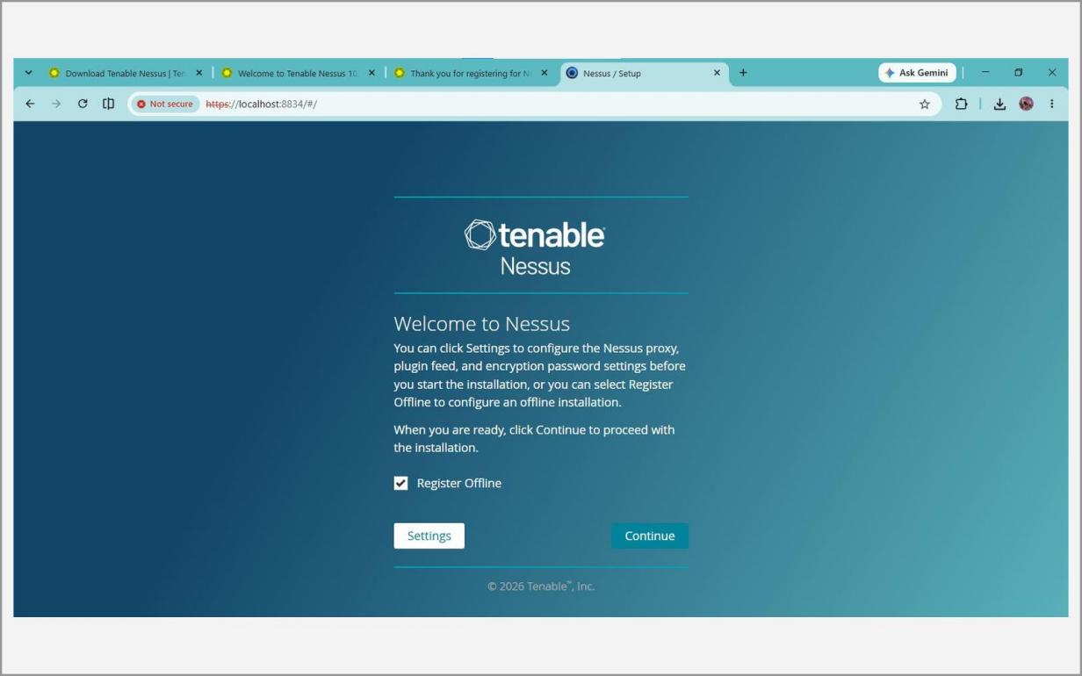
Fig. 6.22 – Welcome to Nessus – set-up
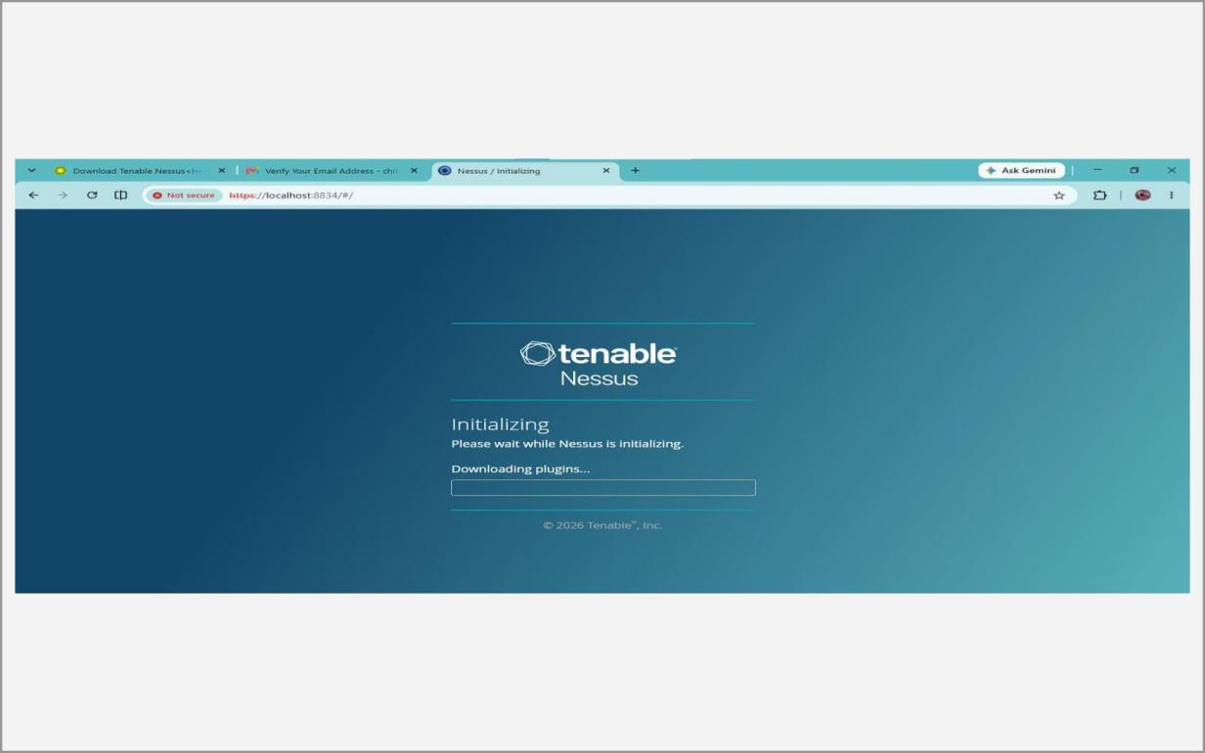
Fig. 6.23 – Initialising and downloading plugins
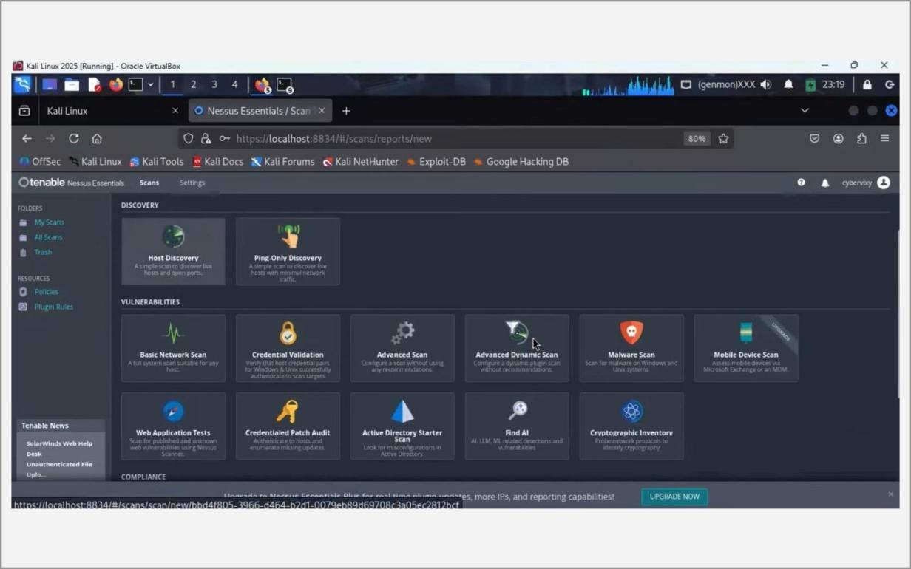
Fig. 6.24 – Scan templates – Basic Network Scan
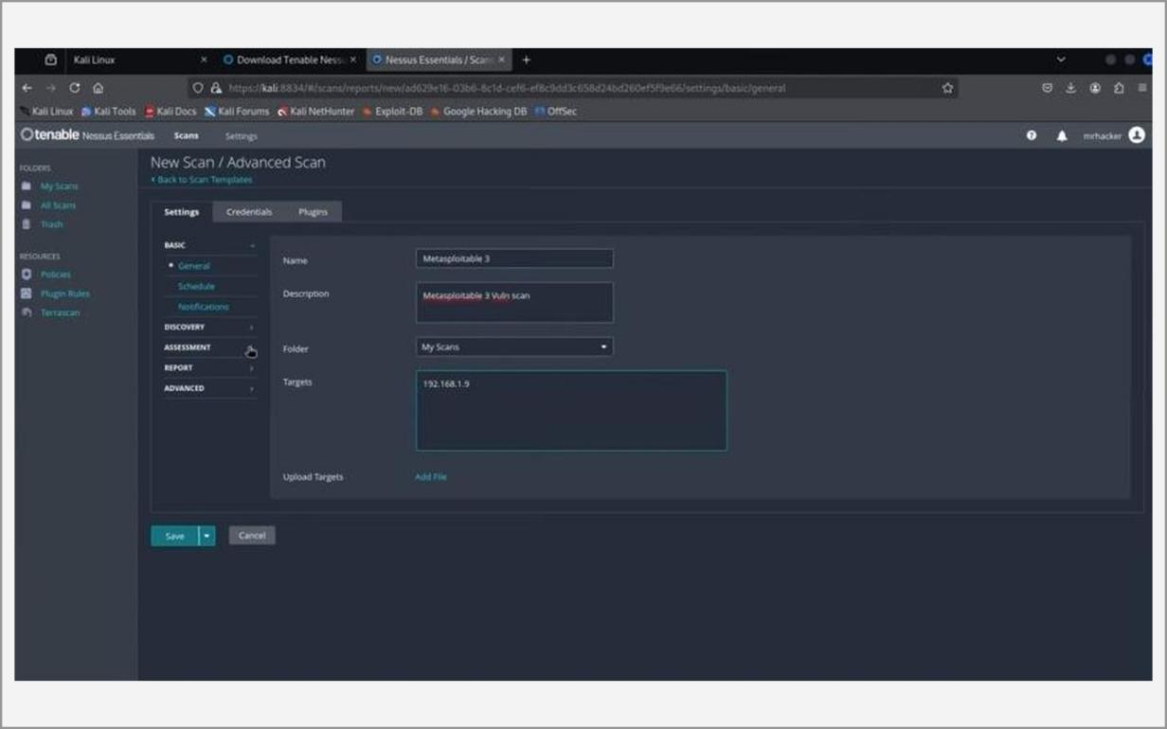
Fig. 6.25 – Configuring the new scan (name and target)
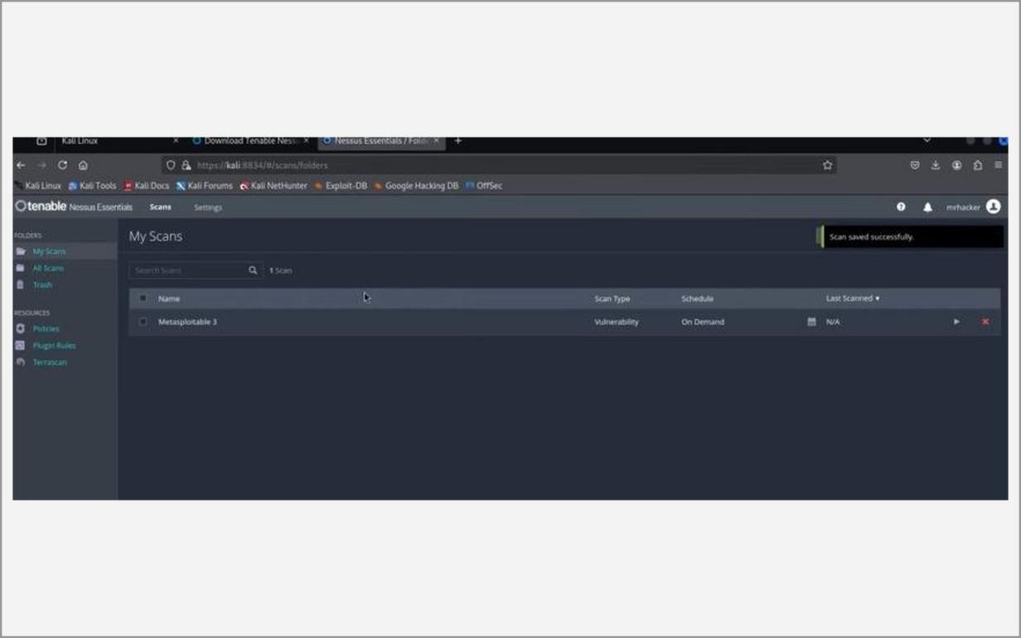
Fig. 6.26 – My Scans – scan running / completed
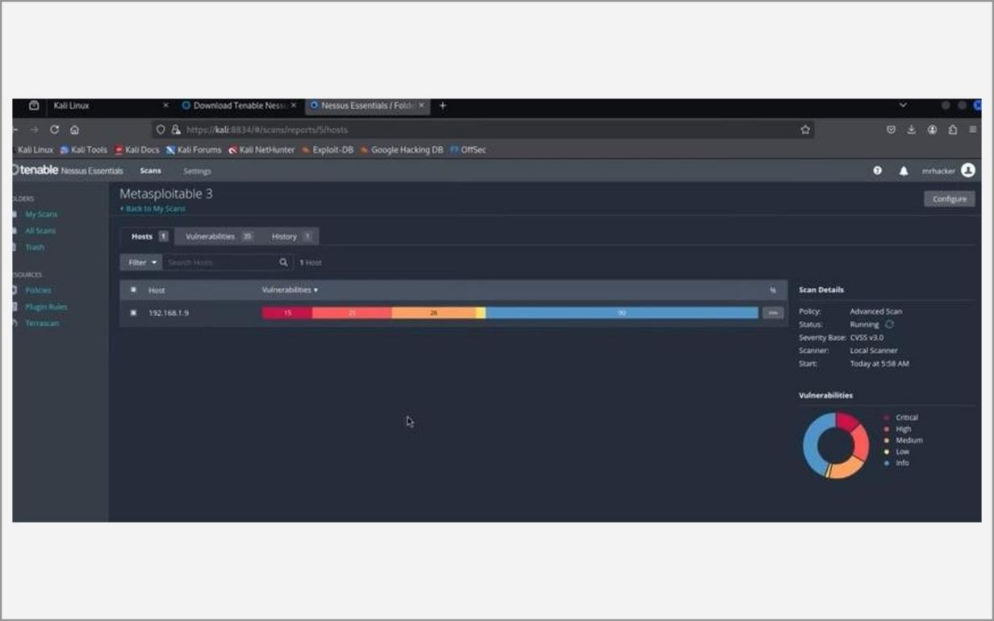
Fig. 6.27 – Scan results – vulnerabilities by severity
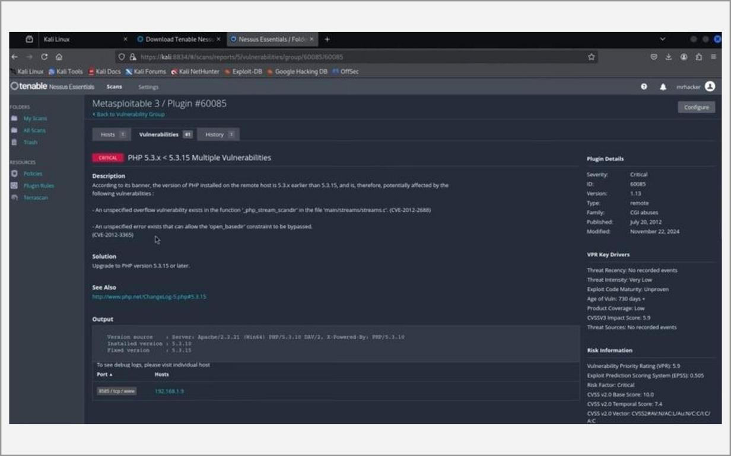
Fig. 6.28 – Details of a vulnerability finding with CVE reference
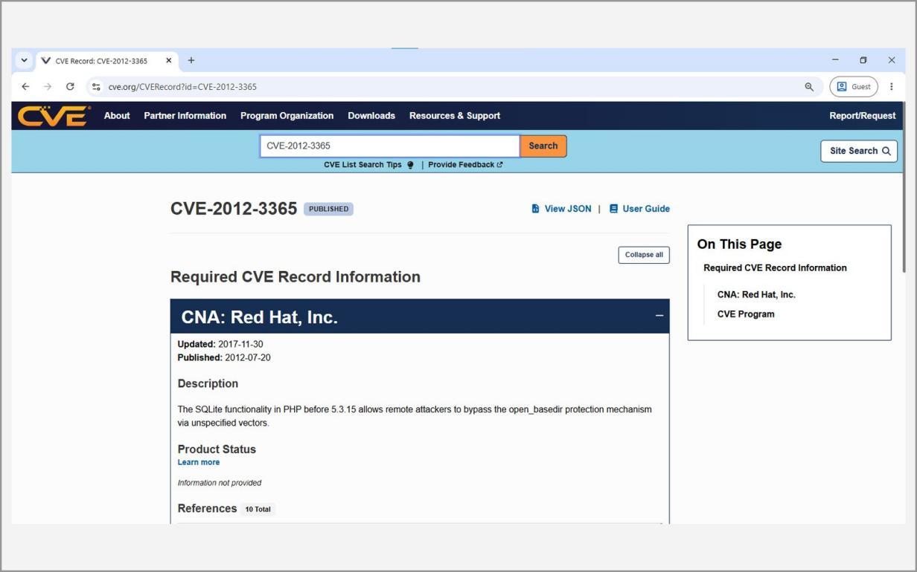
Fig. 6.29 – CVE record on cve.org
Learning Outcomes:
• Discovered live hosts, open ports, services, versions and operating systems using different Nmap scan types and understood open, closed and filtered ports.
• Understood the difference between a ping scan, a basic scan, a SYN (stealth) scan, a version scan and an aggressive scan.
• Used Nikto to identify outdated server software, default or interesting files and missing security headers on a web server.
• Installed and activated Nessus Essentials, ran a Basic Network Scan against a lab target and classified the findings by severity from Critical to Info.
• Traced vulnerabilities to CVE entries and CVSS scores on cve.org to judge their real-world risk.
• Learned that scanning is intrusive and must be done only on authorised systems, never on external or production infrastructure.
Ex. No. 7 Date: 16/09/2026
Information gathering using tools like Robtex
Objective:
The aim of this experiment is to use Robtex, a free web-based network and DNS intelligence service, for passive footprinting of a target domain. Robtex collects public DNS, routing and network-registration data and presents it in one place. Entering a domain or an IP address shows the DNS records, the other domains that share the same name servers or IP address, the history of DNS changes and the network range and autonomous system (ASN) in which the address lies.
Because the data comes from Robtex’s own database, the target’s systems are never contacted, so the technique is completely passive. The results are compared with other OSINT sources such as WHOIS, crt.sh and DNSdumpster to confirm their accuracy.
Tools:
• Robtex (https://www.robtex.com) – a browser-based DNS and IP intelligence tool; no installation or account is needed.
• Web browser – Chrome or Firefox on the host or the Kali virtual machine.
• WHOIS, crt.sh and DNSdumpster – other passive tools used to cross-check the Robtex findings.
Methodology:
Introduction to Robtex and DNS records
Robtex’s interactive graph can show shared-hosting relationships that a simple WHOIS or nslookup query does not reveal, for example many unrelated websites that sit on the same server, or several domains that use the same mail server.
The common DNS record types seen in the output are the A record (maps a name to an IPv4 address), the MX record (the mail servers of the domain), the NS record (the authoritative name servers) and the TXT record (free text, often SPF and DKIM e-mail policies or domain-verification strings). The SOA record and the DNS delegation chain show which servers are responsible for the zone.
1. Open https://www.robtex.com in a web browser. No account or installation is required.
2. Type the authorised training domain (ssn.edu.in) in the search bar and press Enter.
3. Review the summary panel that lists the resolved IP address(es) and hosting details.
4. Study the DNS records returned and interpret them:
• A record – maps the domain to an IPv4 address.
• MX record – mail server(s) responsible for the domain's e-mail.
• NS record – authoritative name servers of the domain.
• TXT record – SPF / DKIM policies and domain-verification strings.
5. Open the Subdomains, “Same first word”, DNS History and DNS Trace sections and the graph view to find related domains and shared-hosting neighbours.
6. Look up an IP address to identify the network range and the Autonomous System Number (ASN).
7. Cross-reference the findings with WHOIS, crt.sh and DNSdumpster to verify them.
Screenshots:
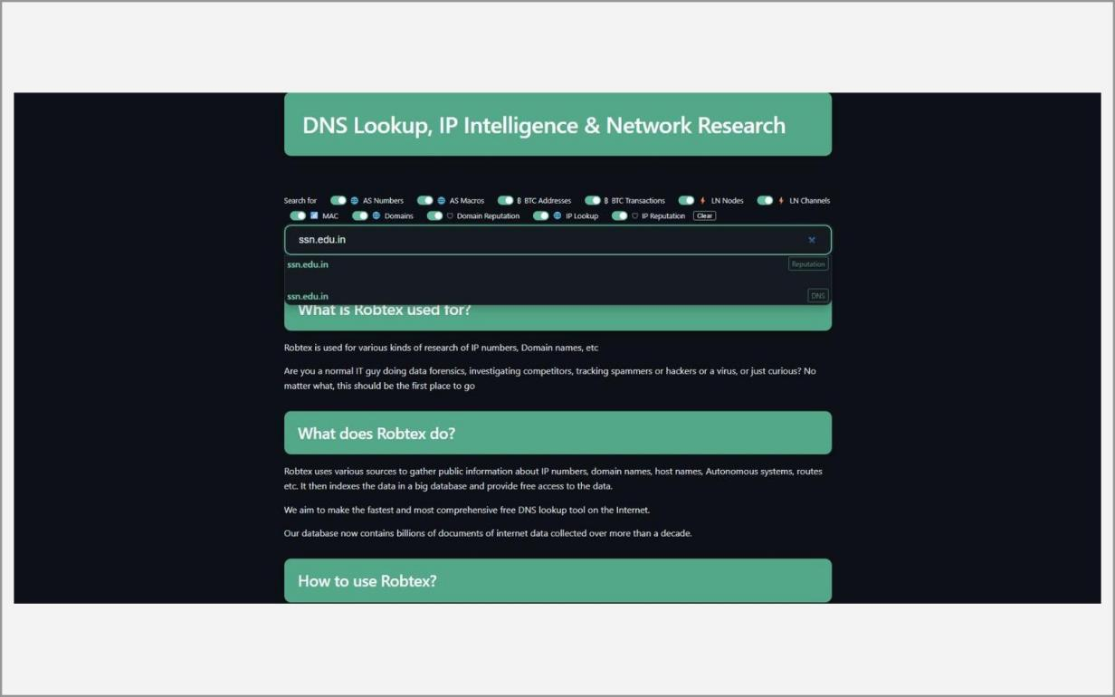
Fig. 7.1 – Robtex home page – DNS lookup and IP intelligence
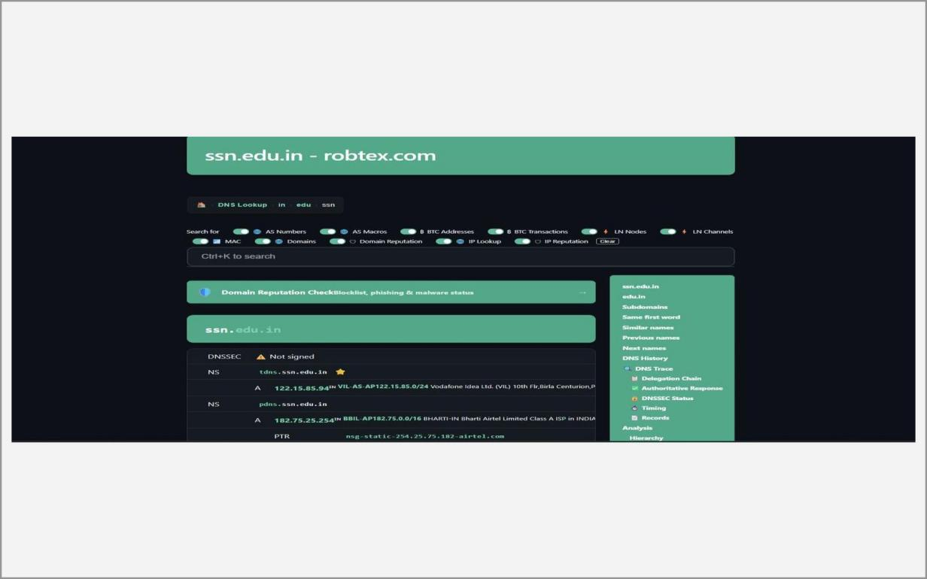
Fig. 7.2 – Domain lookup result for ssn.edu.in
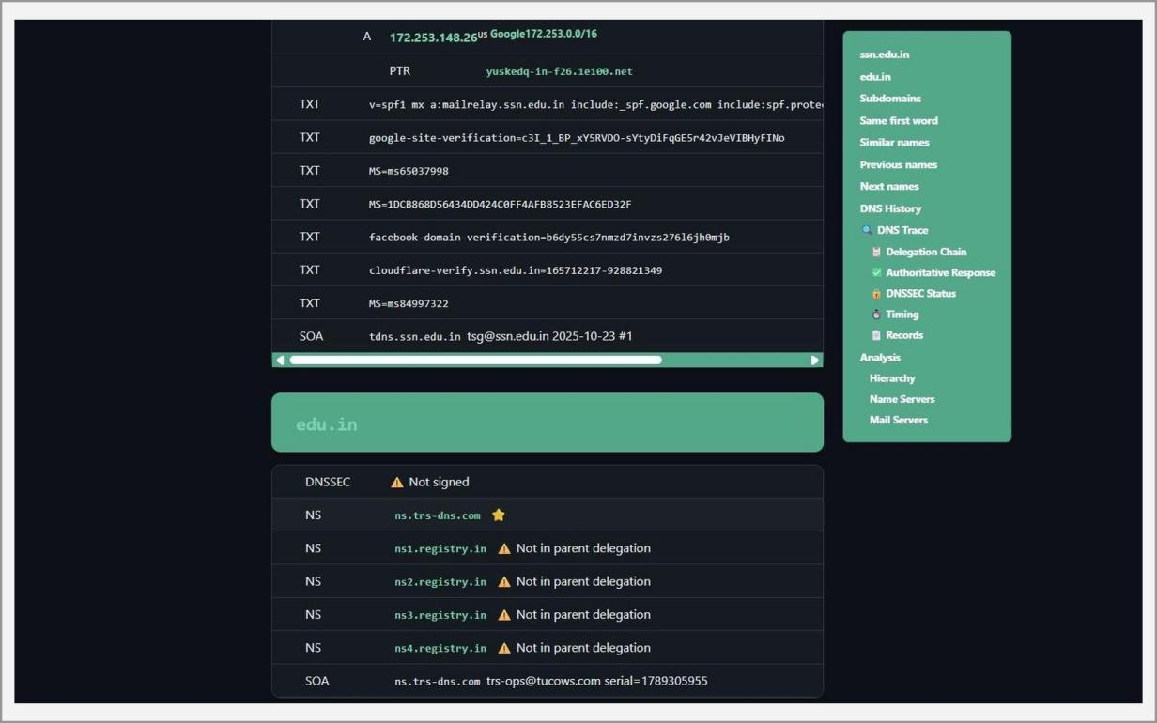
Fig. 7.3 – DNS records – A, MX, NS, TXT
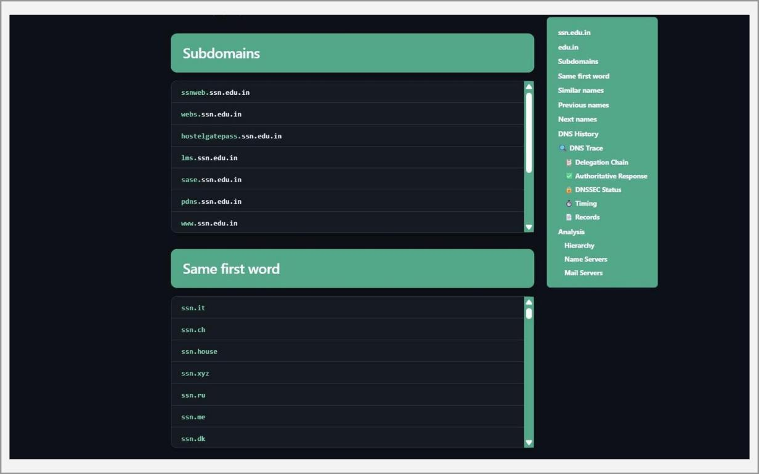
Fig. 7.4 – Sub-domains and domains with the same first word
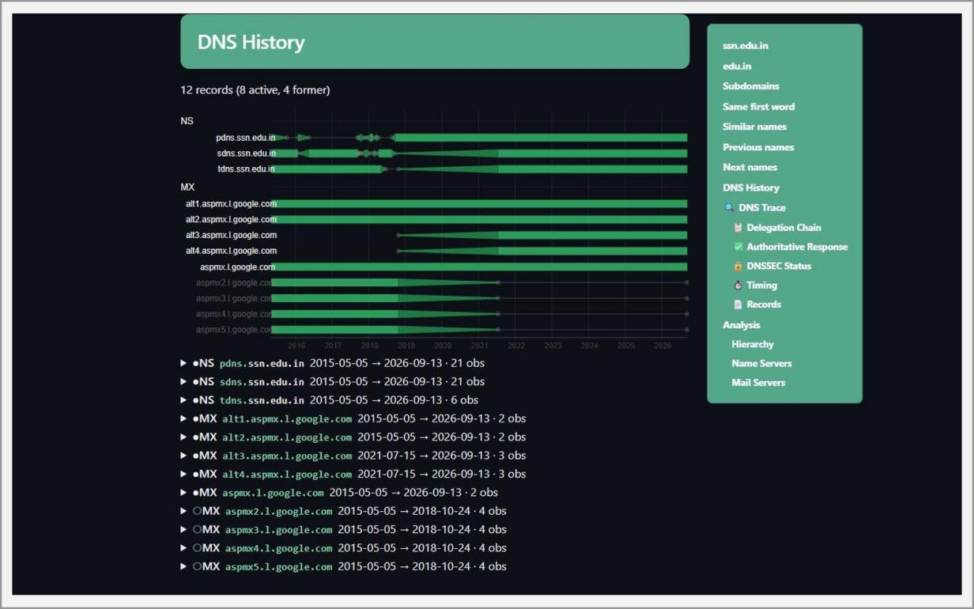
Fig. 7.5 – DNS history of the domain
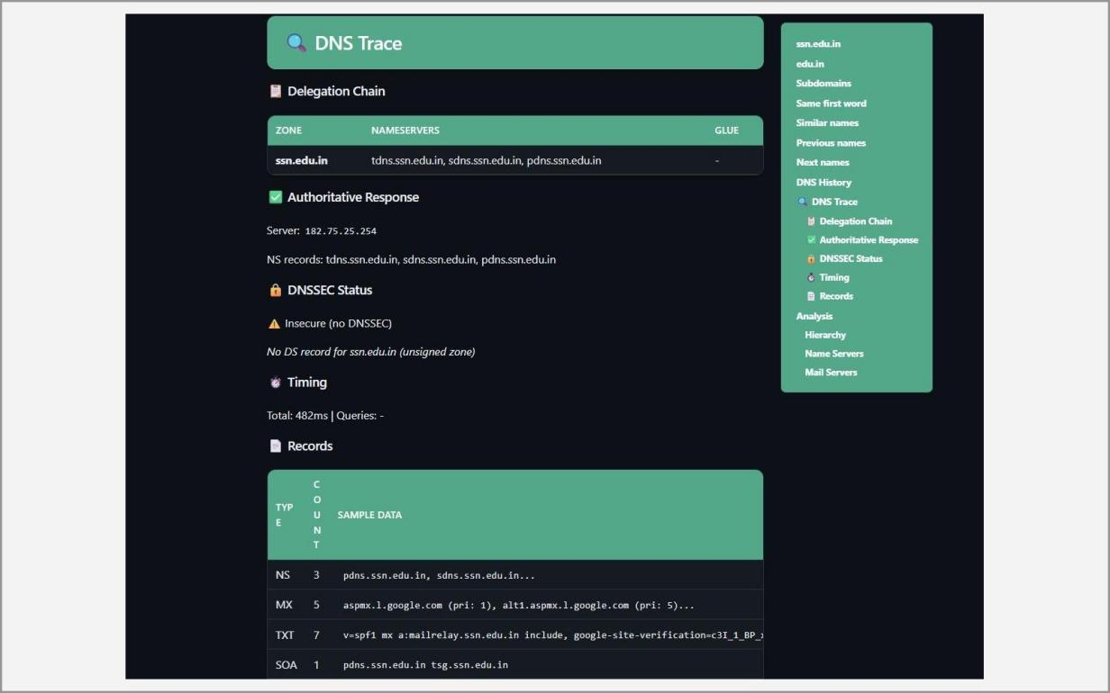
Fig. 7.6 – DNS trace – delegation chain and authoritative response
Learning Outcomes:
• Performed a purely passive domain lookup without sending a single packet to the target.
• Read and interpreted A, MX, NS and TXT records and understood what each one reveals about the infrastructure of the domain.
• Used Robtex’s sub-domain, “same first word”, DNS-history and DNS-trace sections to find related domains and shared-hosting neighbours.
• Identified the network range and the autonomous system of an IP address.
• Cross-checked the findings against WHOIS, crt.sh and DNSdumpster, learning why a single OSINT source should never be trusted alone.
Ex. No. 8 Date: 23/09/2026
Automate dig for vulnerabilities and match exploits using Armitage
Objective:
The aim of this experiment is to install and use Armitage, a graphical front-end for the Metasploit Framework, to automate the discovery of vulnerabilities and the matching of exploits against a lab target. Metasploit is normally used from the msfconsole command line. Armitage connects to Metasploit’s RPC service and shows every target host as an icon on a canvas, recommends exploits based on the services found, and exposes post-exploitation features through menus.
The experiment covers installing Armitage with its dependencies, starting the PostgreSQL database and the Metasploit RPC daemon, creating a workspace, discovering hosts with Nmap, using Find Attacks to match exploits to services, launching an exploit against Metasploitable 2, and managing the resulting Meterpreter session. Everything is performed only against the authorised lab target.
Tools:
• Armitage – a Java-based graphical cyber-attack management tool for Metasploit, originally created by Raphael Mudge.
• Metasploit Framework – the exploitation framework that holds the exploit, payload, auxiliary and post-exploitation modules; Armitage controls it through the msfrpcd daemon.
• PostgreSQL – the database in which Metasploit stores hosts, services and sessions.
• OpenJDK 17 – the Java runtime needed by Armitage.
• Nmap – used by Armitage for host and OS discovery.
• Kali Linux (attacker) and Metasploitable 2 (target) on a host-only lab network.
Methodology:
Introduction to Armitage
Armitage does not run exploits itself. It is a client that sends commands to msfrpcd, and Metasploit performs the work. Because several Armitage clients can connect to one Metasploit instance, a team can share targets and sessions in an exercise.
The Armitage window has a Modules tree on the left, a Targets canvas on the right and a console area below. Find Attacks compares the services recorded for each host with the exploit database and adds an Attack menu to the host. Hail Mary launches all relevant exploits automatically; it is noisy and is used only for demonstrations in an isolated lab. A compromised host turns red and shows lightning bolts, and Meterpreter offers file browsing, screenshots, privilege escalation, hash dumping and pivoting.
Note: Armitage is a Java client of Metasploit's RPC daemon (msfrpcd); host, service and session data are stored in PostgreSQL. Use it only against authorised lab targets.
A. Installation
sudo apt update && sudo apt full-upgrade -y
sudo apt install armitage
1. Start PostgreSQL and initialise the Metasploit database (once per machine), then check it:
sudo service postgresql start
sudo msfdb init
sudo msfdb status
2. Verify the installation:
armitage --help
msfconsole -v
B. Launching Armitage and connecting to Metasploit
1. Start Armitage as root, accept the default host 127.0.0.1, port 55553 and user msf, click Connect and answer Yes to start the Metasploit RPC server. The first connection can take a minute or two.
sudo armitage
2. Explore the interface: Modules panel (left), Targets panel (canvas) and console tabs (bottom).
C. Workspaces and host management
1. Workspaces → Manage → create a new workspace (for example lab-week9-armitage) and switch to it.
2. Hosts → Add Hosts (one IP per line) or Hosts → Nmap Scan → Quick Scan (OS detect) on 192.168.56.0/24 to populate the Targets panel; right-click a host → Services to see open ports.
D. Finding and launching attacks
1. Select the target host and choose Attacks → Find Attacks. Armitage compares the recorded services with the exploit database and adds an Attack sub-menu to the host.
2. Right-click the host → Attack → choose a module, check RHOSTS, RPORT, LHOST, LPORT and Target and click Launch.
3. (Optional) Attacks → Hail Mary runs all applicable exploits automatically – noisy, use only for demonstration in the lab.
E. Post-exploitation with Meterpreter
1. A compromised host turns red with lightning-bolt icons. Right-click → Meterpreter → Interact opens a Meterpreter console (sysinfo, getuid, ps …).
2. Use Explore → Browse Files / Screenshot, Access → Escalate Privileges / Dump Hashes and Pivoting → Setup as required.
Screenshots:
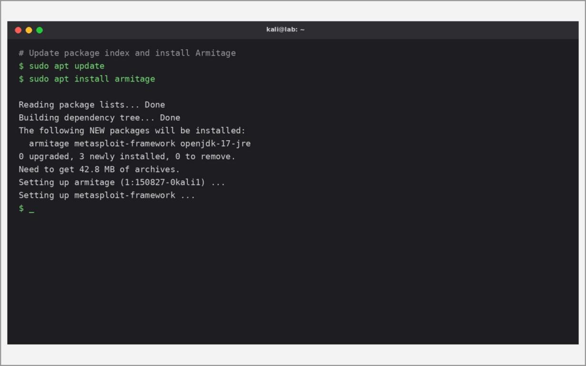
Fig. 8.1 – Updating the system and installing Armitage
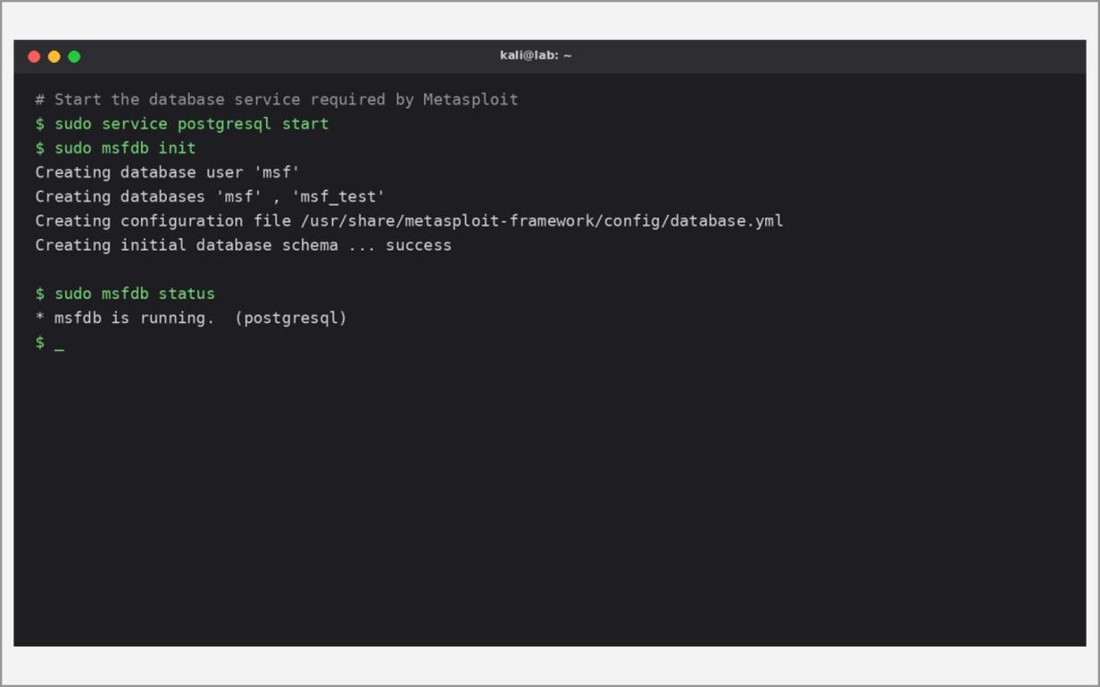
Fig. 8.2 – Starting PostgreSQL and initialising the Metasploit database
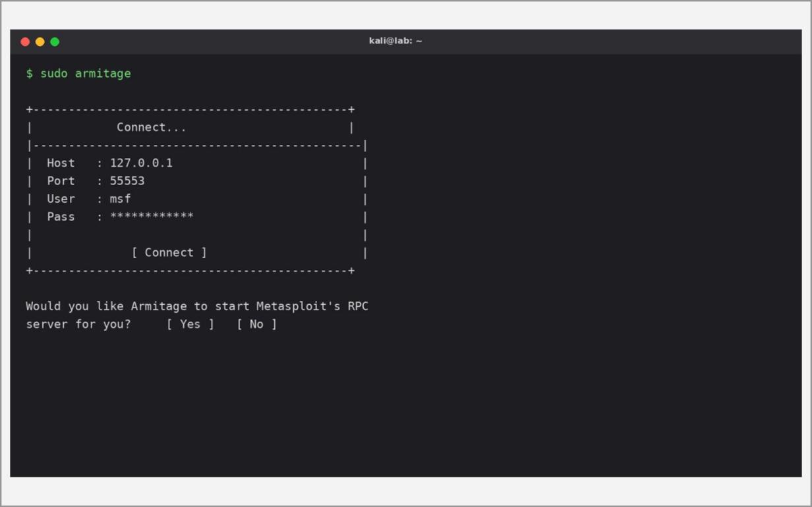
Fig. 8.3 – Armitage connection dialog (127.0.0.1:55553)
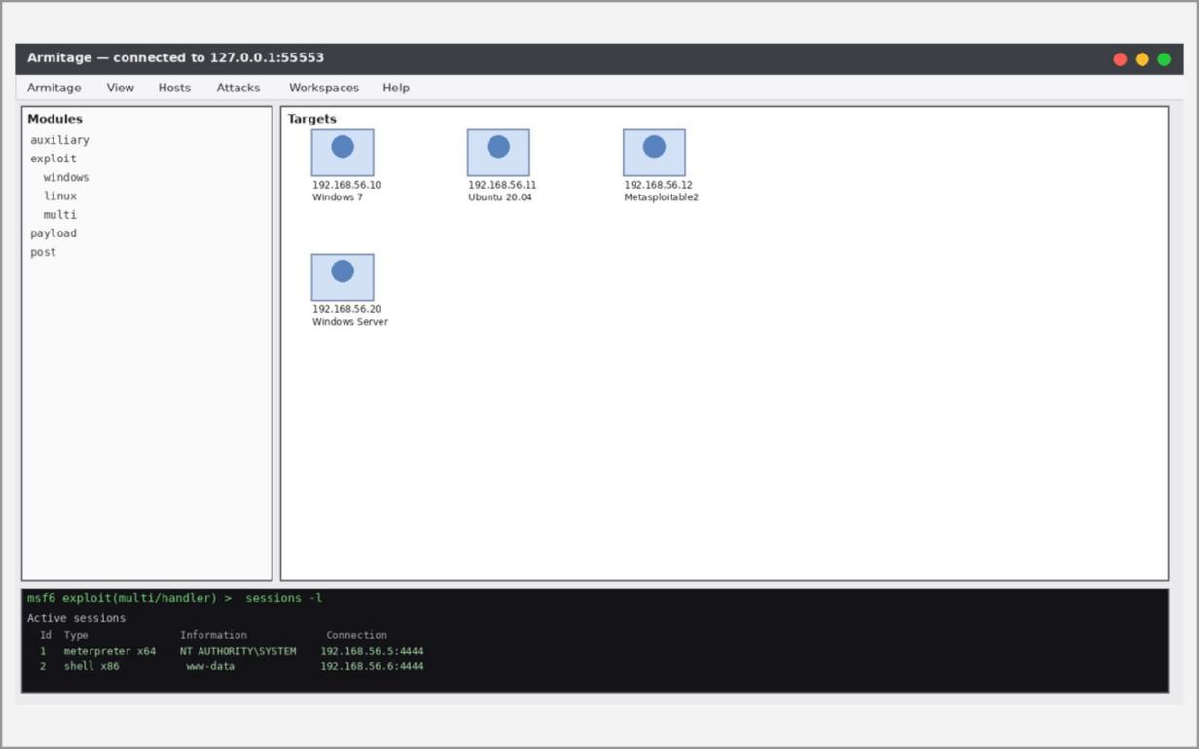
Fig. 8.4 – Armitage main window – Modules, Targets and console
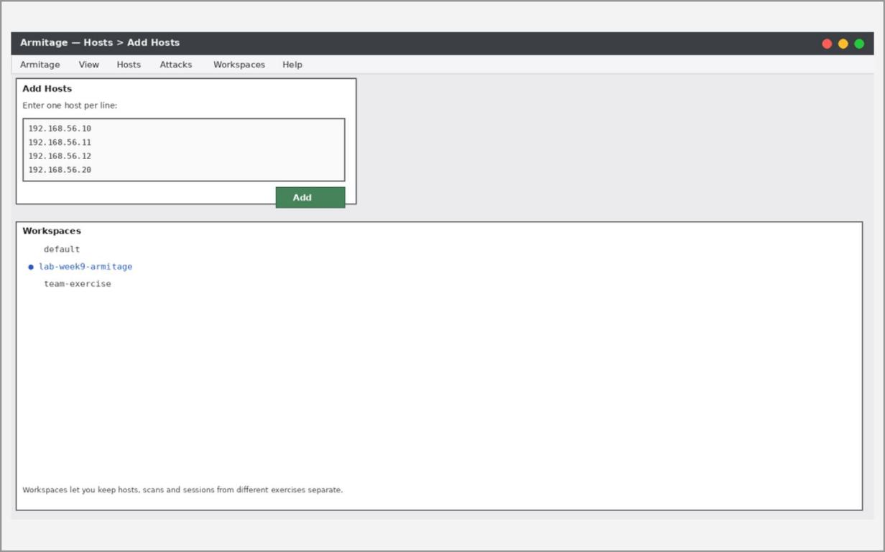
Fig. 8.5 – Workspace creation and Add Hosts
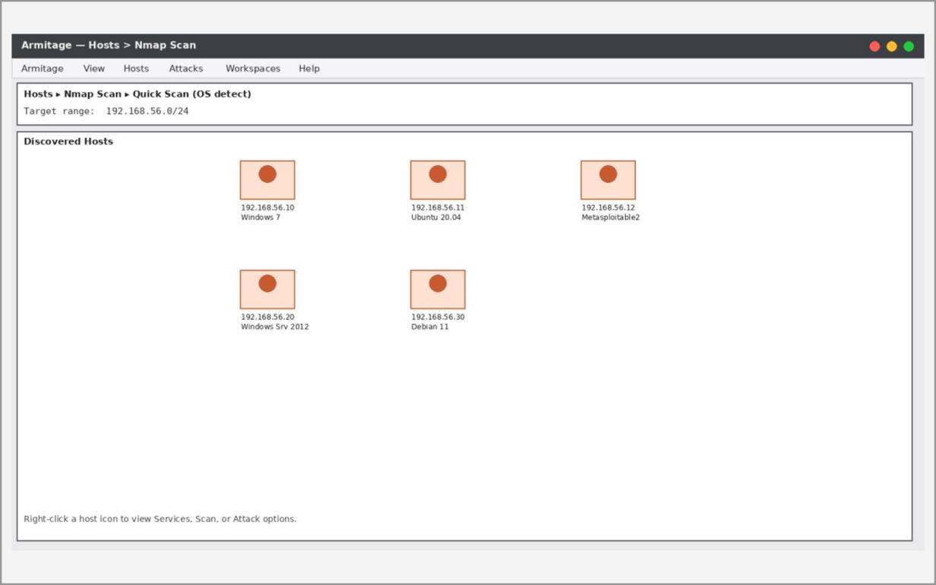
Fig. 8.6 – Hosts → Nmap Scan – discovered hosts
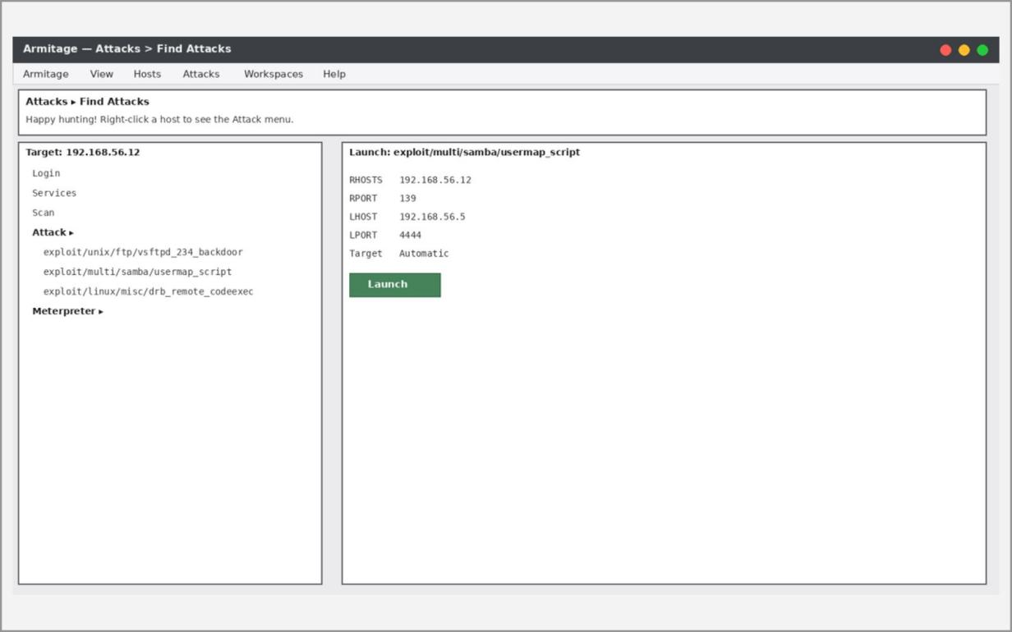
Fig. 8.7 – Attacks → Find Attacks – matching exploit modules
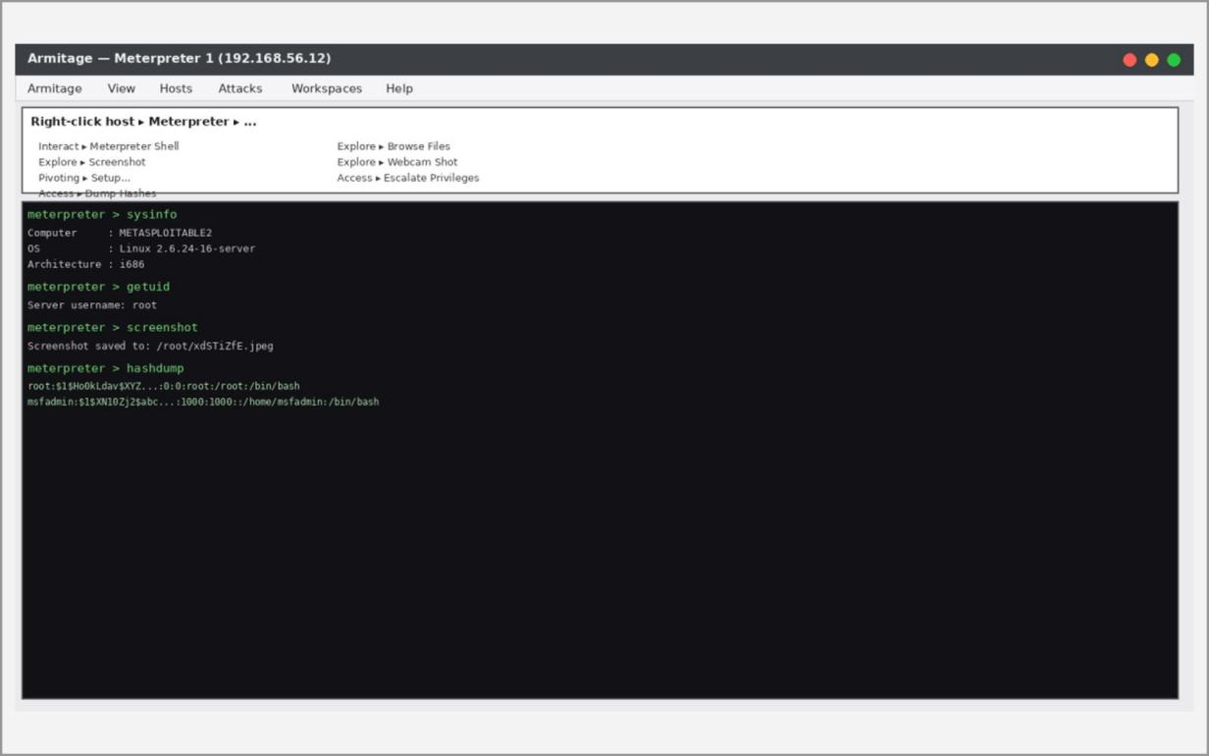
Fig. 8.8 – Meterpreter session – interacting with the compromised host
Learning Outcomes:
• Installed Armitage together with Metasploit, Java and PostgreSQL and verified the set-up with armitage --help, msfconsole -v and msfdb status.
• Connected Armitage to the Metasploit RPC service and organised targets using workspaces.
• Discovered hosts with Nmap, matched them to exploit modules with Find Attacks and launched an exploit against a lab target.
• Managed a Meterpreter session and understood post-exploitation actions such as file browsing, privilege escalation and pivoting.
• Followed the lab safety rules: only authorised, isolated targets, and Hail Mary only as a lab demonstration.

